Topics

* Core Java
* JDBC, Servlets & JSP
* HTML, CSS, Typescript, Javascript
* Git
* UML
* Junit
* Spring Framework
* Spring Boot & Microservices
* Python
* Cloud & Containers
* Design Patterns
* React.js

Java

It is a platform independent & object oriented programming language.

Platform Independent: You can run java programs on various platforms without re-compiling

Object Oriented Language: You create real world entities in the application and define the properties & behaviors of these real world entities, these real world entities are called as objects.

Two things are must in object oriented language which are also called as building blocks of an object oriented language

1. class: blueprint or template of an object
2. object: an instance created from the class

run -> entry point -> C/C++/Java -> main method

Java: public static void main(String[] args) { }

class Hello {   
 public static void main(String[] args) {   
 System.out.println(….);  
 }  
}

String[] - it is a command line argument which accepts the input from the user before launching the main

static - you can access static members without creating the object

public - visible outside the class

Softwares required

1. JDK - javac, java commands
2. Editor - notepad, vscode or IDE like Eclipse

Eclipse -> File -> Other -> Java Project

Fundamentals

1. Variables - these are the memory to store the data
2. Datatypes - byte, short, int, long, float, double, char, boolean, arrays & complex types
3. Operators - *, -, +, /, ++, --, <=, >=, ==, >, <, %, !=, &&, ||
4. Conditional statements - if else .. if else if .. else, switch
5. Loops - for, while, do while
6. Jump statements - break, continue, return

Java Naming conventions

avoid using variable names like a, b, c, i, j, k, x, y, z as they don’t explain themselves what they are instead use variable names like name, age, phoneNumber, gender and so on

Similarly for methods / functions you must use the names which are having meanings like

display(), update(), getDetails(), searchEmployee(), searchCustomer() and so on, avoid using test(), demo(), abc() and so on.

While or Do While loop

While loop: It first checks the condition & then executes the loop

Do while loop: at least once the loop is executed and then the condition is checked to continue

for each or enhanced for loop iterates the elements without using the index.

Activity:

Create an array of numbers like 1, 4, 3, 6, 2, 5, 0, -5, iterate over an array and display the maximum, minimum and sum of elements in the array  
ex: Max: 6, Min: -5, Sum : 16

Note: Use only one loop to display max, min & sum

For the same array search an element 2 that must print 2 is found  
then search an element 9 that must print 9 is not found

Command line arguments: These are the inputs which you can provide while running the program so that programs can use these inputs before starting, the String[] in the main is a command line argument you can pass while using java command or in eclipse you can pass through Run As option.

i.e.,

java TestApp 20 30 40   
java TestApp Hello Everyone

Type conversion: Converting one type to another type, it can be automatic or explicit depending on the type of variable you are using

Auto-widening (Type promotion)  
int x = 25; // int = 4, long = 8  
long y = x; // type promotion

Explicit-narrowing

long x = 25; // long = 8, int = 4  
int y = (int)x; // explicit narrowing

Auto-boxing & Auto-unboxing: These are automatic because it deals with converting primitives to wrappers and vice versa

int x = 25; //  
Integer y = x; // Integer = int >> Auto-boxing, 25 will stored as an Integer object

int z = y; // int = Integer >> Auto-unboxing

class Calculator {   
void add(byte x, byte y) {   
  
 }  
}  
int a = 25;  
int b = 30;  
add((byte)a, (byte)b);

Object Oriented Programming

class: It defines the structure, it can have following members

* variables or fields
* methods: Will have reusable logics
* constructors: are called when objects are created, you can have initialization logics

object: It is an instance of a class which is created with new keyword

User user1 = new User();

Constructor vs Methods

|  |  |
| --- | --- |
| Constructor | Method |
| Constructors are called when objects are created | Methods are not called when objects are created |
| It will not have return type | It must have return type |
| Its name must be same as the class name | It’s name need not to be same as the class name, however you can give class name but they are invoked only when you call them explicitly |
| It usually will have initialization logic | It will have reusable logics |

Activity:

Create User class with id, name, constructor to initialize the id & name, display method to print id & name, in main method create 2 objects & call the display method.

Classes can have static and non-static(instance) members

static members you can access directly from the class name, however non-static members you can access only by creating the object whenever you want these members to accessed outside the class.

class User {   
 int id;

static int counter = 5;  
}  
User.counter = 7; // valid  
User.id = 33; // invalid, because id is instance variable

static members are loaded at the time class loading, non-static members are loaded at the time of object creation.

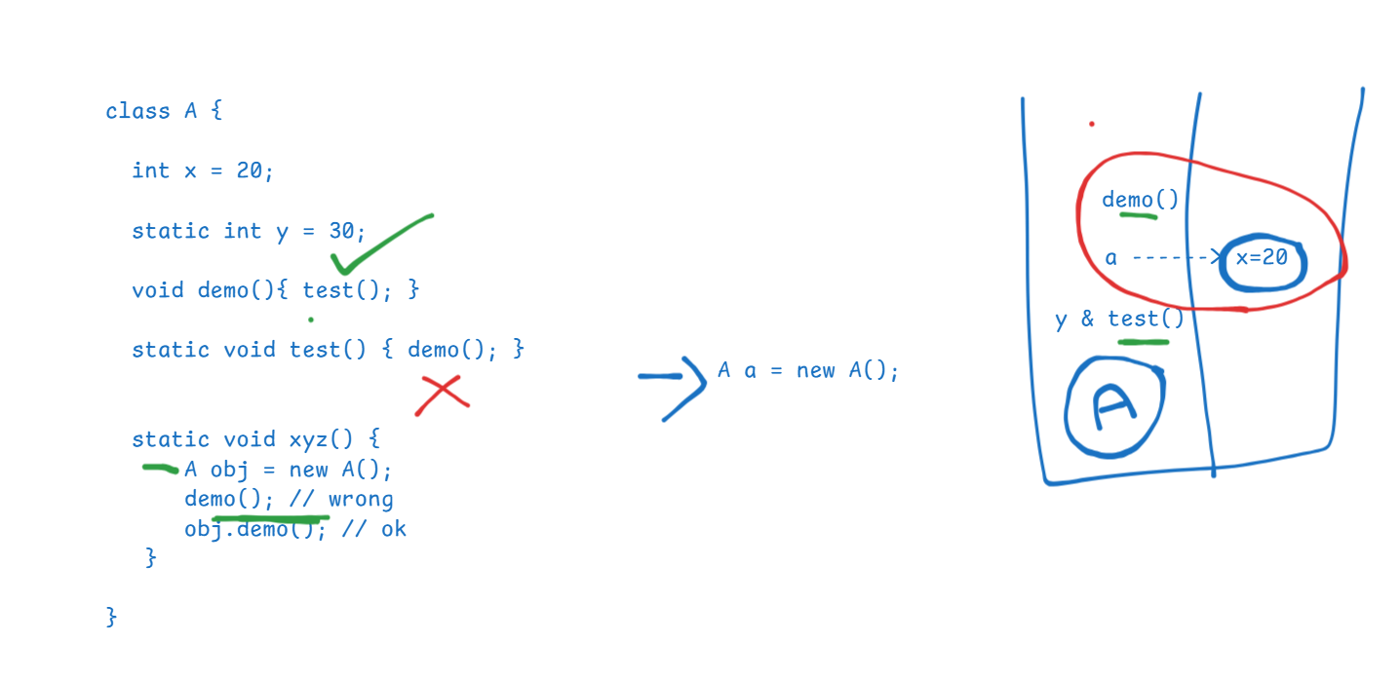

Quiz:

int x = 20;

int y = ++x;

System.out.println(y); //21  
System.out.println(x); // 21

1. class A {   
    static void demo() { test(); } // error  
    void test() { System.out.println(“hello”); }  
   }
2. class A {  
    static void demo() { A a = new A(); a.test(); } // ok  
    void test() { System.out.println(“hello”); }  
   }

}

class A {   
 // default constructor in case you have not written  
}   
class B {   
 B(int x) {   
 }  
 // only one constructor will be created which takes int parameter  
}

byte x = 30;  
long y = 40;  
int z = (int) y; //   
int z1 = x; //

Principles of OOPs

Inheritance  
Encapsulation  
Polymorphism  
Abstraction

Inheritance:

Acquiring the properties & behaviors of a class from another class, you use extends keyword to inherit   
class Person {   
 name, gender, email, dob // properties  
 display() { } // display data   
}  
class Employee extends Person {   
 employeeId, salary   
}  
class Student extends Person {   
 rollNo, grade  
}

Note:

* In Java you can achieve various types of inheritance like single level, multi-level, hierarchical, multiple(supported only through interface) & hybrid (supported only through interface)
* If a class doesn’t extend any class it automatically extends Object class
* Subclass constructors calls the default constructors of the parent class by default, however you can pass parameters to the super() to call the parameterized constructor of the parent class

Polymorphism:

A method that has many forms or a method that can do more than one job, there are two types of polymorphism

1. Compile time – overloading – method invocation is determined at compile
2. Runtime – overriding – method invocation is determined at runtime

class Person, class Employee extends Person, class Student extends Person { }   
  
Method Overriding: you will create the same method of super class in the subclass with different logic & to achieve runtime polymorphism you will use the super class reference variable and call the overridden method  
void test(long x) { }   
int a = 20; test(a);  
long b = 30; test(b);  
byte c = 40; test(c);

Method Overloading: You will create multiple methods with the same name in the same class with different signature(parameter type or order or return type)

Encapsulation: It is mechanism of hiding the data by making data private & the only way you can access the data is using public methods, private data will not be visible outside the class so that it restricts the direct access from the outsider

class Employee {   
 private int id;  
 private int age;  
 Employee(int id) { this.id = id; }  
 public void setAge(int age) { this.age = age; }  
 public int getAge() { return age; }  
 public int getId() { return id; }  
}  
Employee emp = new Employee(34);  
emp.id = 356; // error  
emp.age = 4939; // error

Abstraction:

Hides the complexity and shows only the necessary details so that it will be easy to use the object, here the developers need not to worry about how the method is implemented, instead they must know what a method does.

We achieve abstraction by creating abstract methods in 2 ways

abstract methods: These are the methods which doesn’t have logic or body

1. interface: Will have only abstract methods & constants
2. abstract class: can have both abstract methods (methods without body) & non-abstract methods (or methods with body)

interface: Methods are by default abstract & public, variables are by default public, static & final, however you can’t have constructors, hence you can’t create the object of the interface

interface UserDB {   
 void store(); // public abstract void store();  
 void delete();  
}

A class can implement the interface (a class can also implement one or more interfaces)

D4 implements the interface  
class UserDBOneImpl implements UserDB {   
 // mandatorily you must implement all the methods of interface  
}

D1 ui1(UserDB db) { db.store(); }  
D2 ui2(UserDB db) { db.delete(): }  
D3 ui3(UserDB db) { db.store(); }

D5 ui1(new UserDBOneImpl());

Customer -> login(), transfer(), getDetails(),

Employee -> deleteAccount()  
  
interface CustomerOP {   
 login(); transfer(); getDetails();  
}  
interface EmployeeOP {   
 deleteAccount();   
}  
class BankOp implements CustomerOP, EmployeeOP { 4 methods }  
Customer -> ui(CustomerOP cop) { cop.login(), cop.getDetails(), cop.transfer() }  
Employee -> ui(EmployeeOP eop) { eop.deleteAccount(); }

Abstract class

It allows you to have abstract methods and methods with body, go for abstract class when you don’t know the full implementation of the class

ex:

interface DataStructure {   
 void add(int x); // LIFO, FIFO, SO, RO, Uniqu  
 void delete(); // LIFO, FIFO, SO,   
 void findAll();  
}  
abstract class AbstractDS implements DataStructure {   
 void findAll() { … }  
}   
class StackDS extends AbstractDS {   
 // mandatorily implement all the abstract methods like add, delete  
}   
class UniqueDS extends AbstractDS {   
 // mandatorily implement all the abstract methods like add, delete  
}  
Note: Abstract class can have constructors, but you can’t create object of an abstract class

Note: From Java 8 there are few changes done in the interface

Difference between interface and abstract class

|  |  |
| --- | --- |
| Interface | Abstract class |
| All the methods are by default abstract & public | You need to explicitly use abstract keyword |
| All the fields are public, static & final | Fields are not constants unless explicitly defined |
| Can’t have constructors | Can have constructors |
| Provides full abstraction | Provides partial abstract |
| An interface can extend one or more interfaces which is called as multiple inheritance | An abstract class can extend only one class |
| We can’t instantiate | We can’t instantiate |
| More secured when you want to share the interface | Not secured when you want to share the abstract class to other developers |

Packages & Visibility of members

For visibility java has 4 access specifiers

class A {   
 private int x; //   
 int y; // default or package private  
 protected int z;   
 public int i;   
}

1. private: Visible only within the class
2. no keyword i.e., default or package private: Visible within the package
3. protected: within the package & outside the package only to the subclasses
4. public: Visible to all

package com.ibm package com.org;  
public class A { class B {   
 protected int z; // can’t access z  
} class C extends A { // z will be inherited

Exception Handling

5 keywords – try, catch, finally, throw & throws

try { }: try block should have code that might generate exception, ex: accessing the DB, accessing the files, working with remote service

catch(..) { } : catch block will handle the exceptions generated in try block, you can have multiple catch blocks

finally { } : This is absolutely executed whether or not exception handled, some mandatory statements that needs to be called like closing the files, db connections

throw: It is to manually generate an exception or user defined exception, ex: UserNotFoundException, AgeInvalidException, AccountNotFoundException, InsufficientBalanceException

throws: It is to forward the exception from one method to another when a method wants a caller to handle the exception, because caller knows what to do with the exception.

Exception hierarchy

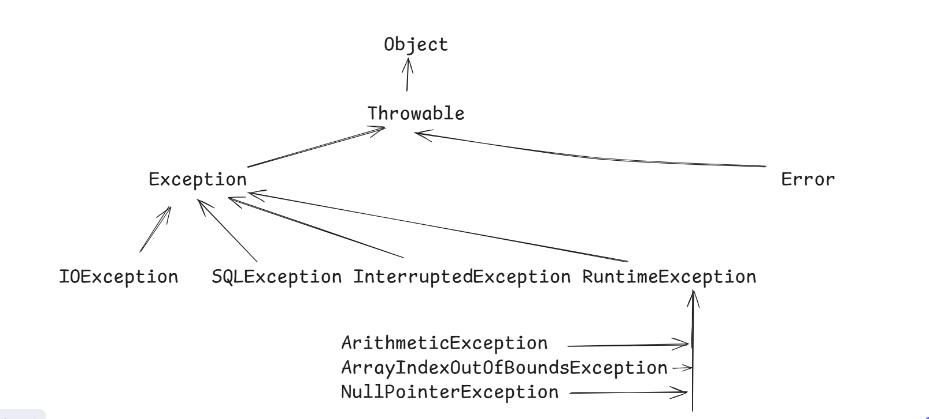

Error you can’t handle, but Exceptions you can handle, here there are 2 types of exceptions

1. Checked exceptions, which must be handled at the compilation time using try – catch or it must be propagated using throws
2. Unchecked exceptions are subclasses of RuntimeException which are not forced to handle at the compilation time, because these exceptions are programmers mistakes that can be resolved with the proper logic

try with resource:

It is introduced in Java 7, to automatically close the resources like Files, Databases, Scanner to reduce too much try catch finally, this syntax you can use only on the classes that implement AutoCloseable or Closeable

try ( Scanner scan = new Scanner(System.in);   
FileReader reader = new FileReader(scan.next()); BufferedReader buffer = new BufferedReader(reader) )   
{  
  
}

try( String str = “hello”; ) { }// this gives compilation error

Custom exceptions

Creating exceptions of our own based on the project requirement by extending any one of the Exception class, you can extend any one of the exception class like Exception or RuntimeException, to create checked exception you can extend Exception or sub class of Exception except RuntimeException, if you extend RuntimeException it becomes unchecked.

ex: InsufficientBalanceException, AgeInvalidException, LimitExceedException and so on.

class EmployeeNotFoundException extends Exception {   
 // minimum 2 or more constructors you must create  
}

Employee find(int id) throws EmployeeNotFoundException {   
 if(…) { throw new EmployeeNotFoundException(…); }  
}

Assertions: These are used to test some results in your code, if the result is not as per the expectation then you can make assert false that can throw an assertion error, it is used only at the time of development / testing

int age = scan.nextInt();

assert (age >= 18) : “Age is less than 18”;

This works only if you enable the assertion, you get an assertion error if the assert condition is false.

By default assertions are disabled, to enable you must use -ea option in the vm argument i.e., java -ea in case you are using command prompt, else in Eclipse you need to use configuration in Run As option

Multithreading

Running more than one task at the same time, means at the same time multiple threads can run the methods by sharing the CPU time

There are mainly two ways to write multi threaded applications in Java

1. By extending the Thread class
2. Another is by implementing a Runnable interface, it has run() method that is an entry point for the threads

Note: Thread class implements Runnable interface internally

To create threads you must use Thread class that provides various methods to manage threads

Thread thread1 = new Thread(runnableTypeObject);  
Thread thread2 = new Thread(runnableTypeObject)

thread1.start(); // it registers the threads in the thread schedular

thread2.start(); // 2nd thread registers in the thread schedular

Once the threads are registered run() method logics will be executed

Thread.currentThread(): returns the currently running thread  
Thread.sleep(long): thread goes to sleep state

getName(): returns the name of the thread

setName(String): to provide the name for the thread

Executor Framework

it takes care of creating the threads and allows to reuse the threads in the thread pool.

Thread t = new Thread(..); // here thread will be created & destroyed once the job is done

Executor executor = Executors.newFixedThreadPool(3);

executor.execute(runnableType);

JRE & JVM architecture & Garbage collector

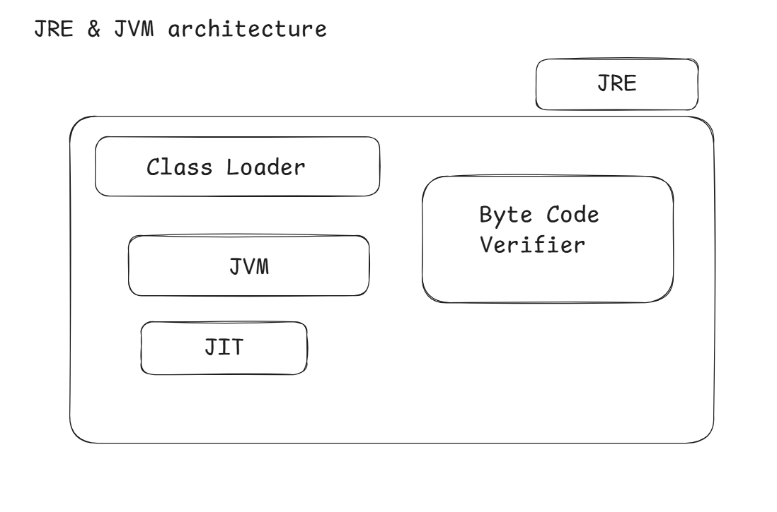

Garbage collector is a thread, which takes care of marking all the objects that has no reference & remove those objects automatically so that it gives space for other objects

main() {   
 test();  
 demo();  
}  
test() {   
 A a = new A();  
 B b = new B();  
}  
demo() {   
 X x = new X();  
}

Here once the test() method is completed its execution, a & b references will be removed whose objects are eligible for garbage collection, when garbage collector marks the object it will find two types of objects.

1. object with reference
2. object without reference – only these objects will be removed.

String class

It creates an immutable string object, once string object is created you can’t modify its content.

String methods:

concat(), toUpperCase(), toLowerCase(), charAt(), length(), equals(), equalsIgnoreCase(), substring(), indexOf(), split(), strip(), isBlank() and so on.

String s1, s2, s3, s4, s5;  
s1 = “hello”;  
s2 = “hello”; // s1 == s2 >> true   
s3 = new String(“hello”); // s1 == s3 >> false  
s4 = new String(“hello”); // s3 == s4 >> false

s1.equals(s3); // compares content instead of address  
s1.concat(“123”);  
System.out.println(s1); // hello  
s1 = s1.concat(“12345”);  
System.out.println(s1); // hello123

Inner class

These are the classes that you can nest inside another class, you use nested classes when outer class is dependent on another class:

ex: Thread class is having a nested enum called State, enum is also a type of class but will have fixed set of constants.

There are four types of inner class you can create

1. Static inner class
2. Non-Static inner class
3. Anonymous class
4. Local inner class

enum: it is a type of class which helps you to create fixed set of named constants

enum Gender {   
 MALE, FEMALE  
}  
You can create a variable of Gender which can accept either MALE or FEMALE value onlye  
Gender gen1 = Gender.MALE;  
Gender gen2 = Gender.FEMALE;  
gen1 = Gender.XYZ; // error

Instead of create String gender you can create an enum Gender

Event Management System Use Case

class Event {   
 id, name, time, location, organizerNames, startDate, endDate; // properties  
 updateEvent(startDate, endDate) { }   
 updateEventTime(time) { }   
 display(id) { … } // display the event details based on the id  
}  
main method -> you can create 3 to 4 event objects -> display all the events -> updateEvent() & display the updatedEvent

Day 4 topics

1. Collection with Generics
2. IO Streams – File handling & Serialization(optional)
3. Reflection API
4. Java 8 features
5. Java 11 features
6. Java 17 features
7. HttpClient
8. Internationalization
9. Arrays
10. Object class methods
11. Java annotations - @Override, @SuppressWarning
12. Debugging
13. Interview questions

Collection Framework

Collection can maintain multiple objects and it is dynamic in nature, it has predefined classes & interfaces that can maintain the objects in various forms

Arrays are also a collection but its size is fixed & you need to write the algorithm to maintain the elements in various forms

Employee[] employees = new Employee[5]; // object array

// employees can store maximum 5 employee objects, from employees[0] to employees[4]

Collection vs Array

|  |  |
| --- | --- |
| Arrays | Collections |
| Size is fixed | Size is dynamic |
| Manually you need to write algorithms to maintain elements in various forms like unique elements, sequential elements, sorting elements and so on | You get inbuilt methods to add, remove, iterate the elements |

Collection framework provides various interfaces & classes, below is the collection hierarchy

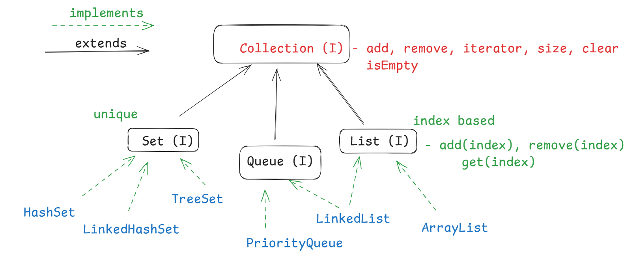

Note: You don’t need to know how these algorithm is internally implemented, instead you must know how they maintain the data

Set: Supports only unique elements  
TreeSet: Maintains the elements in sorted order, ex: storing student based on result  
LinkedHashSet: Maintains the elements in Sequential order, ex: online token based processing

HashSet: Maintains the elements in Random order, but it is faster in retrieving the data, because it uses hash based algorithm

Queue: It is used to process the data after removing, it provides methods like poll() to remove the element

PriorityQueue: It removes the element based on the priority i.e., sorted order

ex: online bidding

stock market [ order1(1000), order2(1005), order3(990) ]

LinkedList: It removes the elements in FIFO order  
ex: messaging apps

poll in Queue vs remove in Collection: poll() is part of Queue that can remove the element either in sorted order or FIFO order, however remove in Collection removes the particular element

List: It is index based

ArrayList: Maintains the elements in contiguous memory address and if the elements are added in between then other elements are shifted to different memory to maintain the contiguous memory address

ex: Use ArrayList in the application where you frequently retrieve and rarely add or remove the elements, like university applications

ArrayList adding and removing is slower & retrieval is faster

LinkedList: Maintains the elements in non-contiguous memory address, adding & removing is faster & retrieving is slower

ex: Online shopping apps

Collection can store multiple objects however storing multiple objects would be problematic at the time of retrieval hence collection uses generics to define what type of objects it will store

Without generics

List al = new ArrayList();   
al.add(5);  
al.add(88.5);  
al.add(true);  
al.add(new Employee(…));  
al.add(“hello”);  
With generics// it was introduced in Java 5  
List<Integer> al = new ArrayList<Integer>();  
al.add(5);  
al.add(8);  
al.add(“hello”); // compilation error  
al.add(44.5); // compilation error

Note: You must use only classes in generics you can’t use primitive data types

List<int> al = new ArrayList<int>(); // wrong  
List<Double> al = new ArrayList<Double>(); // correct  
List<Employee> al = new ArrayList<Employee>(); // correct

Iterator: It is an interface used to iterate the collection, it has 3 methods

1. hasNext: checks next element is present if present returns true else false
2. next: returns the next element
3. remove: removes the iterated element

Collection has iterator() method which you must call to get the Iterator reference  
Iterator<Integer> itr = al.iterator();  
while(itr.hasNext()) {   
 int ele = itr.next();  
 if(ele == 5) { itr.remove(); // removes the element 5 }  
}

Example  
List<Integer> al = new ArrayList<Integer>();

al.add(50); al.add(20); al.add(30); al.add(5); al.add(40); al.add(5); al.add(20); al.add(5);

al [50, 20, 30, 5, 40, 5, 20, 5]

al.remove(5); // remove the element present in 5th index

al.remove(Integer.valueOf(5)); // removes the value 5

Iterator<Integer> itr = al.iterator();

v = 5

itr.hasNext() -> it.next() == 5 -> itr.remove()

Map: It is also a datastructure where it maintains the data in key & value pairs, it is not part of collection hierarchy but it is also dynamic in nature.

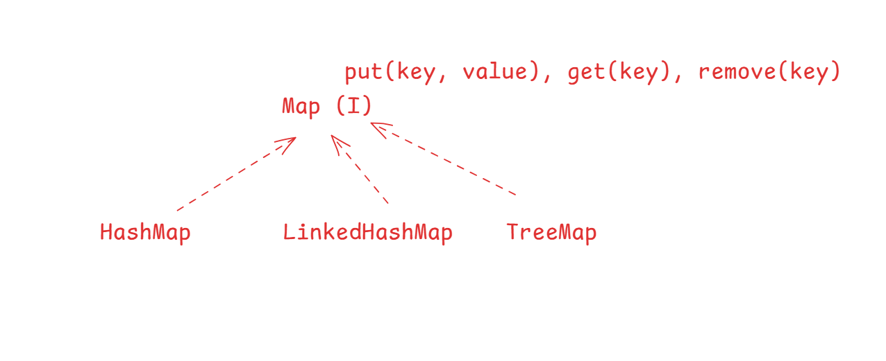Map<Key, Value>: it doesn’t support duplicates, key must be unique, value can have duplicate, it has methods like

* put: stores the data
* get: to read the data based on key
* remove: to remove the data based on key

HashMap: maintains random order

LinkedHasMap: maintains sequential order

TreeMap: maintains the key in sorted order

Note: Map & their implementations are present in java.util package.

Map<Integer, String> map = new HashMap<Integer, String>();  
map.put(123, “Raj”); map.put(456, “Vijay”); map.put(345, “Arun”);  
S.o.p(map.get(123));  
S.o.p(map)  
map.remove(123);  
S.o.p(map);   
change HashMap to TreeMap & LinkedHashMap & observe the output

You can maintains database credentials or server informations in the map in key & value structure

map.put(“dbuser”, “admin”);  
map.put(“dbpwd”, “Welcome@123”);

Java 8 features

1. Functional interface or Functional programming
2. Lambda expression
3. New Date & Time classes
4. Default & Static methods in interface

Activity

Create a class Event with following properties like eventId, eventName, startDate, endDate, constructor to initialize all the four properties, toString method to return all the properties, getters, setters for all the properties, in a separate class create the main method add 5 Event objects to the HashSet and print each event object by iterating the HashSet, next ask user to enter an event id and remove the event object from the HashSet which matches to the eventId, then again print the event objects present in the HashSet.

Add a duplicate event object in the same HashSet and check whether duplicate is added or not

Event.java

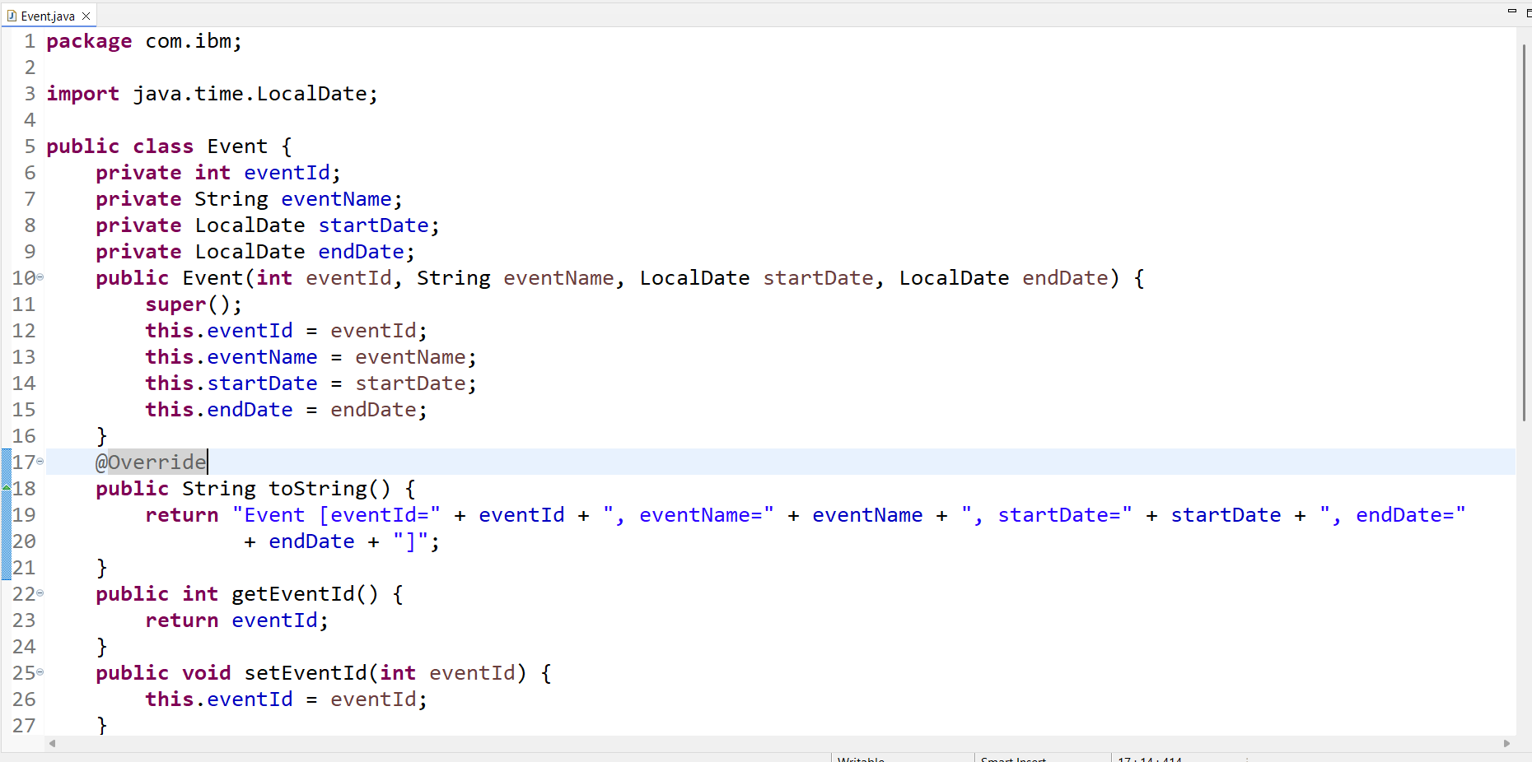

TestEvent.java

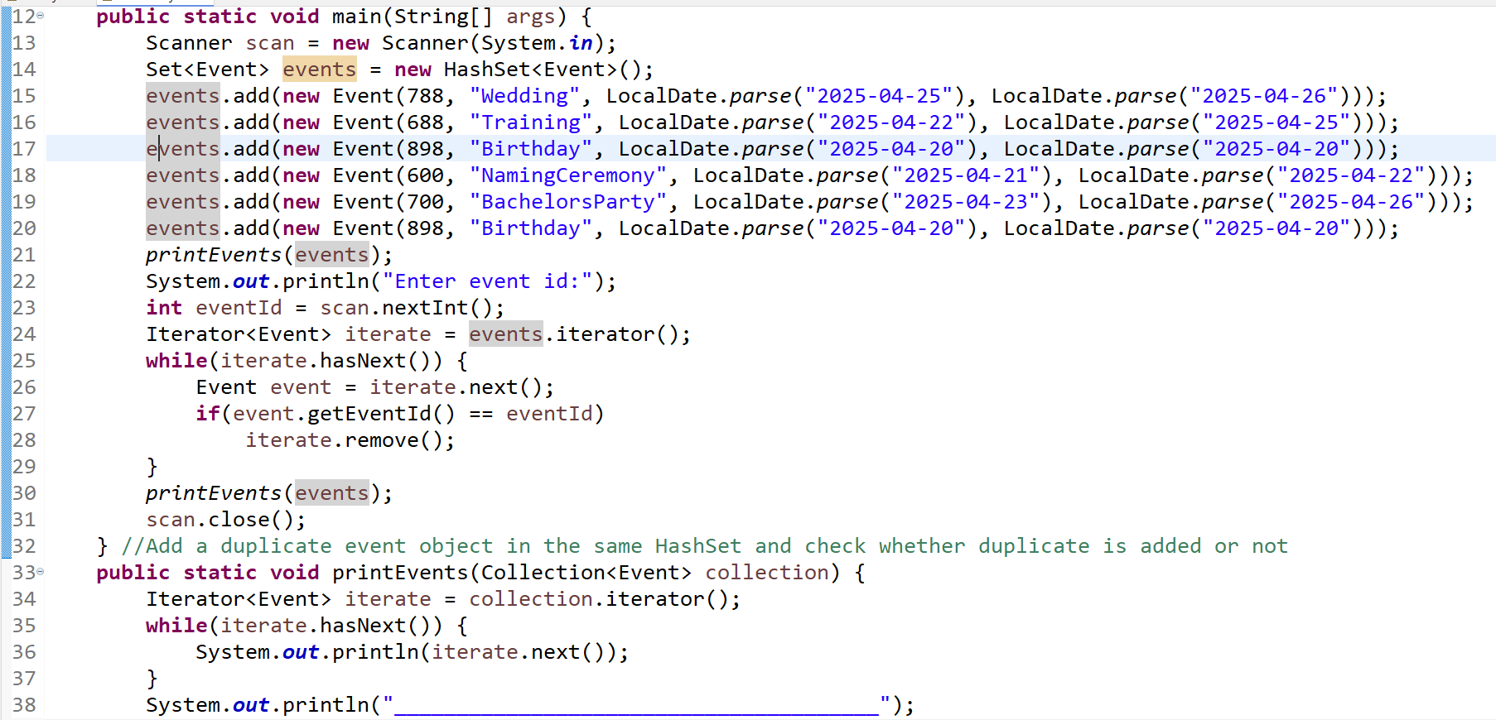

Whenever you add complex elements into the Set you must override 2 methods of Object class which are

1. equals(): comparing the objects whether they are equal or not
2. hashCode(): specifies where the object must be stored in the hash bucket

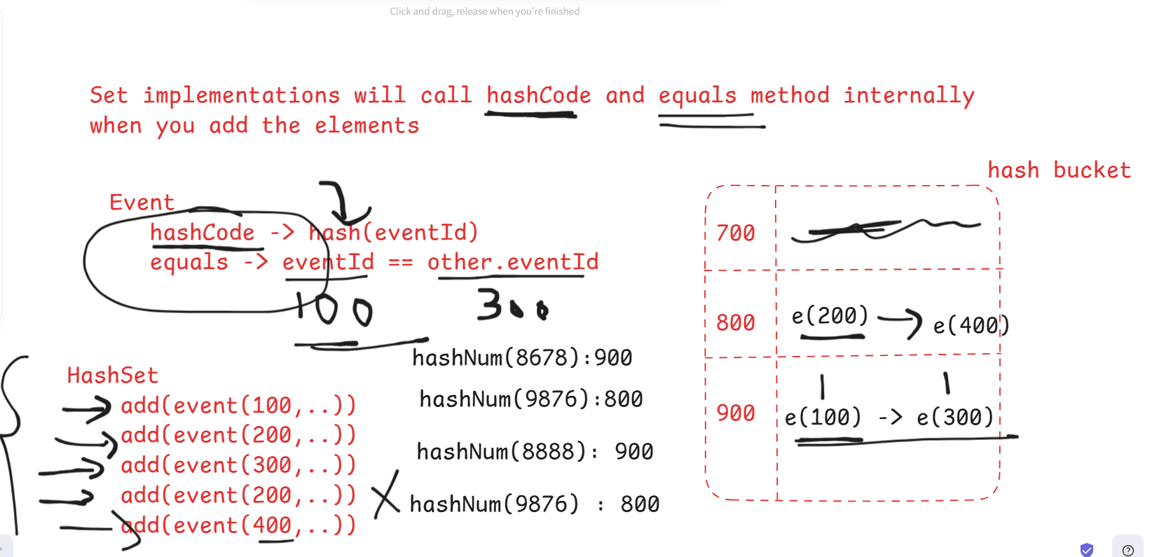

Sorting the event objects

You can add event objects into the TreeSet to keep in the sorting order, however TreeSet looks for Comparable or Comparator type to sort the objects, if they are not used then TreeSet throws ClassCastException.

Note: Simple types, String, LocalDate and few other classes are of Comparable type hence TreeSet can sort them, however custom classes not implementing Comparable can’t be sorted

How TreeSet can arrange the even objects using compareTo method.  
555, 666, 777, 888

event(777)  
event(666)  
event(888)  
event(555)  
event(444)

777-> compareTo -> compare(x, y) -> 0 -> 777(pivot)  
666 -> compareTo-> compare(666, 777) -> -1  
888 -> compareTo-> compare(888, 777) -> 1  
555-> compareTo-> compare(555, 777|666) -> -1

Comparable can be used for natural sorting, i.e., like a default sorting for complex type, you can use sorting id’s in ascending or as the default sorting technique, however when you need other properties to be sorted like name, startDate, endDate then you must use Comparator interface, which needs to be implemented outside the class that needs to sorted.

Comparator has one abstract method int compare(x, y)

You can implement Comparator using a class or nested class or anonymous inner class

Comparator<T> c1 = new Comparator<T>() {   
 public int compare(x, y) { return … }  
}  
You must pass this comparator object to the TreeSet(Comparator)  
Set<T> set = new TreeSet<T>(c1); // TreeSet uses Comparator to compare the object  
Set<T> set = new TreeSet<T>(); // TreeSet uses Comparable to compare the object

Functional interface are those interface which will have only one abstract method

ex: Comparator, Runnable,

You can use lambda expression to simplify writing the implementations to these functional interface

|  |  |
| --- | --- |
| Implementation of Functional interface | Lambda Expression |
| Comparator<T> cmp = new Comparator<T>() {   public int compare(T x, T y) {   return value   } } Set<T> s = new TreeSet<T>(cmp); | Comparator<T> cmp = (x, y) -> value;  Set<T> s = new TreeSet<T>(cmp)  Or Set<T> s = new TreeSet<T> ( (x, y) -> value)) |

Java 8 features

* LocalDate, LocalTime, LocalDateTime
* Functional interface & Lambda expressions
* static & default methods in interface
* Method reference
* Stream APIs

Java 11 features

* Few utility methods int the String class – isBlank, strip, stripLeading(), stripTrailing()
* HttpClient – access remote service to send request & handle response

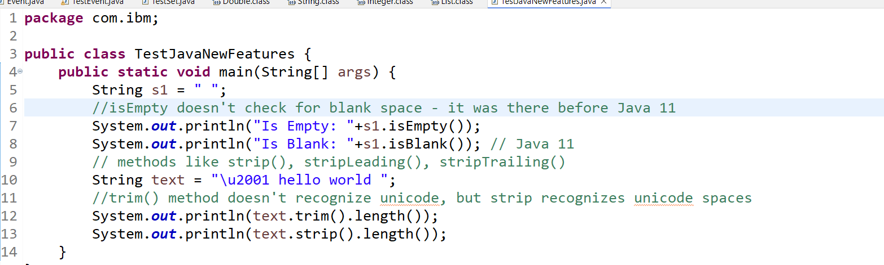

Java 17 features

Sealed & Non-Sealed classes to have more control over inheritance to specify who can inherit which class, sealed class tells who all are permitted to extend, the subclass of sealed class must be either non-sealed or final or sealed

non-sealed will provide an option for any class to extend, final class can’t be extended

class A { } // any class can extend  
sealed class A permits B, C { } // only B & C  
non-sealed class B { }   
final class C { }

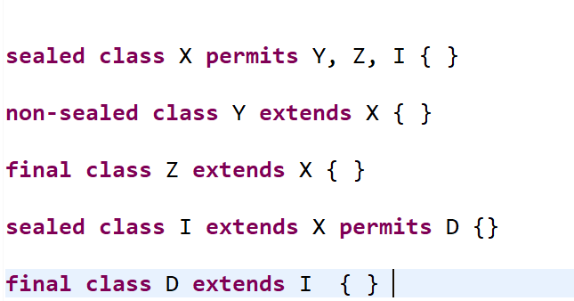

Internationalization

Adapting your application texts to display in various languages, there’s a class called Locale to implement Internationalization which provides various language for you   
ex:   
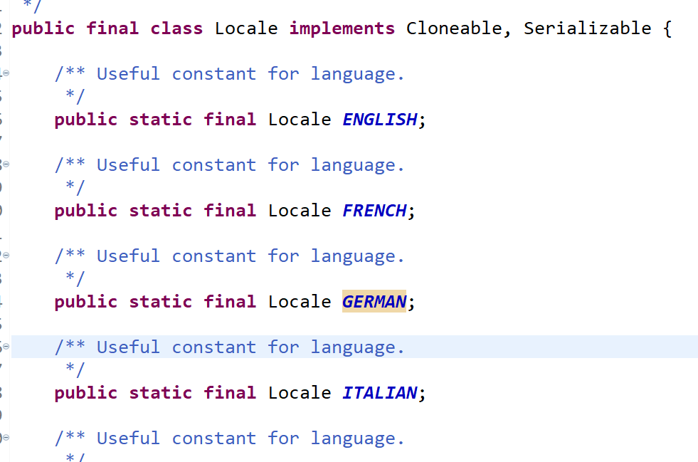

Reflection API: It is to analyze the classes to identify its members like methods, variables, constructors  
Suppose you want to see what all the methods present in String class, then you can use Reflection on String class.  
Class c = Class.forName(“java.lang.String”);  
c.getMethods(); // it gives all the methods of String class  
c.getConstructors(); // it gives all the constructors  
c.getFields(); // it gives all the fields

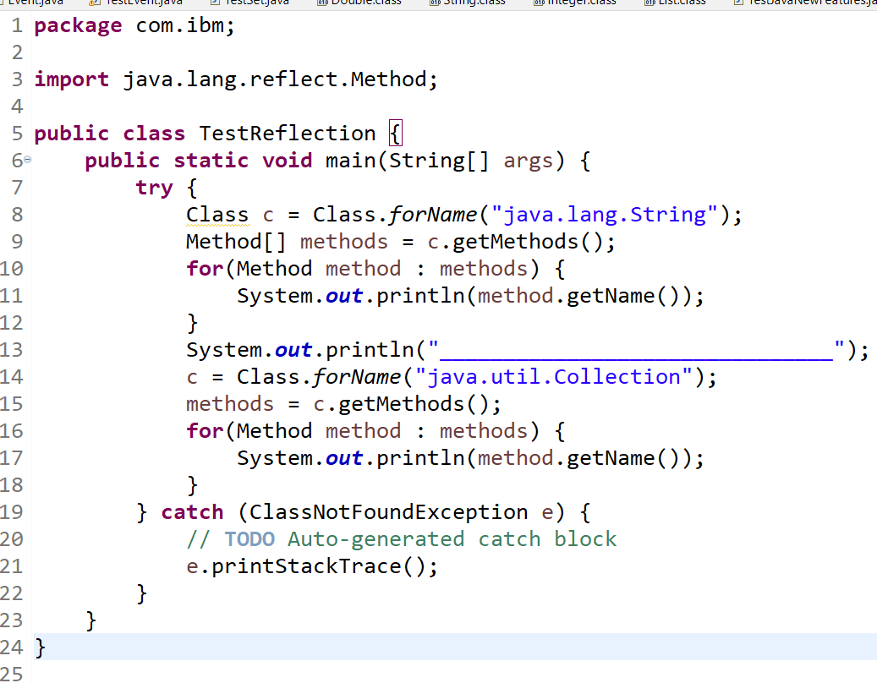

Serialization: To store the objects into the file, we can use few classes to serialize the object

1. ObjectOutputStream -> provides writeObject(Object) -> this can write the object to the file

ObjectOutputStream oos = new ObjectOutputStream(new FileOutputStream(“demo.txt”));

oos.writeObject( event );

class Event implements Serializable { }   
Serializable: It is an empty interface which is a marker interface that adds a type to the class, so at the time of serialization writeObject() checks if the object is of Serializable type, only then the object will be stored else an exception is thrown.

Deserialization: It is to read the serialized objecdt

1. ObjectInputStream ois = new ObjectInputStream(new FileInputStream(“demo.txt”))

Event event = (Event) ois.readObject();

Debugging in java

In real time developers need to debug the application to understand the flow of the program, because debugging gives line by line information when the program gets executed.

HTML & CSS

Folder structure

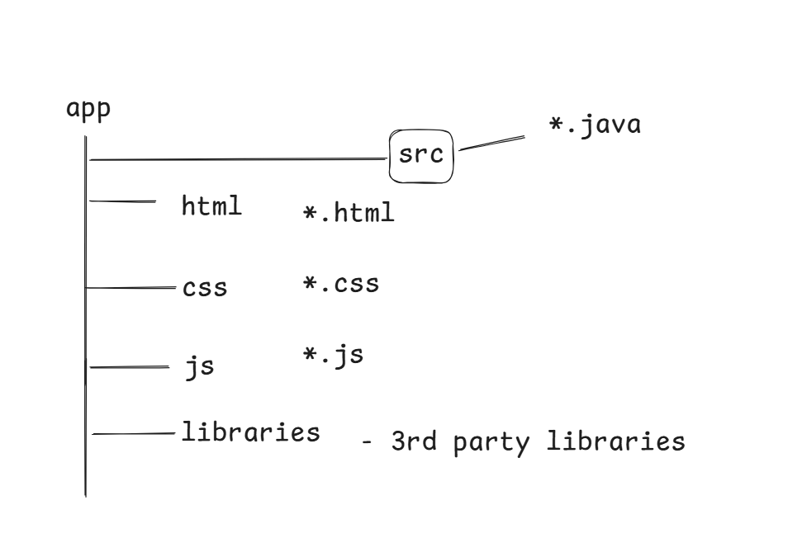

HTML: it used to create websites that can display the content with inbuilt HTML elements (tags)

CSS: it used to style the HTML elements

Javascript: it adds interactivity to your website by dynamically manipulating HTML & CSS

Naming conventions

Name all the web resources like html, css, javascript in smaller case, create index.html which is usually treated as welcome file in all the applications, most of the servers treat index.html as a welcome file.

CSS types

1. inline stylesheet: each element will have a style

ex: <p style = “color:red;font-family:arial’>some content</p>

1. internal stylesheet: for the entire document you will have a style, all the elements will get those styles except the inline, because inline overrides internal

ex: <style> p { color : blue; font-size:’calibri’ } h2 { color : red }

1. external stylesheet: you can create a separate css file and link to multiple HTML

ex: to link <link rel=”stylesheet” type=”text/css” href=”css/styles.css”>

Types of selectors

1. tag selector: for a tag you will apply style
2. class selector: a tag with class attribute, it is used when you want multiple tags with same class to get a style
3. id selector: an HTML element will use id to uniquely identify itself, you can use id selector to apply style with id

<p class = “danger”>some content</p>  
<h2 class = “danger”>some content</p>  
<button class=”primary”>Button</p>  
<button class=”secondary”>Button2</p>  
.danger { color: red;}   
.primary { color : blue; }  
.secondary { color: black }

<p id = “p1”>some content<p>  
#p1 { color : orange }

UML

Unified Modeling Language, it is a graphical representation of the software system, it is done by the top management people like SME’s / Business analysts, it will have following diagrams like

1. Class diagram
2. Object diagram
3. Use case diagram
4. Interaction Sequence diagram
5. Interaction Communication diagram
6. Activity diagrams
7. State diagrams
8. Component diagrams

Class diagram & Object diagram

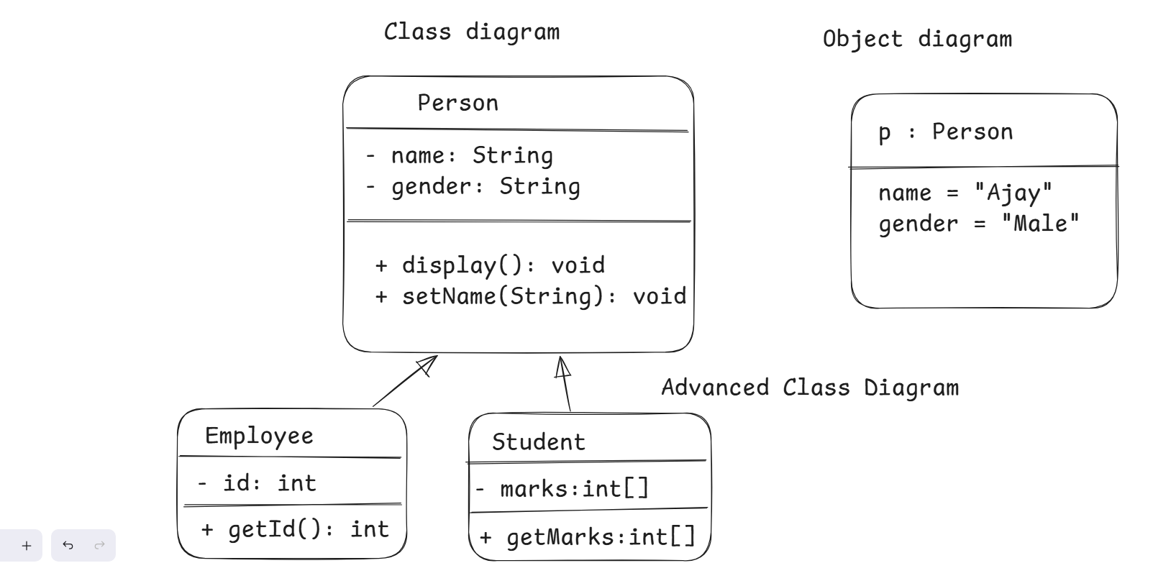

Use case diagram: It represents features of the application

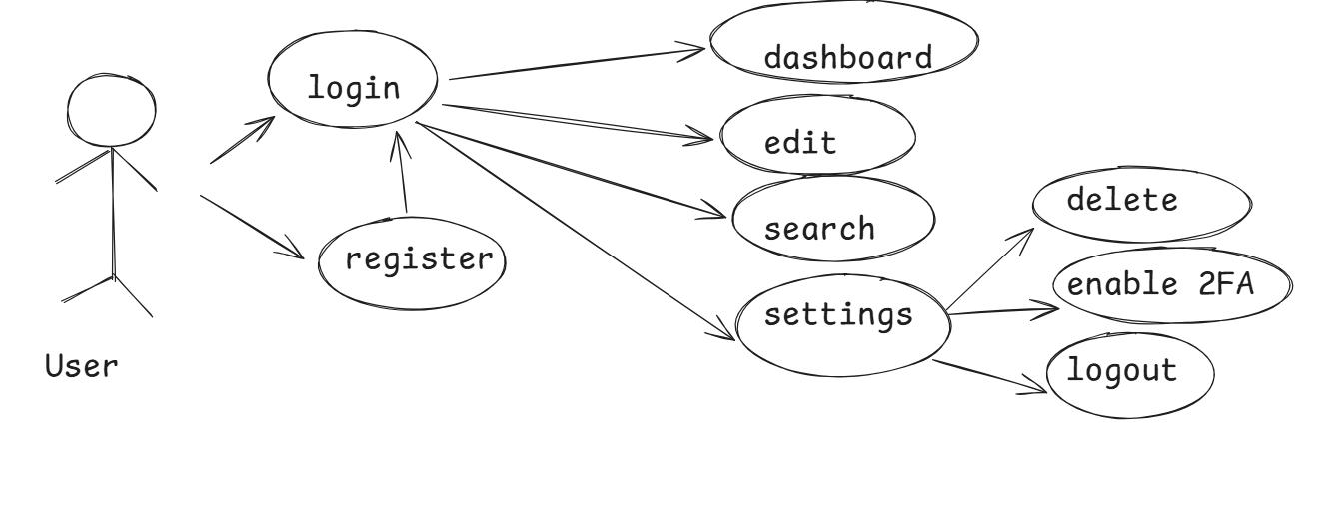

Interaction sequence diagram

interaction communication diagram

state diagram

activity diagram

component diagram: represents independent components and how they are connected to each other, i.e., an order object needs product, customer & account informations

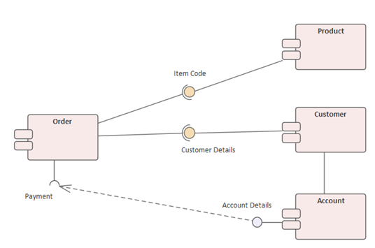

Javascript:

It is a programming language for HTML & CSS, it can manipulate HTML & CSS at runtime like adding | updating | deleting | reading HTML and CSS.

Javascript supports lot of programming constructs like

* variables
* functions
* operators
* loops
* conditional statements
* classes, objects, arrays

How to create variables in Javascript

var name = “Ajay”;  
var age = 25;  
var salary = 35000.0;  
var isMarried = false;

You can use let & const keywords to create variables instead of var keyword, because var is global variable, it is accessible outside the function also, however let & const are blocked scoped,

How to create functions in Javascript

function display() {   
 // logics in display method  
 }  
function add(x, y) {   
 let z = x + y;  
}

How to create arrays in Javascript

let items = [ “apple”, “orange”, “mango” ] ;

How to iterate an array in Javascript

for(let item of items) {   
 console.log(item); //prints in browser console  
 [or]  
 document.write(item); // prints in browser body  
}  
For of: it is to iterate arrays

// traditional for loop  
for(let i = 0; i < items.length; i++) {   
 console.log(items[i]);  
}

For in: it is to iterate the objects

How to create objects in Javascript

let emp = { id : 100, name : “Ravi”, age : 39 }  
console.log(emp.id); // 100  
console.log(emp[id]); // 100  
console.log(emp[name]); // Ravi

for(let key in emp) {   
 console.log(emp[key]);  
}

How can javascript access HTML element

let ele = document.getElementById(“p1”); // returns an element having the id = “p1”  
let ele2 = document.getElementsByTagName(“p”); // array of <p> elements will be returned

ele.innerHTML = ‘some content’; // adds an HTML content to the element

let counter = 0;  
for(let x of ele2) {   
 x.innerHTML = counter++;  
}

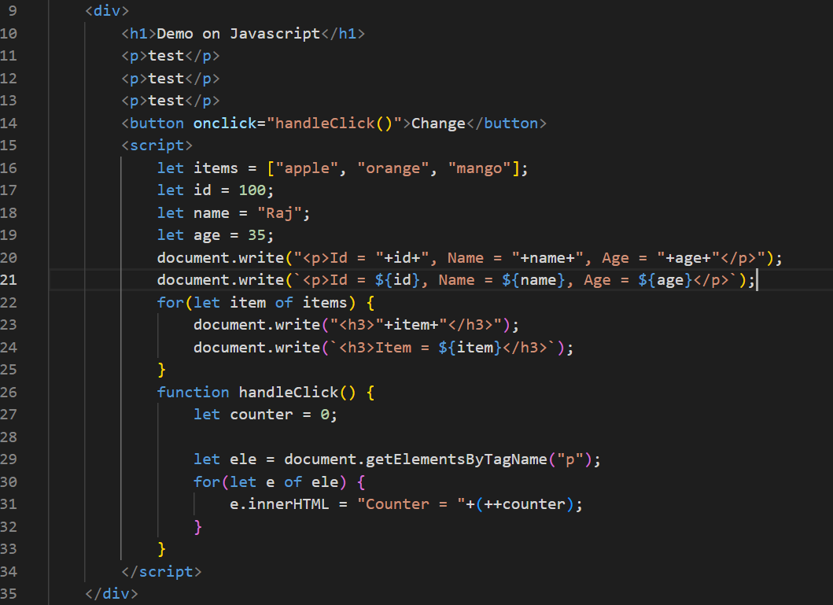

Output

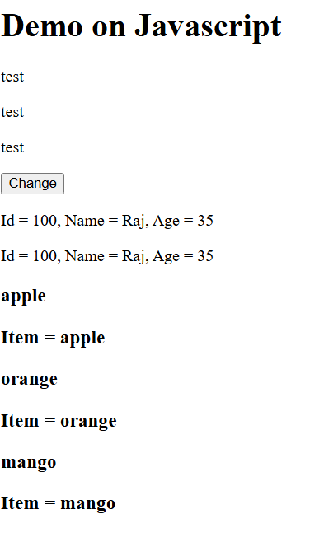

Node.js: It is a javascript runtime environment that can execute javascript in the backend without the need of browser, if you run javascript at the backend you could able to write programs that can access files, database, serve request to the clients

Node.js provides npm (Node Package Manager) which lets you install third party libraries that are written in javascript

Typescript: It is a super set of javascript, that adds types to the Javascript, so that the results of javascript will be predictable & the data will safe, developers can write the typescript and compile it using typescript compiler that generates the Javascript, then you can run the Javascript

npm install -g typescript: this command downloads the typescript compiler, here -g is a global installation, if you ignore -g then it installs in the current location where you are entering install

Basic Types in Typescript

string

boolean

number

any

Syntax:

let name : string; // you can only store string, if store other types you get error, in Javascript you don’t get error because it doesn’t recognize the types.

function greet(name : string) : void { // returns void   
}  
greet(20); // error

let userId : string | number; // userId can store string or number

userId = “user01”;  
userId = 12345;

Note: When you create a function without a class, then function keyword is mandatory, however when you create a function inside a class you must not use function keyword

class A {   
 test() { … } // it is understood it’s a function  
}

MongoDB: It is a NoSQL Database which doesn’t maintain the structure of the document, in MongoDB the data will be stored in JSON / Javascript object format which are called as documents

SQL vs NoSQL

In SQL it is mandatory that every record in a table to be of same structure i.e., if a table has 4 columns then each record will have values for those 4 columns

In NoSQL each record can have different structure, it is useful when the records are dynamic

MongoDB setup

It stores all the data in a folder called data/db which you can create in your root directory/drive like C drive in Windows

Note: you must have this folder in your C drive only then you can start the MongoDB

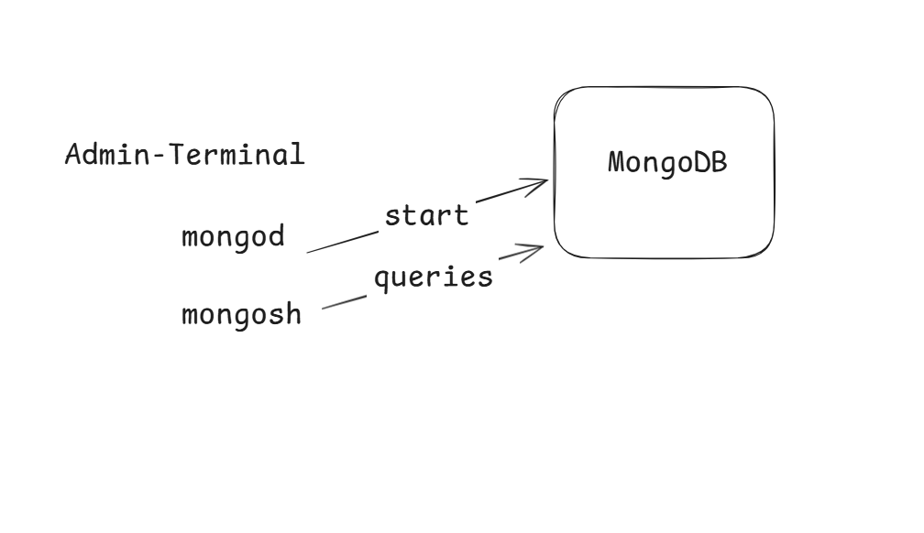

mongosh you don’t get in the mongodb installation, you need to download a separate zip file mongodb tools

SQL & MongoDB terminologies

|  |  |
| --- | --- |
| SQL Terminology | NoSQL Terminology |
| Database | Database |
| Table | Collection |
| Records | Documents |
| Columns or Attributes | Attributes or Keys in the document |
| Primary Key column can have any name | Primary key column must be _id |
| SQL queries | Inbuilt Javascript functions |
| Parent & Table are linked with foreign key | No concept of foreign key, but you can nest the child documents |
| Oracle, MySQL, Derby, DB2 they all use SQL which are RDBMS | MongoDB use NoSQL |

Note: MongoDB uses Javascript function hence it is case sensitive

How to create a collection

db.createCollection(“employee”); // employee collection will be created  
To perform CRUD operation you have inbuilt methods like insertOne, insertMany, deleteOne, deleteMany, updateOne, updateMany, findOne, find and so on, all these methods you need call from the collection name

How to store one or more documents in a collection  
db.employee.insertOne({_id: 123, name : “Atharva”, date: new ISODate(“2024-04-08”)});  
db.employee.insertMany([ {_id : 456, name : “Ravi”, date: new ISODate(“2000-06-16”) }, { ……. }, {….. } ]);  
How to read all the documents

db.employee.find(); // get all the documents  
How to read a single document: You use _id since it is unique  
db.employee.find({_id:123}); // returns a document that has _id = 123

db.employee.find({name : ”Raj”});// returns one more documents having name = Raj

How to update the document

db.employee.updateOne({_id:123}, {$set:{name:”Rajesh”}});

How to update one or more documents

db.employee.updateMany({name:”Raj”}, {$set:{name:”Rajesh”}});

How to delete the documents

db.employee.deleteOne({_id:1});  
db.employee.deleteMany({name:”Raj”}); // documents whose name is Raj will be deleted  
db.employee.deleteMany({}); // all the documents will be deleted

Try from the official document these operators

$or, $and, $eq, $ge, $le, $like, $match, $group, $sort, $sum

SQL: Structure Query Language, it is the language RDBMS use, there are 5 types of SQL commands

1. DML – insert, update & delete
2. DDL – create, alter, truncate, drop
3. DRL – select
4. TCL – commit, rollback, savepoint
5. DCL – grant & revoke

Datatypes:

1. int
2. varchar
3. date
4. bigint
5. double
6. boolean
7. datetime
8. float

Constraints: These are rules you can apply on a table or a column

1. primary key: uniquely identifies the record, doesn’t support null
2. unique: supports unique but also supports null
3. not null: no null is allowed
4. check: to have conditions on the value like age <= 60 & age >= 18, gender must be either male or female
5. foreign key: linking child table with the parent table, customer table linking with account table, then student table linking with marks table, employee with department table
6. default: its value is considered when no value is provided

ex: profile table status ‘isActive’ by default

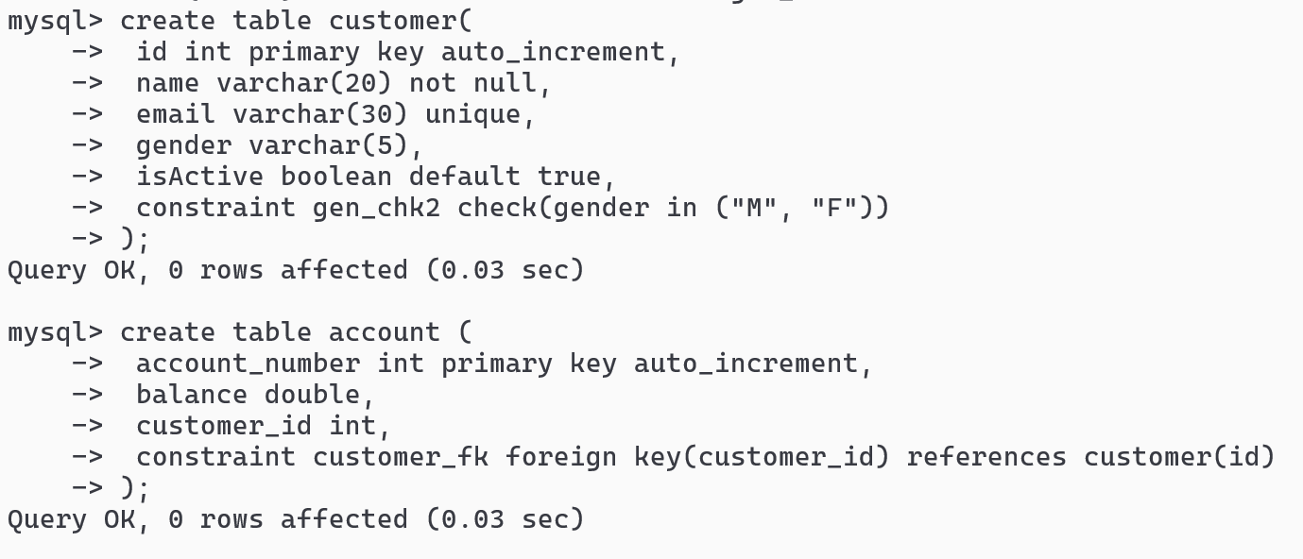

Types of JOIN

1. Inner JOIN: only matching records
2. Left JOIN: all the records from the left table & right table will have only matching records
3. Right JOIN: all the records of right table & left table will have only matching records
4. Full JOIN: all the records of right & left table is displayed even if they don’t match

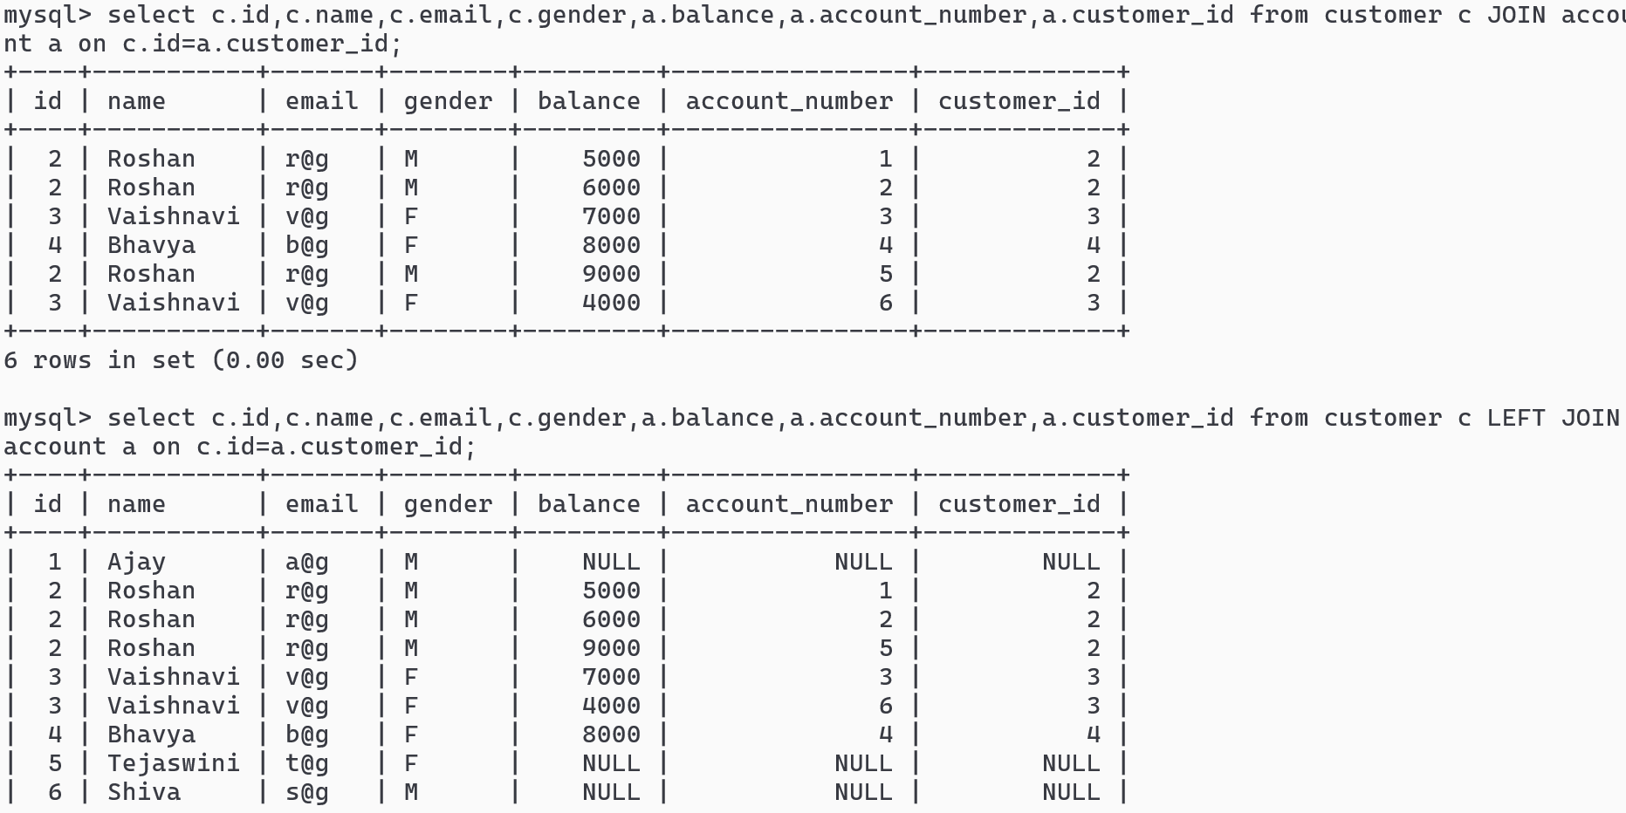

Inbuilt SQL functions

1. Single row function – each record will have separate result – upper, lower, to_char, concat, trunc, round and so on.
2. Aggregate function – single result for multiple records – avg, sum, min, count, max,

JDBC: It is an API that stands for Java Database Connectivity to allow java programs to interact with RDBMS like MySQL, DB2, Oracle and etc.

JDBC uses JDBC drivers which are java programs to connect to the specific database, these drivers are provided by database vendors

Steps to follow to interact with database, there are totally 5 steps

1. Loading the driver: Class.forName(“com.mysql.cj.jdbc.Driver”); // MySQL Driver

Loading the driver is optional from Java 8 onwards, because from Java 8 it automatically loads the driver based on the URL

1. Establishing the connection: Connection con = DriverManager.getConnection(url, username, password);

url = jdbc:mysql://localhost:3306/ibm_db

username = root

password = root

1. Creating the Statement: Statement stmt = con.createStatement();
2. Execute Statements

int c = stmt.executeUpdate(“insert into employee values….”);

// update & delete queries can also be passed, the int represents the number of rows affected

ResultSet result = stmt.executeQuery(“select * from employee”);

// result stores the select result, you need to navigate over the result using the getters methods

while(result.next()) {   
 int id = result.getInt(“id”); String name = result.getString(“name”);   
 LocalDate dob = result.getDate(“dob”).toLocalDate();

Employee emp = new Employee(id, name, dob);  
//use some collection and store the emp  
 list.add(emp); // List<Employee> list = new ArrayList<>(); created before while()  
}

1. Closing the resources (optional if you use try with resource)

rs.close(); stmt.close(); con.close();

Statement comes with 3 types

1. Statement: Better when queries are changing
2. PreparedStatement extends Statement: Better for dynamic queries
3. CallableStatement extends PreparedStatement: Used to invoked stored procedures which are programs stored in the database, these are called as PL/SQL

Statement vs PreparedStatement

Statement object queries are always parsed, compiled and executed in the database on each execution  
Statement stmt = con.createStatement();  
int c = stmt.executeUpdate(“insert into employee(name, dob) values(“+input1+”,”+input2+”)”);

ResultSet rs = stmt.executeQuery(“select * from employee where id = “+input3);

PeparedStatement object queries are pre-compiled, they are parsed & compiled only once & stored in the database cache memory and on each execution only the values are replaced and directly executed

PreparedStatement pstmt = con.prepareStatement(“insert into employee(name, dob) values(?, ?));  
pstmt.setString(1, input1); pstmt.setDate(2, input2);  
int c = pstmt.executeUpdate();  
PreparedStatement pstmt = con.prepareStatement(“select * from employee where id = ?”);  
pstmt.setInt(1, input3);  
ResultSet result = pstmt.executeQuery();

try with modern syntax eliminates 5th step

try (  
 Connection con = DriverManager.getConnection(url, username, password);  
 PreparedStatement pstmt = con.prepareStatement(query);  
) {   
 // set values to the ?  
 try (ResultSet rs = pstmt.executeQuery) { ……………….. }   
 or   
 int c = pstmt.executeUpdate();  
}

To store you can create a int saveEmployee(Employee employee) { }

main method will pass employee object to the saveEmployee() and saveEmployee() must insert name & dob

DBUtil.java takes care of having a reusable connection

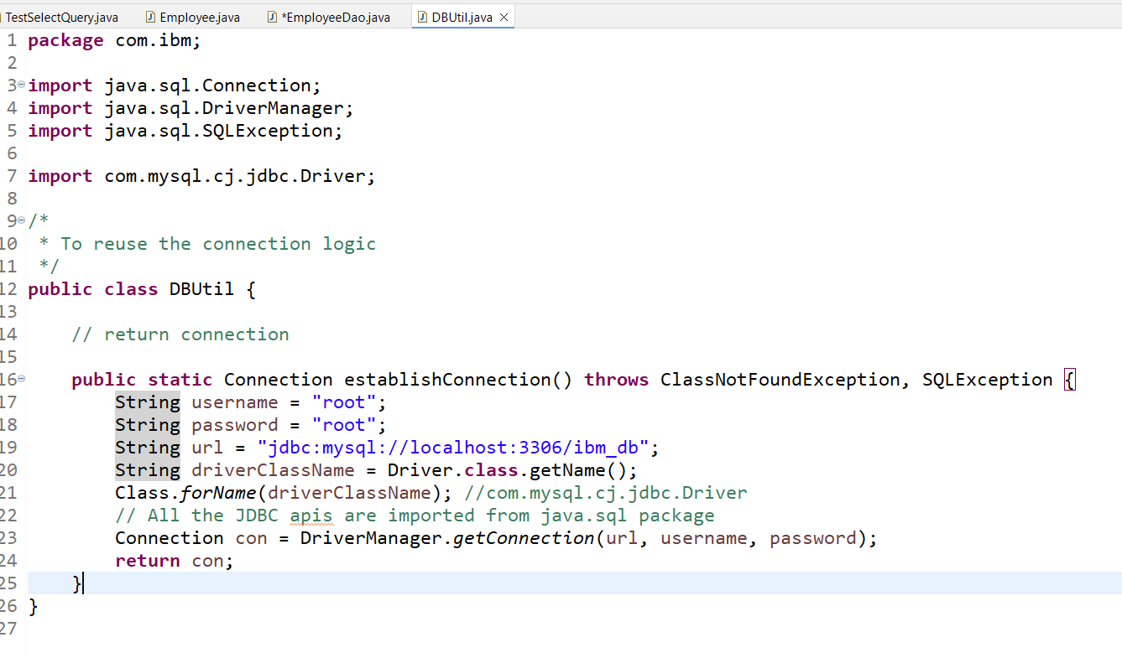

Storing the data with getting the auto-generated value

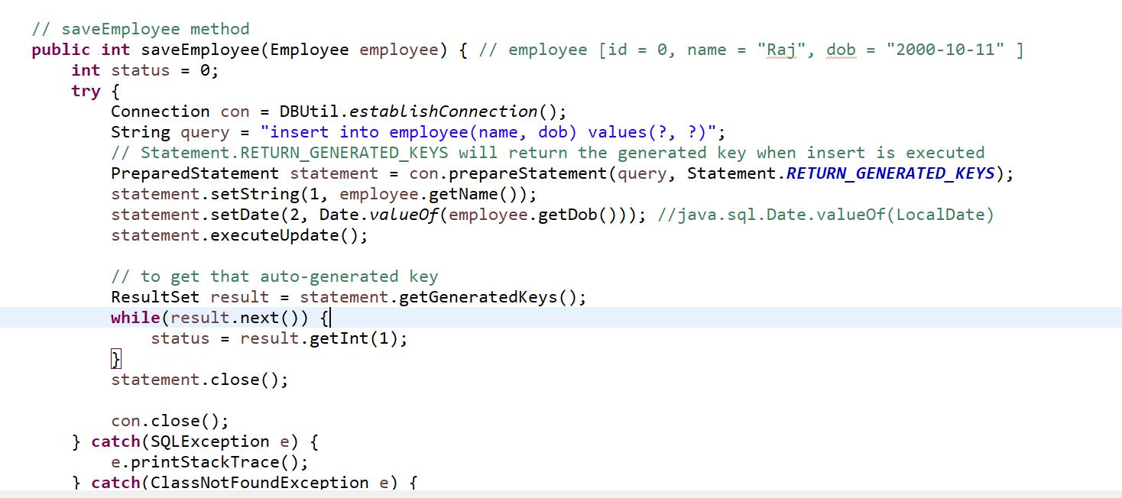

main method

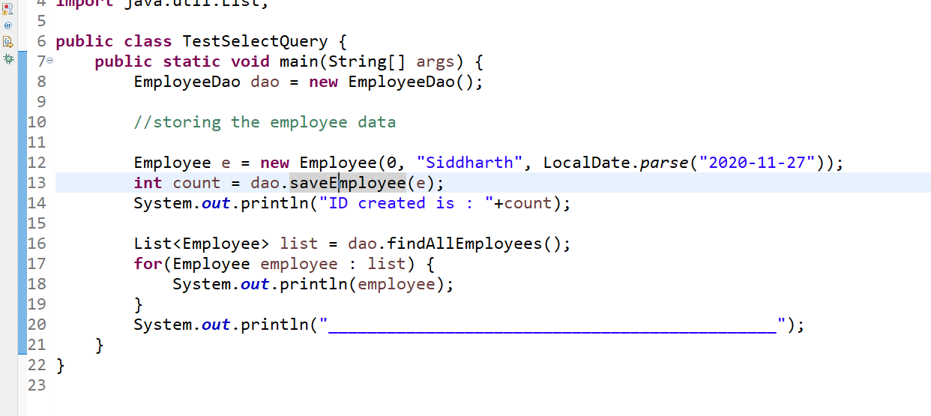

Output:

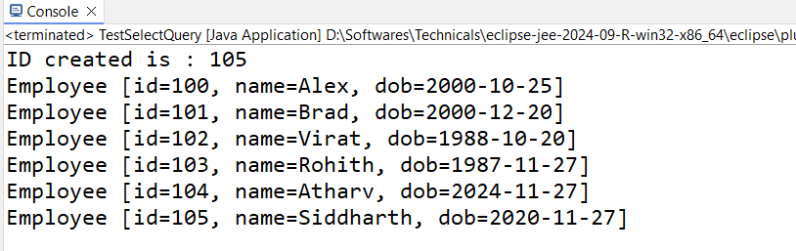

Servlets & JSP

Servlets & JSP are used to develop web applications using Java, both are used to create dynamic web applications, but Servlet came first to address the limitation in the servlet JSP was released.

Servlets are java programs that are executed at the server side to create dynamic web page, it handles client request & generate the response in HTML format.

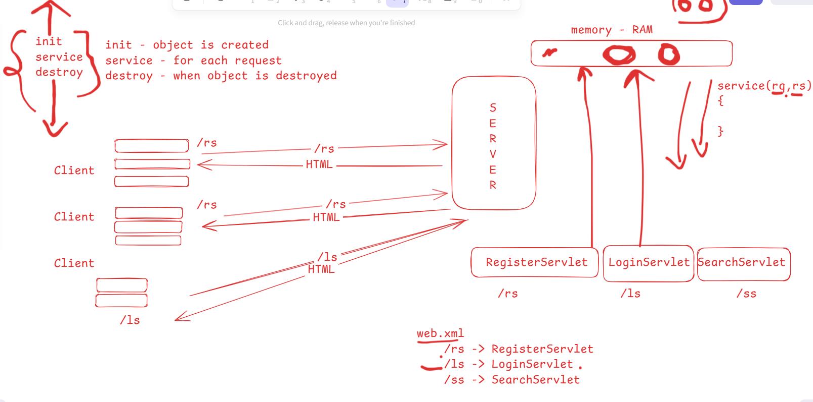

web.xml is called as deployment descriptor it will have URL mapping, welcome file lists

From Servlet 3.0 on wards URL mapping can be done with annotations

There are 3 life cycle methods in Servlet

1. init - initialization logic
2. service - handling the protocol(FTP, SMTP, HTTP), handling the requests & generating the response
3. destroy - clean up operations

Java came up with HttpServlet which handles HTTP protocol in the service() method of the Servlet, so you can create the servlet by extending HttpServlet so that every request using HTTP protocol will be handled automatically, hence you must extend HttpServlet & override doGet(), doPost() methods provided by HttpServlet, which are called by the HttpServlet.service() method based on the type of request

If client sends GET request via URL(data inside URL) -> then doGet will be called  
If client sends POST(data inside request body) request -> then doPost will be called

Servlet Hierarchy

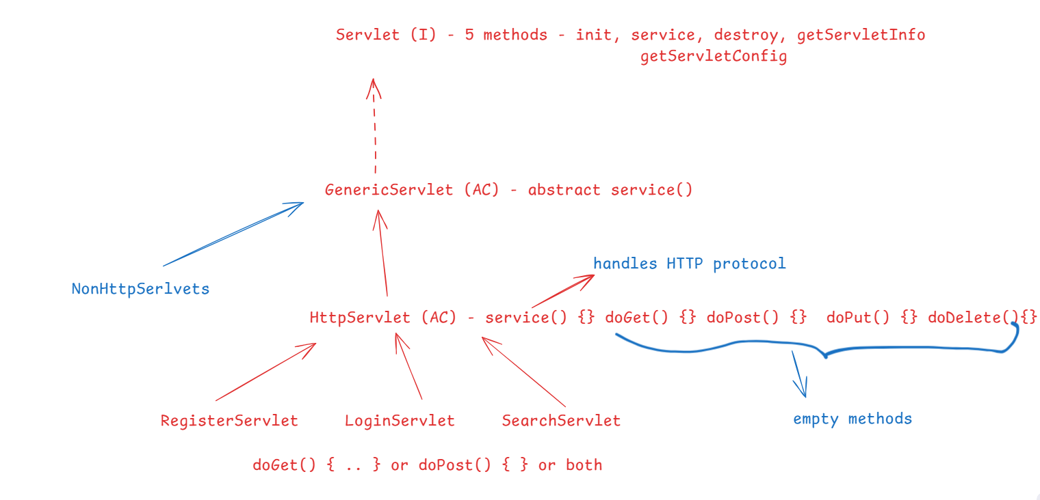

Limitations of Servlet

Servlet embeds HTML code within the Java code & its complex to design the UI, but its dynamic, however to design the dynamic UI java introduced JSP which you can use to create dynamic web pages because its syntax is like HTML, but you can’t ignore servlet because it can have java code & do more job than the JSP

In MVC architecture   
Servlets take Controller part  
JSP take View part  
DAO takes Model part

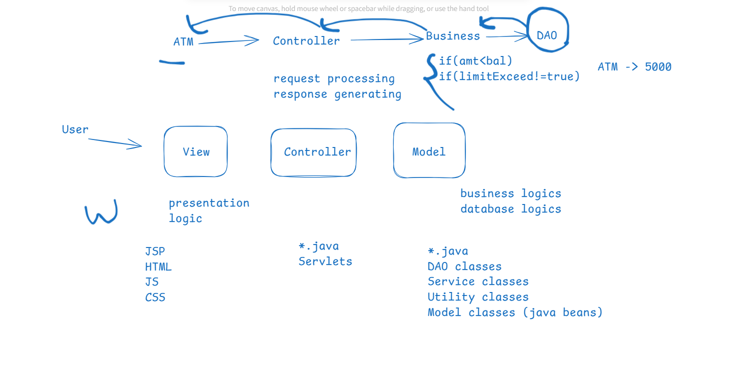

JSP (Java Server Pages)

It has 5 building blocks

1. Directive elements
2. Scripting elements
3. Expression elements
4. Inbuilt objects
5. Action elements

Directive elements: They start with <%@ and end with %>, there are 3 directive elements

1. <%@page
2. <%@include
3. <%@taglib

Directive elements give instructions to the server like importing a java package, including a file, including some external tag library

<%@page import=”java.time.LocalDate” %>  
<%@include file = “abc.txt” %>  
<%@taglib uri = “externalURL” prefix=”aliasName” %>

Scripting elements

1. scriptlet <% %>: The code you write inside scriptlet is executed for each request
2. declarative <%! %>: Here you can declare variables, its like declaring variables inside the class

Expression <%= %>: it is used to print the java variables or expressions

Inbuilt objects: These are inbuilt variables which you can use in JSP page

1. request
2. out
3. session
4. response

ex:  
<%  
 String name = request.getParameter(“username”);  
 out.println(“<h2>Hello “+name+”</h2>”);  
%>

Inter servlet communication

This is like how two servlets can communicate, where one servlet sends request to another servlet and uses the response of the second servlet

Note: a servlet can send request to JSP also

RequestDispatcher is used to dispatch the request from a servlet to another servlet/jsp/html

RequestDispatcher is an interface with 2 methods

1. forward(request, response)
2. include(request, response)

How to create request dispatcher

RequestDispatcher rd1 = request.getRequestDispatcher(“default.jsp”); [or]  
RequestDispatcher rd2 = request.getRequestDispatcher(“/SomeServlet”); [or] .html

rd1.forward(request, response) or rd1.include(request, response)

forward: shows the destination resource page and ignores the source page  
include: shows both source & destination content

Is it possible to load the servlets or pre-initialize before the first request

Yes, you must use load on start up property in the servlet

Annotation based  
@WebServlet(loadOnStartup=1, urlPattern=”/SomeServlet”)  
XML based  
<load-on-startup>1</load-on-startup>

ServletConfig vs ServletContext

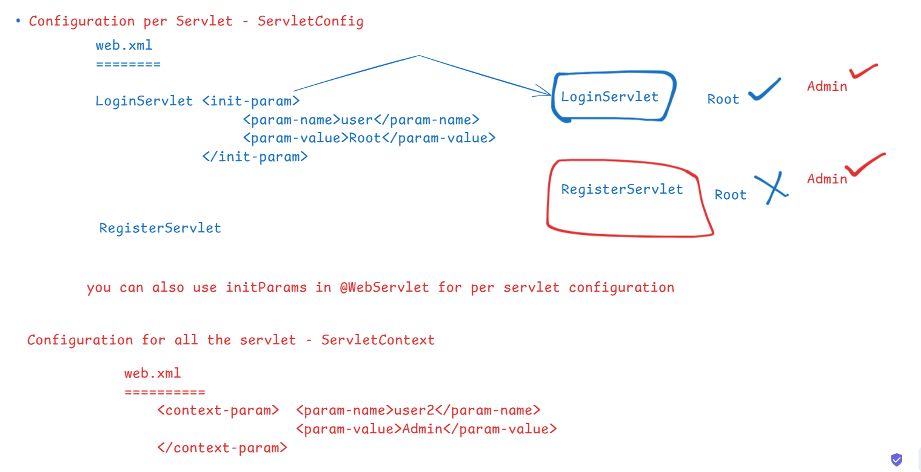

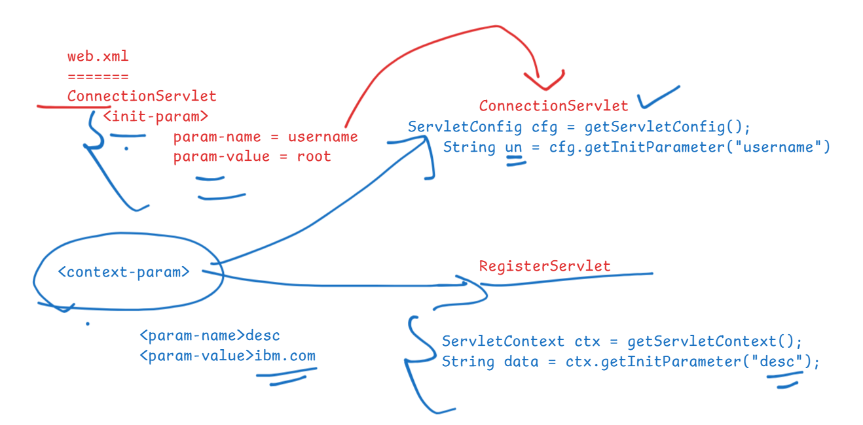

ServletConfig vs ServletContext

ServletConfig: It is the configuration for single servlet  
<init-param> or @WebServlet(initParams = {key : value…. }

ServletConfig cfg = getServletConfig();  
String params = cfg.getInitParameter(“key”);

ServletContext: It is the configuration for all the servlets or entire application

<content-param> is the tag for servlet context  
ServletContext ctx = getServletContext();  
String params = ctx.getInitParameter(“key”);

JSP architecture

a.jsp ---> a_jsp.java [a servlet] ---> a_jsp.class ---> HTML

HttpJspBase is the super class of your converted JSP class

Session Management

Http is a stateless protocol, it doesn’t remember the state, every request is treated as the new request.

To manage the session you have 4 mechanism

1. Hidden form fields: This sends previous data in a hidden form so that current request carries the previous data
2. URL-rewriting: This sends the previous data in the URL & embeds in the current request
3. Cookies: This sends the previous data to the client and when client sends the next request the cookies are added and sent so that the next request can read previous request data
4. HttpSession: This creates an object per browser at the server side & stores in the server, each request coming from the same server can identify the previous request data

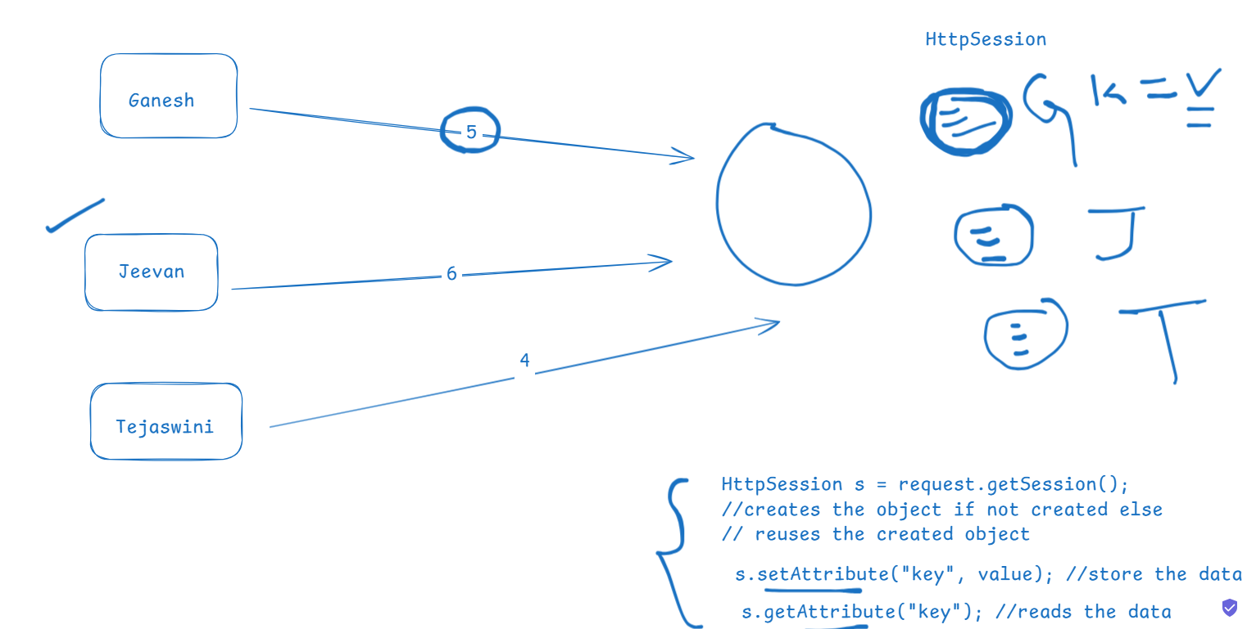

HttpSession important methods

1. boolean isNew(): returns true if session is new else false
2. void setAttribute(key, value):
3. Object getAttribute(key)
4. void removeAttribute(key)
5. invalidate(): to terminate the session

Filters in Servlet

These are intermediate programs which are executed before the request reaches to the servlet & response reaches to the client

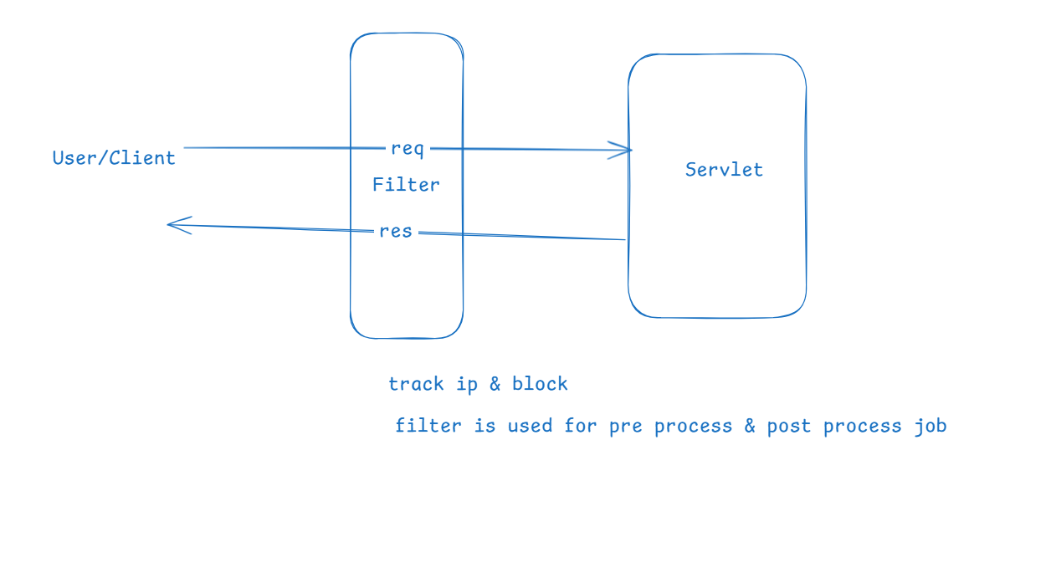

How to create Filter

class MyFilter implements Filter {   
 init() { … } //executed when the filter object is created  
 // doFilter is executed when request & response comes  
 doFilter(req, res, filterChain) {

/* code that executes before request goes to servlet */  
 filterChain.doFilter(req, res); // this code sends request to the servlet  
 /* code that is executed when the response comes from the servlet*/  
 }  
 destroy() { .. } // when the filter is destroyed  
}

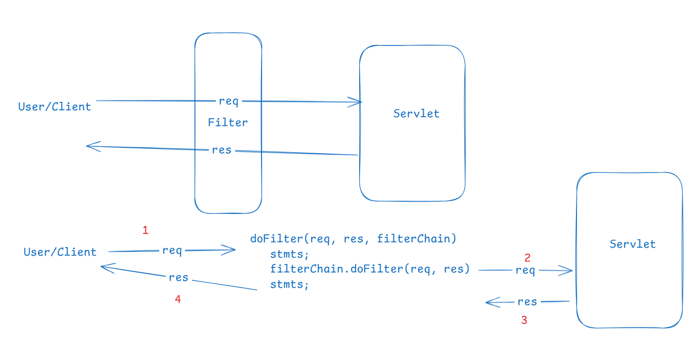

How many methods are there in Filter interface

1. init(FilterConfig)
2. doFilter(ServletRequest, ServletResponse, FilterChain)
3. destroy()

Listeners: These are the programs which are automatically executed when some event happens in the application

1. ServletRequestListener: calls the methods when the request is created / destroyed
2. HttpSessionListener: calls the methods when the session is created / destroyed
3. ServletContextListener: calls the methods when the ServletContext is created / destroyed

Note: These Listeners are interface which you must implement they have methods that executed when certain object is created or destroyed

|  |  |  |
| --- | --- | --- |
| ServletRequestListener | HttpSessionListener | ServletContextListener |
| requestInitialized() | sessionCreated() | contextInitialized() |
| requestDestroyed() | sessionDestroyed() | contextDestroyed() |

Custom tags in JSP

When you want to create your own tags and use in the JSP file, you create custom tags when you want some tags to perform some job then you provide custom tags.

Steps to create custom tags

1. implement Tag interface or extend TagHandler & override methods like doStartTag(), doEndTag() which are executed when the custom tag starts & ends
2. create tld file (tag library descriptor) where you will mention the tag name you want to use in the JSP file & also the implementation of the Tag interface
3. Once you perform above steps server will know what is the tag name and call startTag() and endTag() methods when you start & close the custom tag
4. Use <%@taglib uri = “WEB-INF/abc.tld” prefix=”a” %> to locate the tld file & use the tag with the help of prefix

JSTL

JSTL: Java Standard Tag Library, these are inbuilt tag libraries provided by Java that you can use in JSP files, they perform common operations in the UI like conditions, loops

JSTL Core: It is a tag library that does fundamental operations like variable declarations, conditions & loops

JSTL SQL: It is a tag library that can perform SQL operations using tags

Note: These tag libraries are present in jstl.jar file which you must add in your project and JSP can use <%@taglib > if you want to use the tags provided by JSTL

GreetServlet

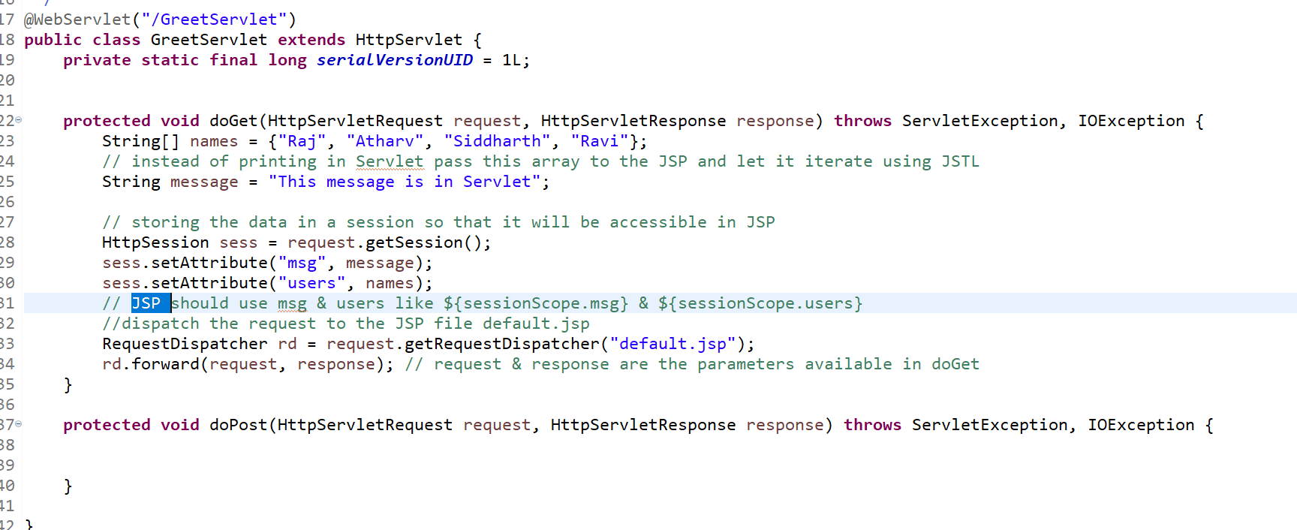

Note: Session object is available to Servlet & JSP, in Servlet its HttpSession & in JSP it is ${sessionScope}

List of tags JSTL core provides

forEach: Iterating arrays & collections  
if: For if condition, you don’t have else, you need use if with ! to make the condition false

choose: It is like switch case

set: It is to declare a variable with a value

Web Security

Authentication & Authorization: It provides a feature where only authenticated and authorized users could able to access the resource

Authentication: Verifying the identity like username & password is correct or not  
Authorization: It deals with the permissions to access certain resources like RBAC(Role Based Access Control)

Connection Pool:

It deals with JDBC connections that can be reused, usually frameworks like Hibernate, Spring uses connection pool mechanism

Advanced JDBC

1. CallableStatement - to invoke the stored procedure
2. DatabaseMetaData - to get the database informations

DatabaseMetaData dbmd = con.getMetaData();  
dbmd.getUsername(), dbmd.getUrl()

1. ResultSetMetaData - to get the result set informations, when you don’t have idea about the columns or datatype of the column

ResultSetMetaData rsmd = result.getMetaData();  
rsmd.getColumnType(1); // type of the 1st column  
rsmd.getColumnName(1); // column name of the 1st column

result.getInt(“ID”); result.getString(“NAME”); is possible once you know the type or name of the column.

Coupon & Product project

When user selects some products it displays the total price, you can have some list of coupon codes below the products, when you select any coupon code some discount must be added

Junit

It is mainly to perform unit testing

Unit testing: testing a single method and analyzing the result is as per the expectation

Junit: It is a java framework for unit testing, you must add Jupiter library to perform unit testing in Java

Junit provides you annotations to run the tests which are

@Test, @BeforeEach, @BeforeAll, @AfterEach, @AfterAll, @ParameterizedTest, @ValueSource and many more, all these annotations you write in your test cases

Test Case: It is a class that will have multiple tests which you can run

Test Suites: It is a group of test cases which you can run together

Dependencies

1. Jupiter
2. Jupiter parameters

Testing exceptions: If You want to test exceptions, then your test case must use the throws clause

@ParameterizedTest: When you want to test with multiple parameters you can use this

@ValueSource: it provides multiple values

JSP scopes: There are four scopes in JSP

1. page: this is the default scope of the data you create in JSP
2. request: the data will be available within the request
3. session: the data will be available to multiple requests, it is like HttpSession
4. application: the data will be available to multiple sessions, it is like ServletContext

JSP Action tags: These allow to perform some actions like accessing a java bean or sending requests to the JSP / HTML

<jsp: useBean id = “x” class = “com.ibm.Employee”/>  
<jsp:setProperty name=”x” property = “id” value = “100”/>  
<jsp:getProperty name = “x” property=”id”/>  
<jsp:forward page = “success.jsp”/>  
<jsp:include page = “error.jsp”/>

<jsp: useBean> creates a java object   
<jsp:setProperty> & <jsp:getProperty> this to set & get the property

<jsp:forward> & <jsp:include> is like RequestDispatcher forward & include

<jsp:include> vs <%@include>

|  |  |
| --- | --- |
| Action include jsp:include | Directive include <%@include |
| It has page attribute | It has file attribute |
| This can include only HTML/JSP, it includes the destination page response content, not the file content | It can include any file, it copies the content of the file |

Modern Javascript features or ES6+ features

These are the features that simplifies Javascript syntax, below are the features introduced in modern Javascript

1. let, const, class, constructor, extends keyword
2. Template strings `Name = ${name}`
3. Arrow functions to simplify writing anonymous functions
4. Destructuring: to simplify accessing object property & array elements
5. Spread & Rest operator: to work with passing multiple parameters in a simplified way
6. Promises: to perform asynchronous operations
7. Async/Await
8. Optional chain

Arrow functions: It can be used as a replacement to the anonymous functions

items = [2, 3, 4, 5, 6];  
// this avoids errors because it auto-iterates until the last element

items.forEach(function(element, index) {  
 console.log(element, index); //2, 0 >> 3, 1 >> 4, 2 >> 5, 3 >> 6, 4  
});

items.forEach((element, index) => console.log(element, index)); // gives the same result

items10 = items.map(function(element, index) { return 10* element; }); // it iterates the element and returns a new array after the iteration

items10 = items.map((element, index) => 10 * element); // arrow function automatically returns the element and don’t need explicitly return keyword, unless you use { } i.e,, return is required if you use { }

Result of items10 is 20, 30, 40, 50, 60

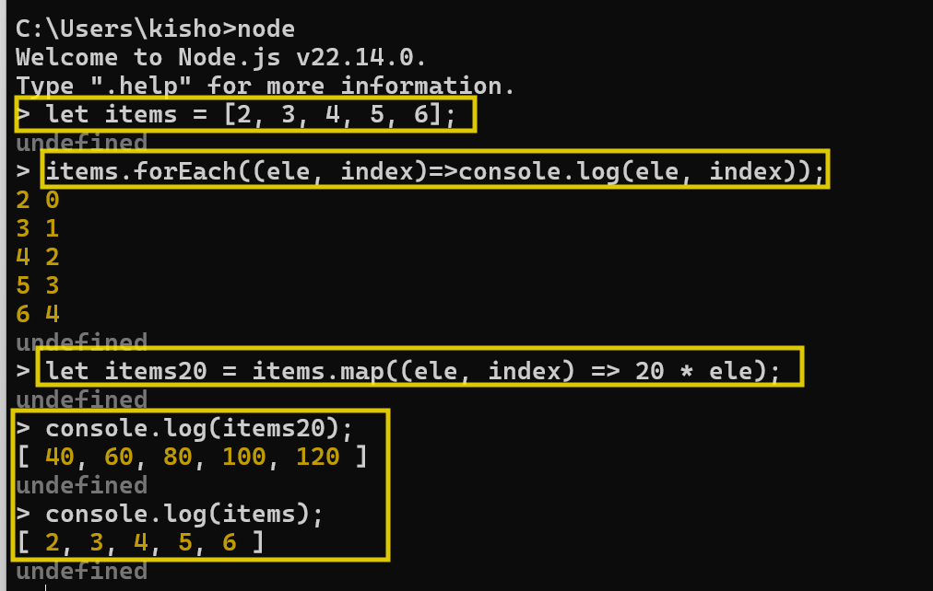

React.js: It is a Facebook product to develop single page applications using independent components

Components are the UI’s which you see in the web page, these can be created independently and you can add them in your page wherever you want and also you can reuse these components in other components

ex: Profile photo is a component, it is reused in posts, comments, likes

ex: ratings component is reused in product informations which appears when you see multiple products and also when you separately click on the product

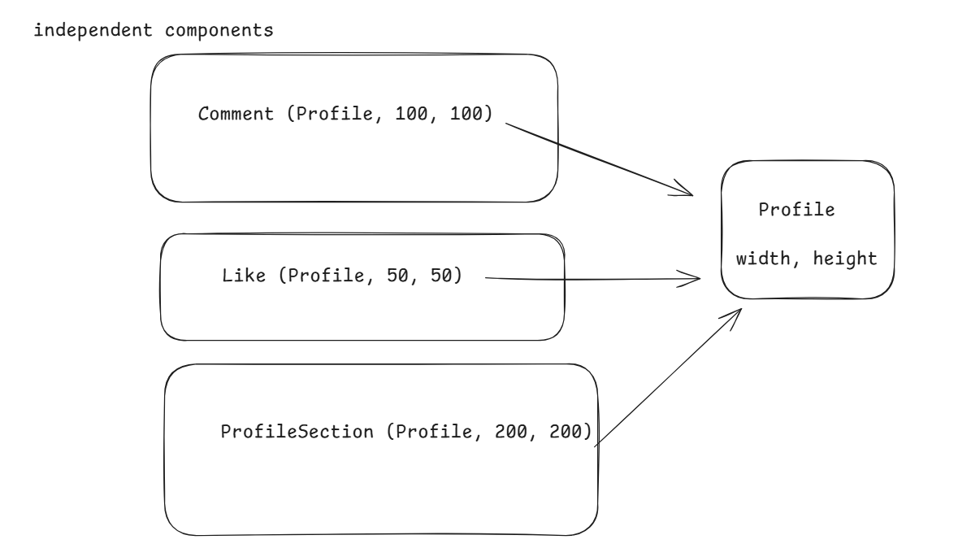

Single page applications are those applications where everything happens in one page, any changes that should happen will not reload the entire page, only part of the page will refreshed, & it has to get those updates only for the part that needs the change, hence it is faster

React.js uses VDOM (Virtual DOM) to increase the speed of rendering

DOM: Document Object Model, which is a tree structure of HTML elements in your browser

VDOM: is a virtual tree structure the react maintains and maps to the DOM

Software’s required to create & run React applications

1. VS Code editor
2. Node & NPM

How to create react project

npm install -g create-react-app # this will install a react toolkit provided by facebook that helps to create react application, then you need to create project

create-react-app demo # a demo project with fully configured to launch react app will be downloaded

There’s another way to directly create the project without installing

npx create-react-app demo # this directly downloads the project without installing the toolkit

Note: React team is soon deprecating the react tool (CRA) kit, because it has slower launching time compare to other tools available in the market

Vite: It is one of the library that helps to quickly create & launch react application which is much faster than the CRA toolkit

npm create vite@latest myapp --react# this will create a react project

Note: It is two hyphens in the template (--template)

Note: vite is a separate team, it allows you to create different types of Javascript project like React, Angular, Vue.js

Note: React team is also using vite instead of React Tool Kit

React.js is a front end technology it uses 2 languages to develop the application

1. HTML
2. JSX (Javascript XML): It is a super set to the javascript, it simplifies writing HTML code inside the javascript

JS HTML code

let element = `<p>Hello ${name}, your age is ${age}</p>`;

JSX HTML code

let element = <p>Hello {name}, your age is {age}</p>

Creating the project

Project structure

index.html: This is the only html file loaded, it has <div id = “root”>

main.jsx: This has the code to access the div#root and add the root component content

App.jsx: This has a function App() which is a root component function

App.css: This will have styles for your root component

index.css: This will have global stylesheet

package.json: This will have all the dependency entries for React and the commands to manage the react application

node_modules: all the dependencies downloaded will be stored here

Two important libraries of React are

ReactDOM: It is a virtual DOM

React: It provides features that helps to create components

How to create components

You need to use function component_name, the name of the component must begin with the uppercase, using lowercase will cause error

ex: function Greet( ) { }, you can use <Greet /> to render the component content

Greet.jsx

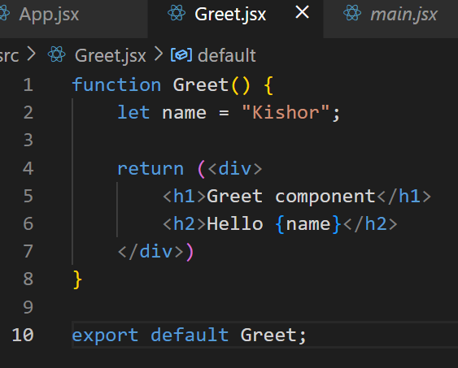

App.jsx

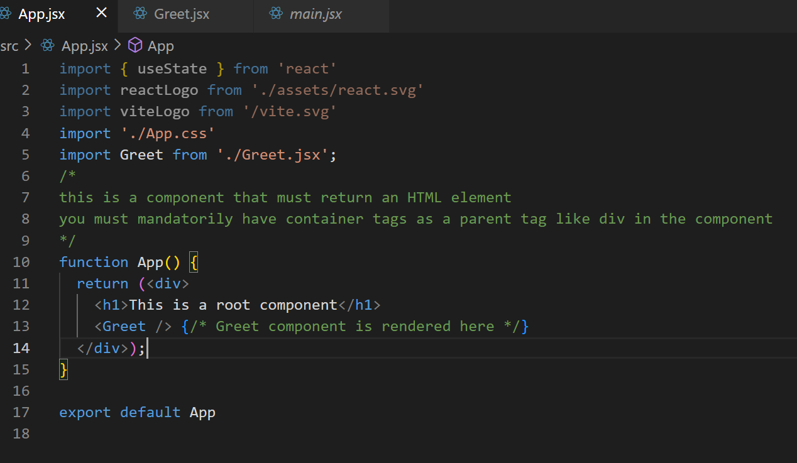

Output:

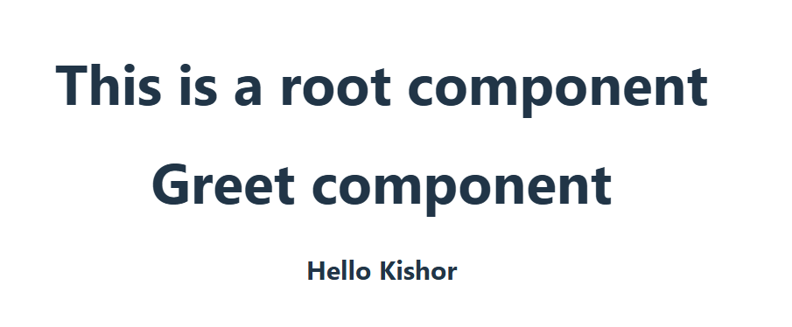

props: It is to pass the data from one component to another component, it is read-only you can’t modify, there’s one more way to pass the data in React which is state that is both read & write

export function Hello(props) {  
 let name = props.name;  
 let age = props.age;  
 return <div>Name: {name}, age: {age}</div>  
 }

<Hello name=”Raj” age = “18” /> Hello(props = {name:Raj, age:18})

There are 2 types of exports & imports

1. default exports & imports: While importing you can give any name, it is by default imported
2. named exports & imports: You need to import with the same name

Default  
function Employee() { }

export default Employee; // Test.jsx

To import

import Employee from ‘./Test.jsx’;   
import Emp from ‘./Test.jsx’; Employee will be imported with an alias name Emp  
<Emp />

Named

export function Employee() { } // Test.jsx  
To import  
import {Employee} from ‘./Test.jsx’;

How to import multiple modules which are named & default

import DefaultModule, {NamedModuel1, NamedModule2…..} from ‘./File.jsx’

Installing bootstrap in the project

project-folder>> npm i bootstrap --save

downloads bootstrap in node_modules/bootstrap/*.css, *.js, *.map

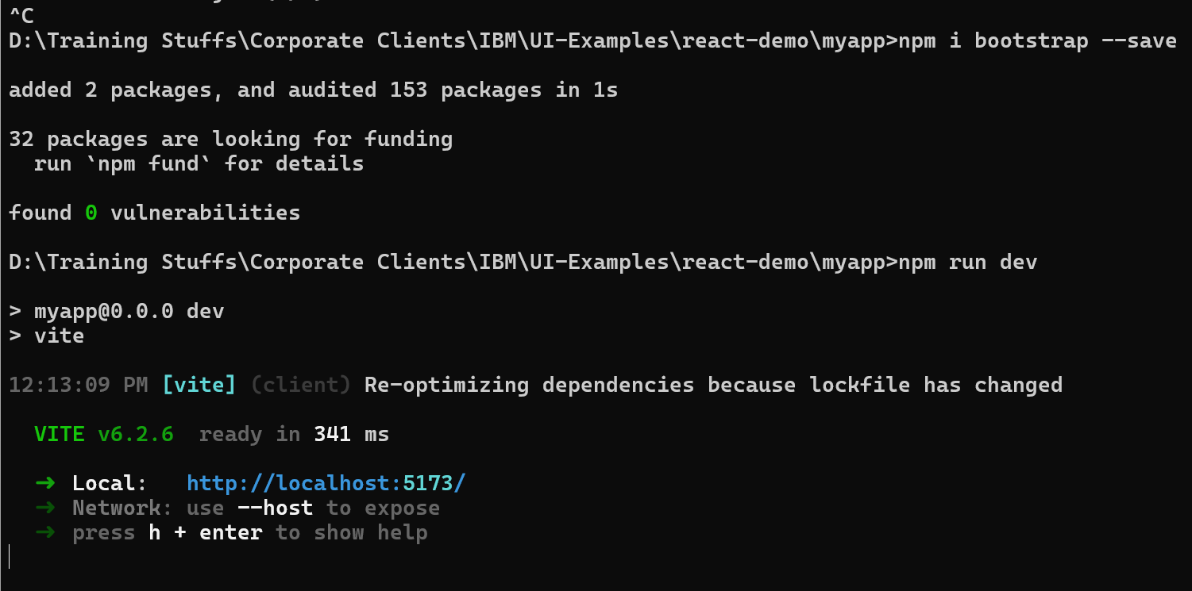

Nullish coalescing

It assigns the default value if value is null

let name = props.name ?? “Guest”;

if props.name is not null, then assigns that name else assigns Guest

How to pass complex data & render it in the component

let cmt = { text: “Hello, how are you”, likes: 10, date: new Date(“2025-04-16”) };

<Comment comment = {cmt} /> props = comment = { …. }

function Comment(props) { let comment = props.comment}

List & Keys in React.js

List is a collection of element and in react each element you iterate must be unique hence you should use key when you iterate an array, in React.js you use map() method to create the List

iplTeams = [“RCB”, “KKR”, “CSK”, “MI”, “SRH”];

<ol>  
{  
 iplTeams.map(( team, index ) => <li key= {team}>{team}</li>  
}

</ol>

Why key must be unique while iterating

React will efficiently renders the content on the web page when the key is unique & it knows which element must be rendered when user removes any element.

Event handling in React

When you do some actions in the web page event occurs based on those events you can execute some logics

React has its own event names which are called as Synthetic events which are almost similar to the event names you use in HTML, but react uses camel case and it is case sensitive

onClick, onSubmit, onChange, onFocus, onBlur and so on

<button onClick = {e => stmts} >Button</button>

or

let handleClick = ( e ) => stmts;

<button onClick = { handleClick } >Button</button>

States in React.js

These are the component states that can be modified you can think of state like an object that can store the form data what user enters or the data fetched from the backend, state is created using an inbuilt React hook function useState(initialValue);  
let [name, setName] = useState(“”); // import {useState} from ‘react’;  
Here name stores the data & setName can modify the name

setName(“Raj”); then the name = Raj

Importing the useState

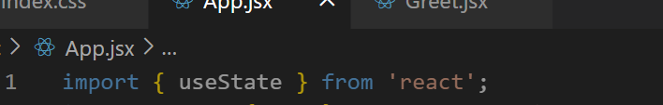

Create state with useState

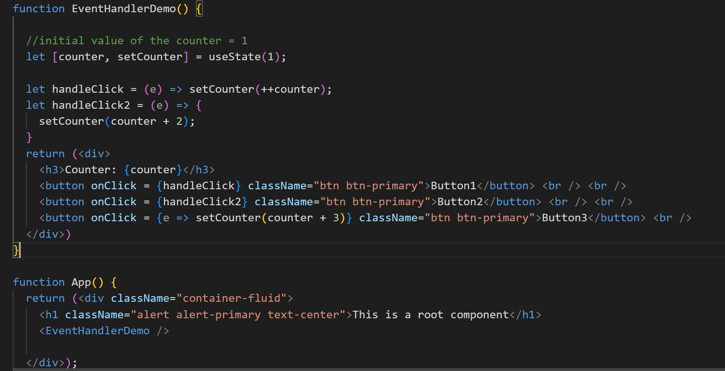

How to read form data and store in the state variable

An event object will be supplied to the handler which can use event.target.value to read the value of the element that generate the event

let [name, setName] = useState(“”);  
let [age, setAge] = useState(“”);

<input type = “text” onChange={e=>setName(e.target.value)} />

<input type = “number” onChange={e=>setAge(e.target.value)} />

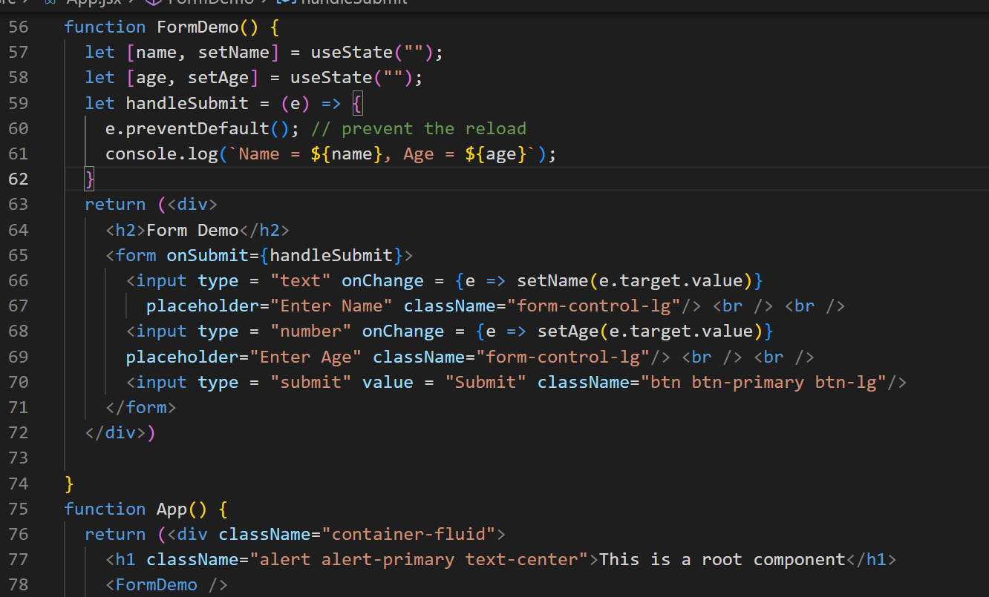

If it is react tool kit from facebook the command to start the application is

npm start

If it is vite then the command is

npm run dev

How to access the backend services in React.js

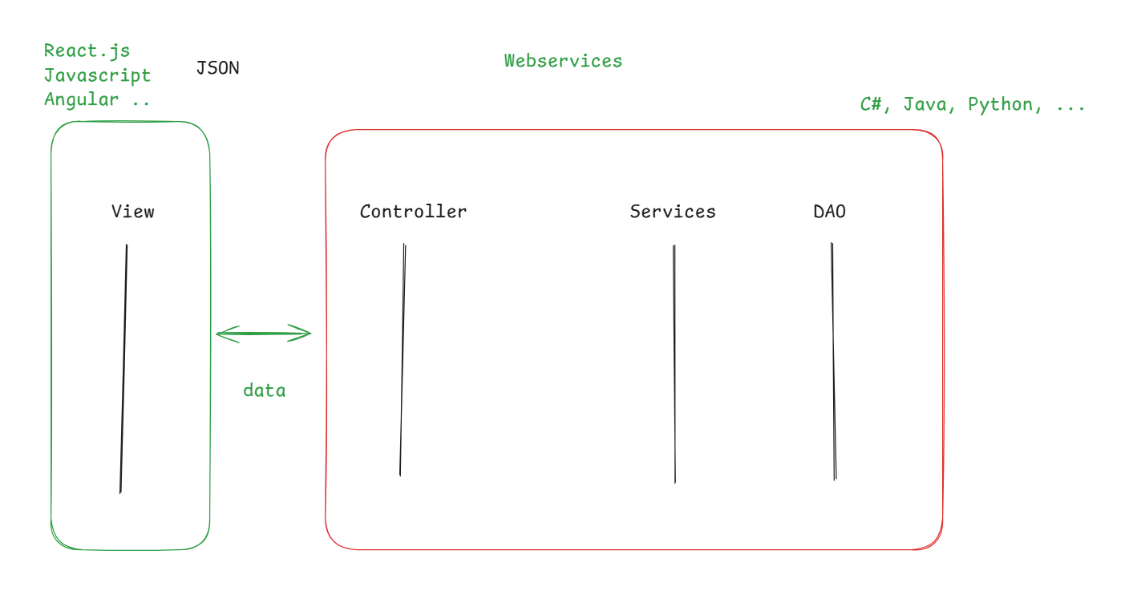

Applications written in different technologies can exchange the data in JSON format so that they can be converted to the structure the language understand

ex: Zomato application can share data to Phone pay, Google pay, Bank App

axios library: It is a library which React.js uses to send the HTTP requests to the backend service & can process the HTTP response, HTTP has 4 important methods to send request

1. GET: Fetching the data
2. POST: Creating the new resource
3. PUT: Updating the existing resource
4. DELETE: Delete the existing resource

Apart from the HTTP methods it has to mention the URL of the backend service

Example:

axios.get(URL)  
axios.post(URL, data)  
axios.put(URL, data)  
axios.delete(URL, data)

All the http methods of axios does an asynchronous operation & hence it returns an object called Promise that needs to be resolved using .then(callback) or reject with .catch(callback)

axios.get(URL).then( response => {…}).catch( err =>{..})

Note the variables inside the then & catch can be anything they are just responses from the asynchronous operation

Installing the axios library

npm install axios --save

React Router

It helps you to navigate from one component to another component without reloading the entire page, you must install a library called react-router-dom to achieve routing

This library gives you following components & hooks

1. BrowserRouter
2. Routes
3. Route
4. Link
5. useNavigate() hook
6. useParams() hook

BrowserRouter: it must be the root component for all the components, including the App component, so that it takes care of routing from one component to another without reloading the entire page  
<BrowserRouter>  
 <App />  
</BrowserRouter>

Link: It is used to create hyperlink that provides the url-pattern for the router

<Link to=”/register”>Register</Link>  
<Link to=”/login”>Login</Link>

Routes & Route: These are the components that can identify what component to render based on the url-pattern

<Routes>  
 <Route path=”/register” element = {<RegisterComponent/>} />  
 <Route path=”/login” element = {<LoginComponent/>} />  
 <Route path=”/success” element={<DashboardComponent />} />  
 </Routes>

useNavigate(): It is to dynamically specify the url-pattern to the router i.e., for programmatic navigation

let nav = useNavigate();  
if(success) { nav(“/dashboard”); }  
else { nav(“/login”); }

useParams: It is to add parameters to the url so that components can read that parameter

<Route path=”/success/:id” component={<DashboardComponent/>} />

success/10, success/20, success/30

let { id } = useParams(); // it reads value of :id written in success/:id

for success/20 the value of :id = 20  
hence let {id} = userParams(); would read 20  
if it is success/30, then the value of :id=30  
so let {id} = useParams(); would read 30

Installing react-router-dom

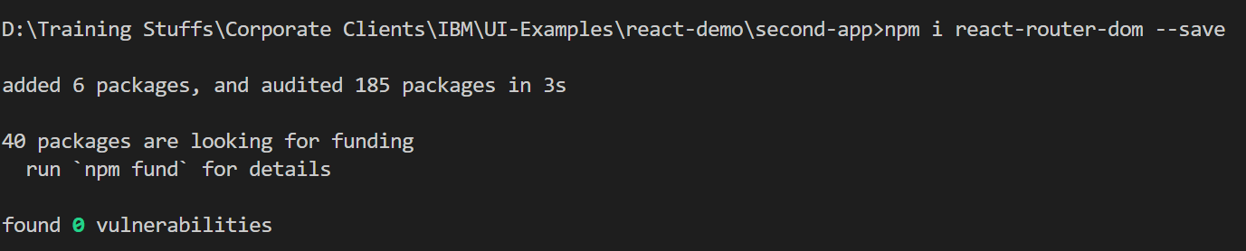

You must import BrowserRouter, Link, Routes, Route, useNavigate(), useParams() from the react-router-dom

Importing BrowserRouter and including App inside BrowserRouter in the main.jsx

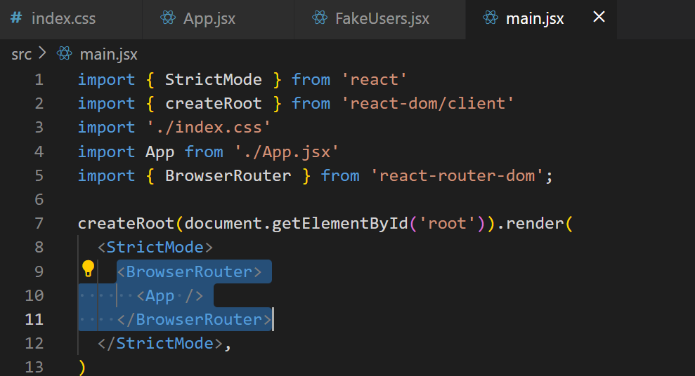

Create Register, Login, Dashboard components with simple text content, but later you can create the real contents like forms, tables and etc.

components/Profile.jsx

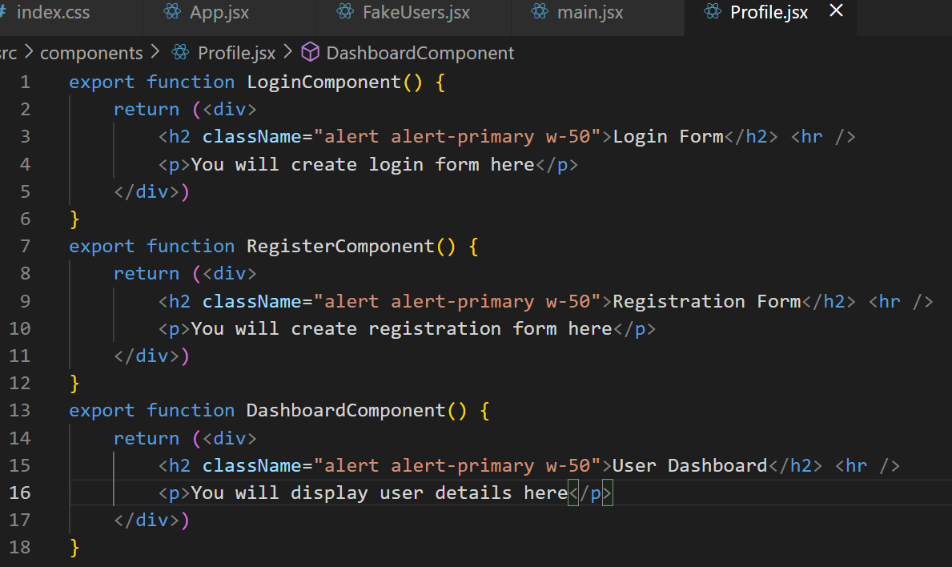

Create Link, Routes & Route to configure the navigation to all the three components

App.jsx

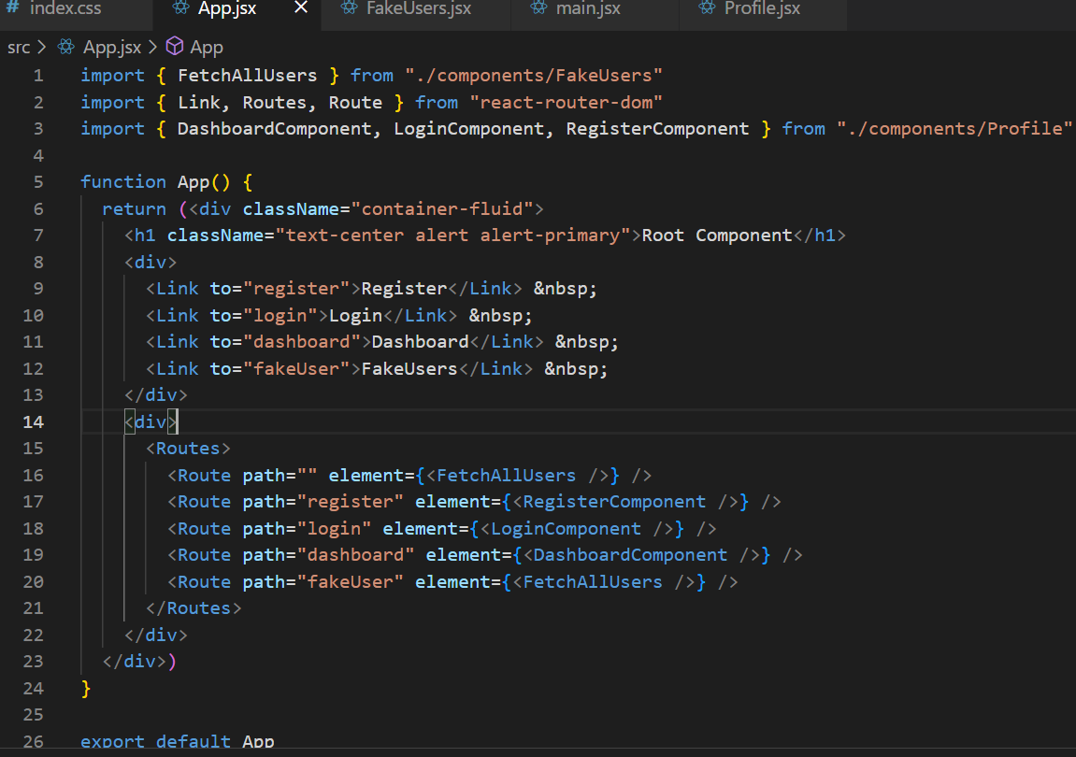

For userNavigate() and userParams() we will create an input box in dashboard and navigate programmatically to the success component

Add a Route to the success/:user/* with a fake content because success component is not developed.

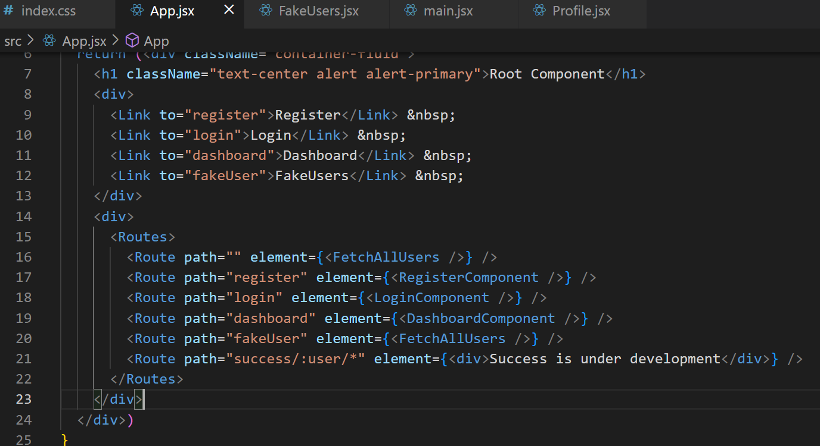

Now in dashboard create a text box that allows you to enter name & success component must display it

Profile.jsx

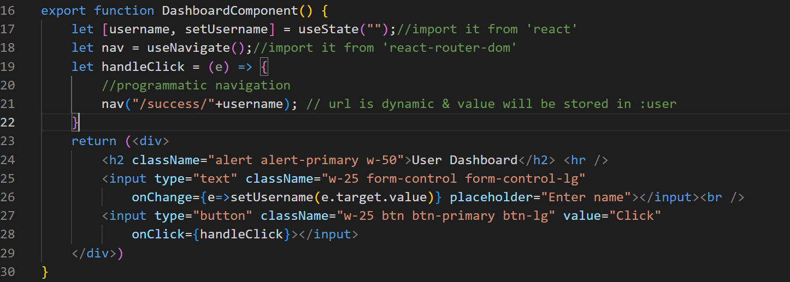

Activity

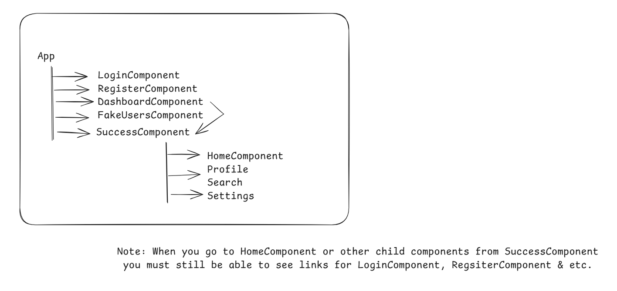

Different ways to create components

1. using function keyword
2. using class by extending React.Component
3. using arrow function

Javascript Destructuring

It helps you to declare and assign values to the variables in a single line without writing multiple lines.

<User name=”..” age=”..” dob=”..” />

Assigning props without Destructuring  
let name = props.name;  
let age = props.age;  
let dob = props.dob;

You can use Destructuring syntax so that you can assign values to all the variables in a single line

let {name, age, dob} = props;

Create a User component & extract name, age, dob with Destructuring syntax & print it, render the User component from the App

Spring Framework

It is an application framework that helps you to develop all types of applications like desktop, web, cloud and enterprise

Framework: It is a semi implemented project that provides lot of repeated tasks you do in your project, for which you don’t have write the code, because framework takes care of those repeated tasks below are the features framework provides for you

Type conversion: Converting from string to number or java to sql and vice versa

Exception Handling: Handling all the resource level exceptions like SQLException, or checked exceptions

Connection pooling: Taking care of establishing DB connections & creating connection pool

Design patterns: Many times developers create design patterns, which are not required, because framework only provides the design patterns

There are other features spring framework provides

FrontController, MVC pattern, Dependency Injection, External Configurations, Microservice design patterns, RESTful service patterns and many more

Spring Framework provides many modules for different types of applications

1. Spring Core / Context: It is the base module for all other spring modules, it helps to provide a spring container to manage all the objects
2. Spring AOP: It is to create Aspects, AOP stands for Aspect Oriented Programming
3. Spring MVC: It is to create web applications with MVC pattern
4. Spring JDBC: It is to interact with the DB using JDBC
5. Spring ORM: it is also to interact with the DB using ORM framework
6. Spring Boot: It is a framework for spring modules
7. Spring Cloud: It is to develop & deploy microservice based applications on various clouds

Spring Core / Context is heart of any spring applications, every modules are dependent on Spring Core, it gives a spring container that takes care of providing all the design patterns, type conversions, object creation/deletion, dependency injection

Dependency Injection:

Dependency injection (DI) is a software design pattern where a class receives its dependencies (other objects it needs) from an external source rather than creating them itself. This promotes loose coupling, Instead of a class creating its own dependencies, they are passed in, often through the constructor or via a setter method.

How does spring framework creates the object & supplies the object

Spring framework uses an XML declaration where it can declare all the classes (beans) which needs to instantiated and supplied to other classes, this xml file is called as spring configuration file, spring container reads this XML and maintains all the objects in it.

Spring uses design patterns to create the objects in the spring container, by default it uses a factory design pattern that creates a singleton object (default scope is singleton object) however you can configure to create a prototype object(multiple objects based on the need).

Spring framework provides 2 interfaces that helps you to get the objects from the container

1. BeanFactory: provides lightweight features like lazy-init
2. ApplicationContext extends BeanFactory: provides extra features like eager-init, internationalization, annotation based configuration

Spring framework has implemented these interfaces in a class called ClassPathXmlApplicationContext, which you must instantiate by providing the xml file that has bean configurations, so that spring container can create all the objects

BeanFactory factory = new ClassPathXmlApplicationContext(“file.xml”);  
ApplicationContext context = new ClassPathXmlApplicationContext(“file.xml”);

ProjectStructure: You must have a maven project

* src/main/java -> *.java
* src/main/resources -> *.xml
* pom.xml -> dependencies

Libraries: spring-context - 6.x.x

Datasource.java

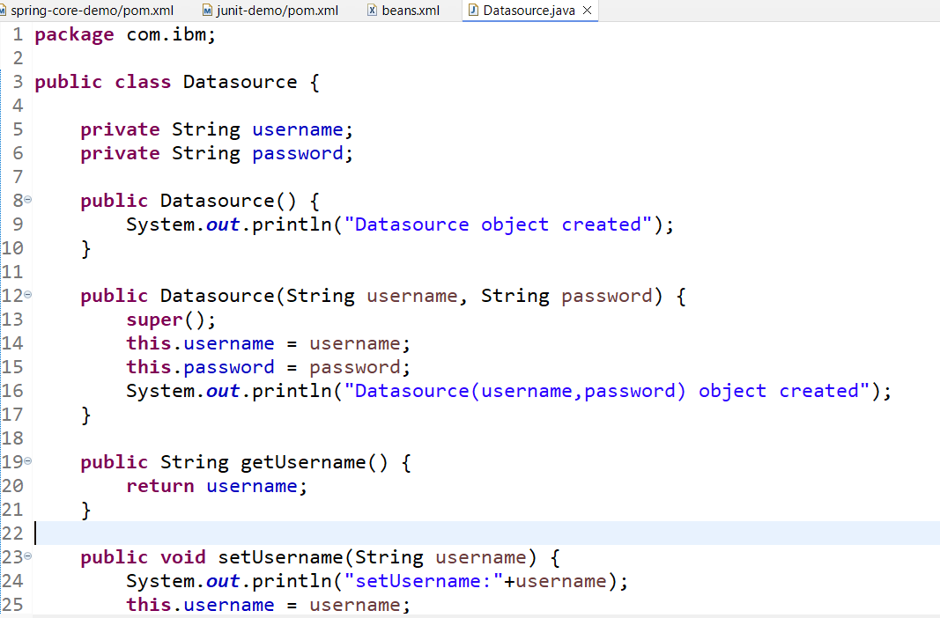

We can tell spring to create the object of Datasource and also initialize their properties, then using BeanFactory or ApplicationContext we can get the object & their details

beans.xml

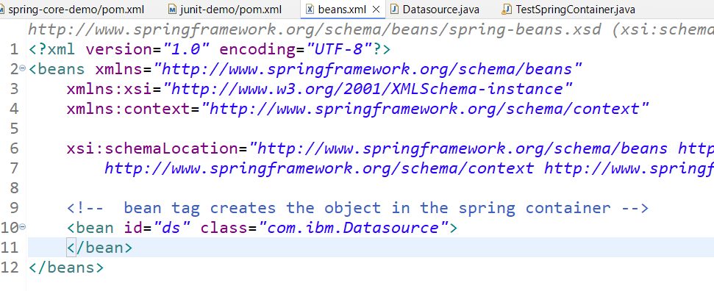

TestSpringContainer.java

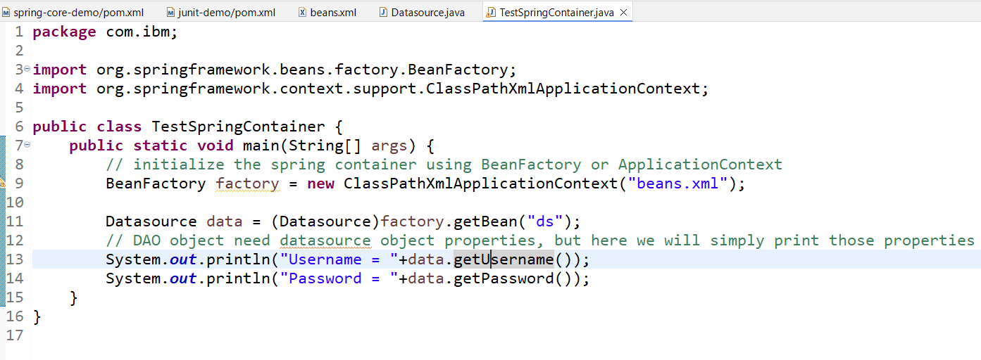

Output:

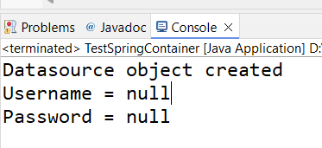

In the above program we can see spring container created the object with default constructor, but properties like username & password are not initialized.

How to initialize bean properties i.e., variables inside the class

These are achieved using dependency injection and there are two ways to initialize the properties

1. setters - setter injection
2. constructor - constructor injection

We must let spring to initialize the properties by using <property> tag for setter injection & <constructor-arg> tag for constructor injection.

Setter Injection

beans.xml

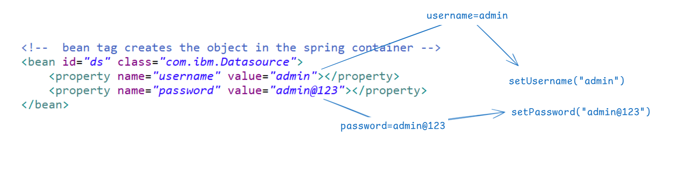

You can notice the setter method invocation in the console

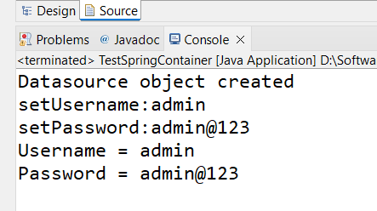

Constructor injection

Initializing the bean properties through constructor

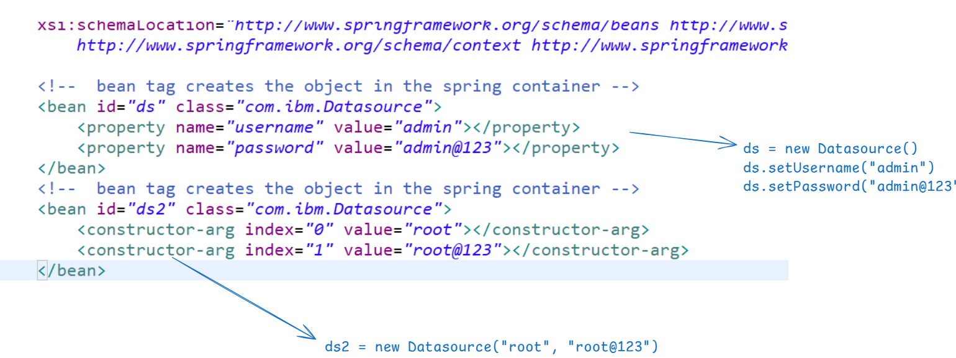

Output:

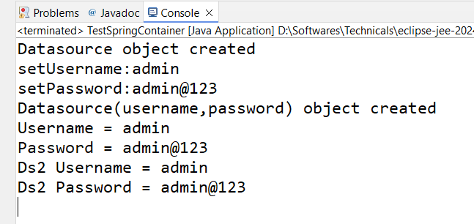

Question: Try to provide name attribute in the <constructor-arg> in place of index

Answer: It works

Question: Change the BeanFactory to ApplicationContext in the main

Answer: It works

Supplying the complex type object

AccountDao.java

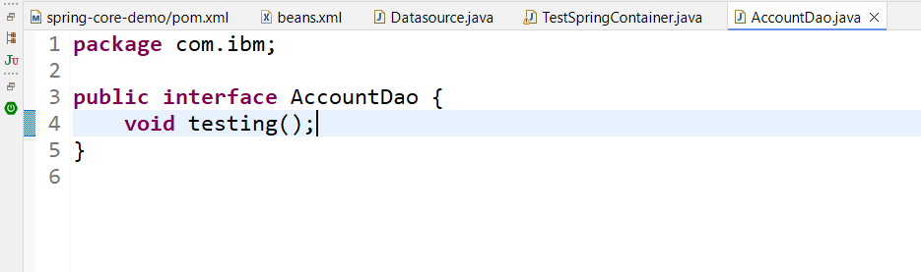

AccountDao1 implements AccountDao

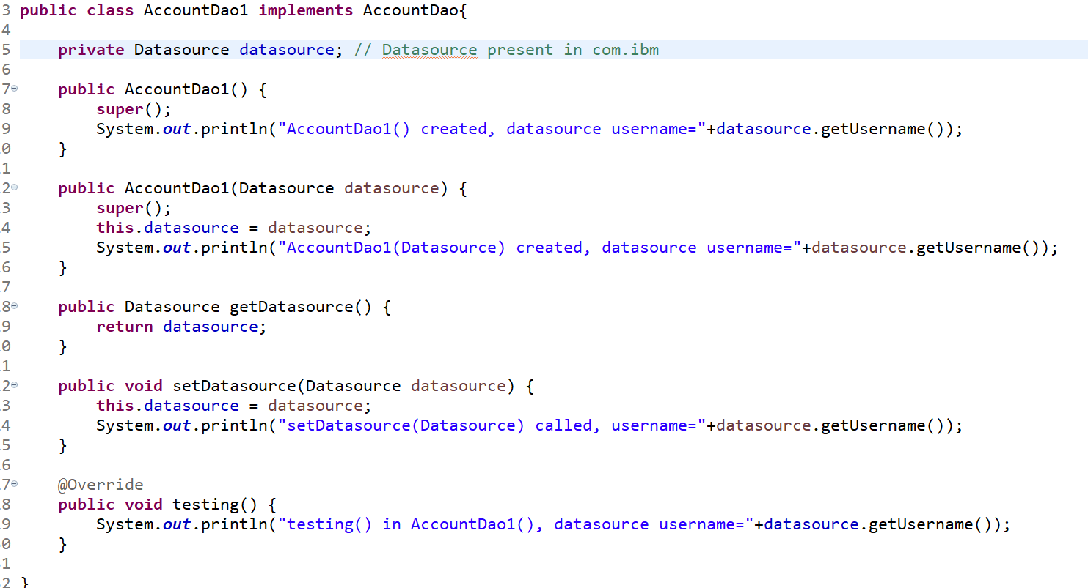

If the AccountDao1 is created spring must supply Datasource object

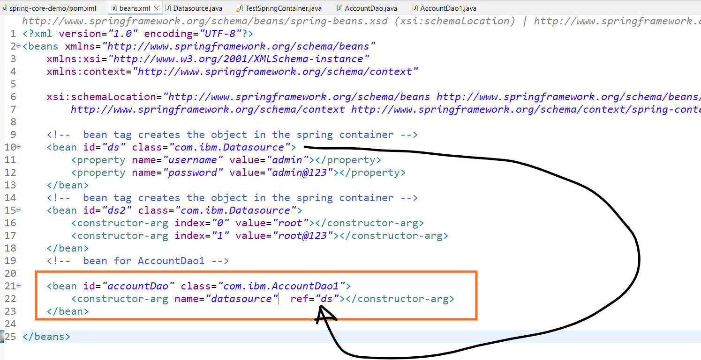

Note: AccountDao1 is using constructor injection

TestSpringContainer.java

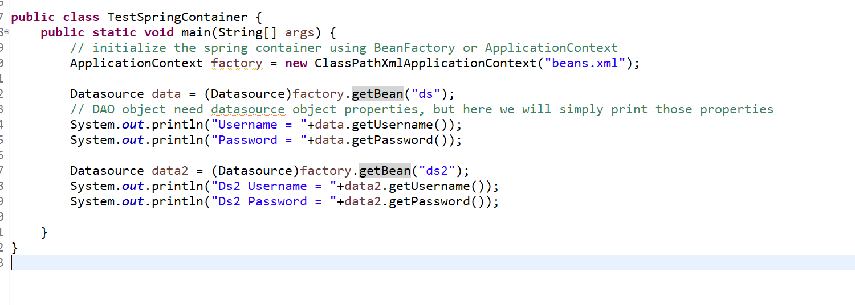

Output:

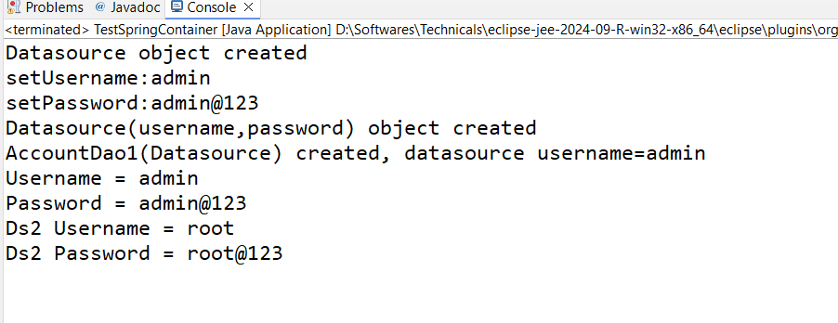

Question: Change the <constructor-arg> in AccountDao1 to <property> and check if that works

Answer: It works, but in default constructor you must not invoke any properties from the dependency as its not initialized

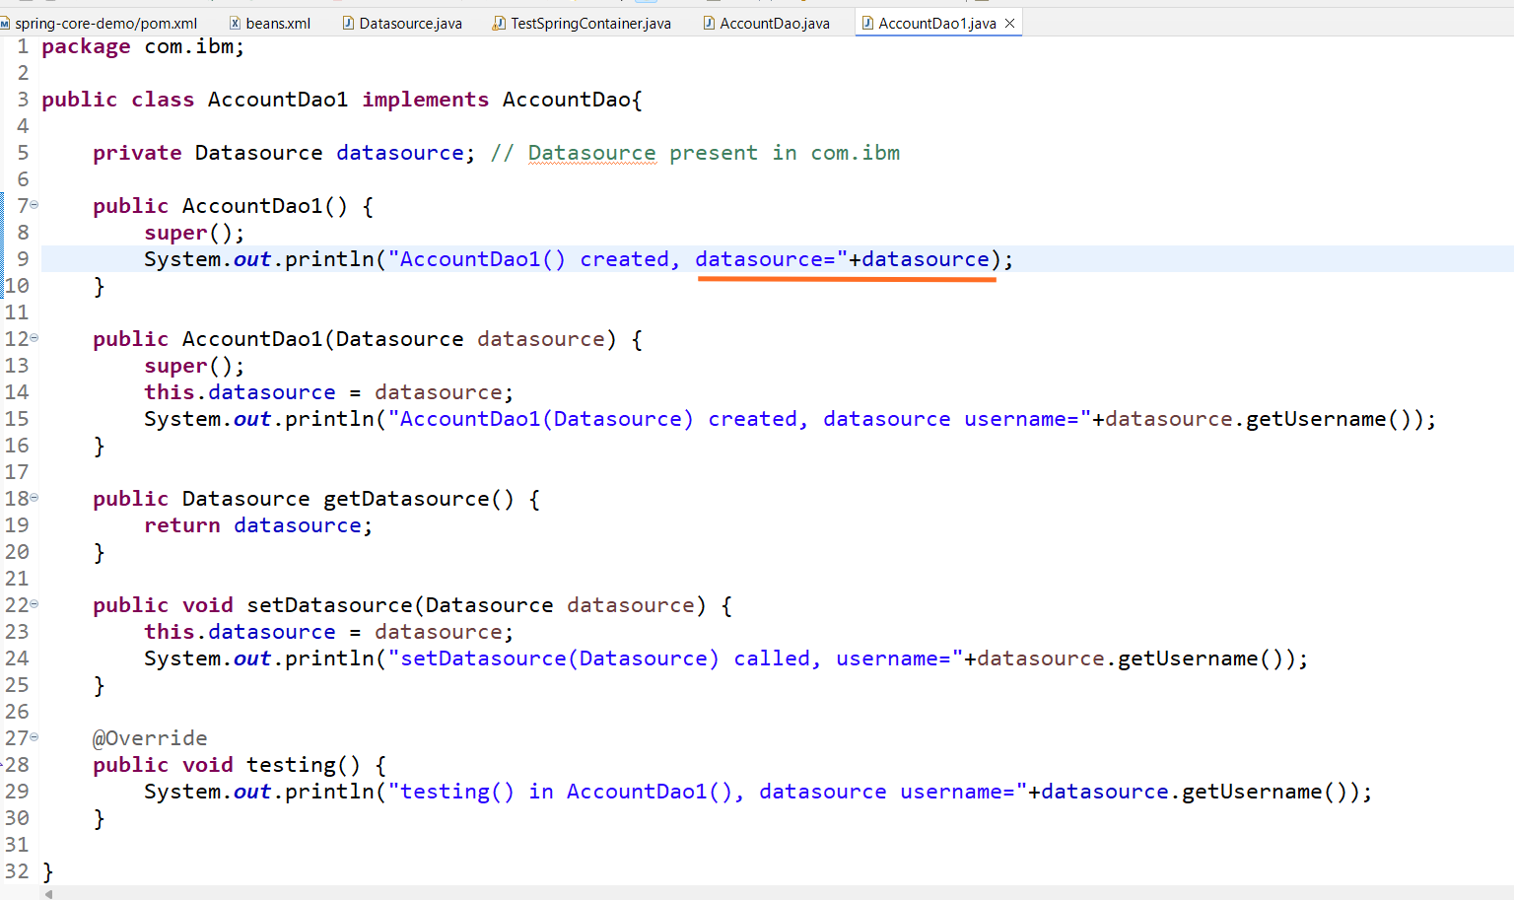

Output:

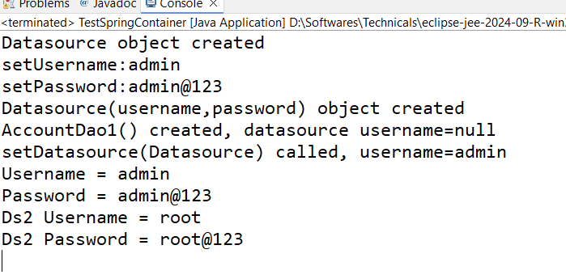

Bean scopes & life cycle methods

Bean Scopes

In Spring bean will be available in various scopes

1. singleton: default scope
2. prototype : create object any number of times
3. request: create bean for each HTTP request, Only valid in the context of a web-aware Spring ApplicationContext.
4. session: create bean for every HttpSession, Only valid in the context of a web-aware Spring ApplicationContext.
5. application: scopes a single bean definition to the lifecycle of a ServletContext. Only valid in the context of a web-aware Spring ApplicationContext.

Life cycle of a bean  
<bean id = “b1” class=”com.ibm.Test” init-method=”setup” destroy-method=”cleanup”>…</bean>  
init-method: it is called when a bean is created  
destroy-method: it is called when a bean is destroyed  
Alternatively, you can also implement the interfaces like InitializingBean or DisposableBean instead of using init-method or destroy-method  
class Test2 implements InitializingBean, DisposableBean {   
 // afterPropertiesSet() >> InitializingBean >> called when bean is created  
 // destroy() >> DisposableBean >> called when bean is destroyed  
}  
Activity: Create two classes Test1 & Test2 and declare these classes with <bean> for one class you use init-method & destroy-method attributes and for another class use only InitializingBean & DisposableBean, in all the methods print some message & create a separate class for main & initialize the ApplicationContext you will see init-method & InitializingBean method getting called automatically.  
Collection Injection  
Activity: Create a class Locations that will have List<String> cities, whose values will be provided from XML and print those values in the main method

solution for Collection Injection Activity

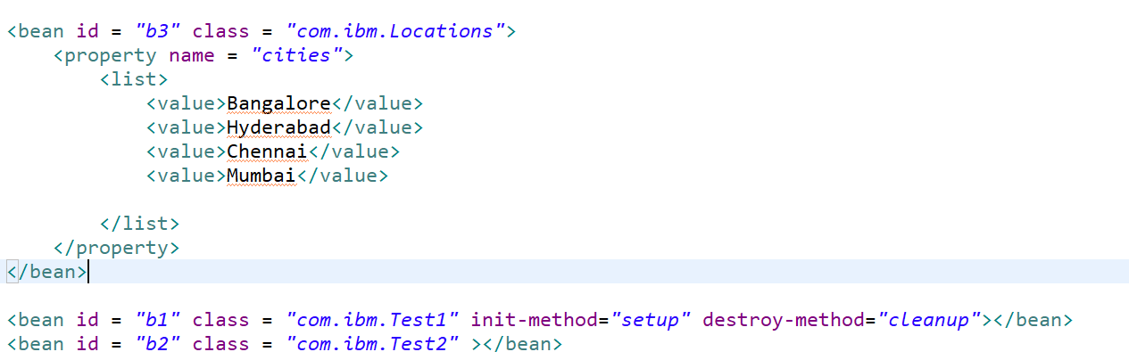

TestSpringContainer.java

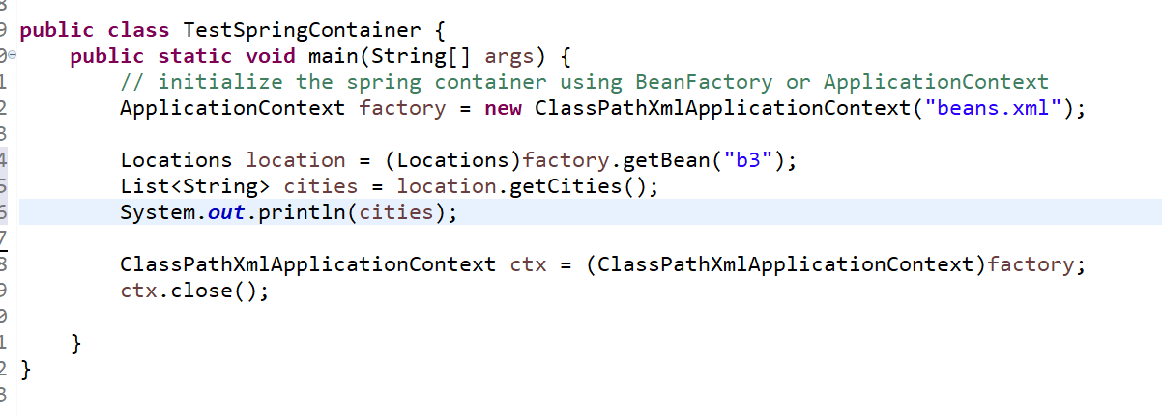

Autowiring

It is a feature in dependency injection which can automatically supply the object to another object without using <property> or <constructor-arg>

class CustomerDao { }   
class AccountDao { }   
class CustomerService {  
 private CustomerDao customerDao;  
 private AccountDao accountDao;  
}

<bean id = “dao1” class = “com.ibm.CustomerDao”></bean>  
 <bean id = “dao2” class = “com.ibm.AccountDao”></bean>

<bean id = “service” class = “com.ibm.CustomerService” autowire=”byType”></bean>

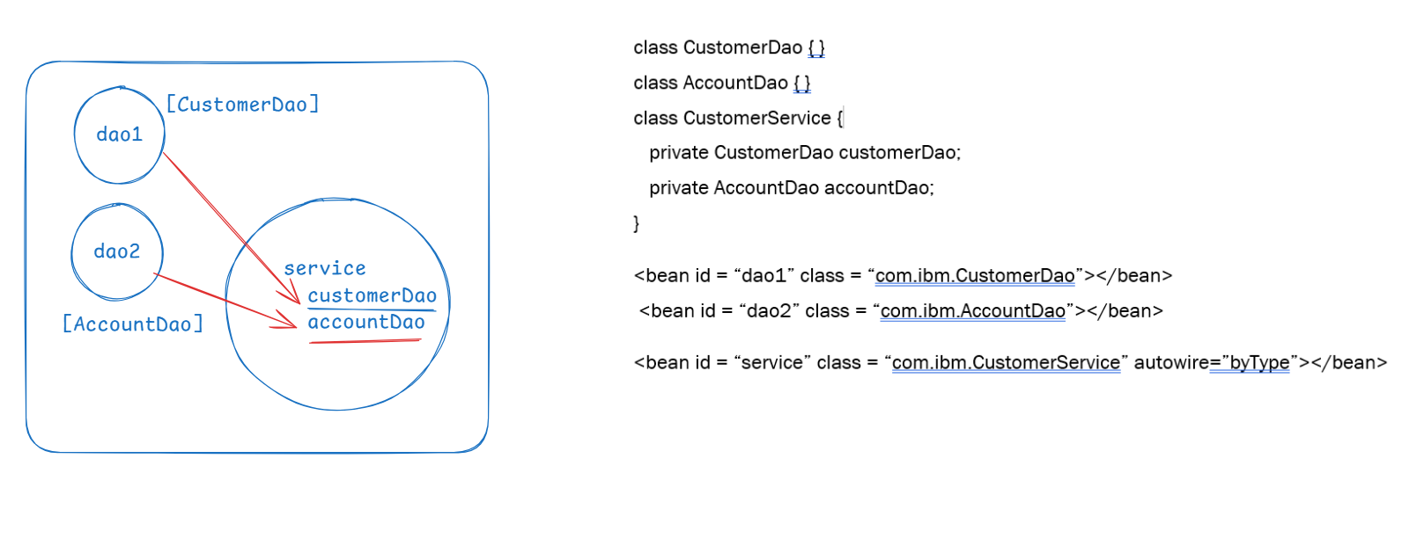

Note: If there are multiple objects of same type then Autowiring byType will fail, in that case you must use Autowiring byName

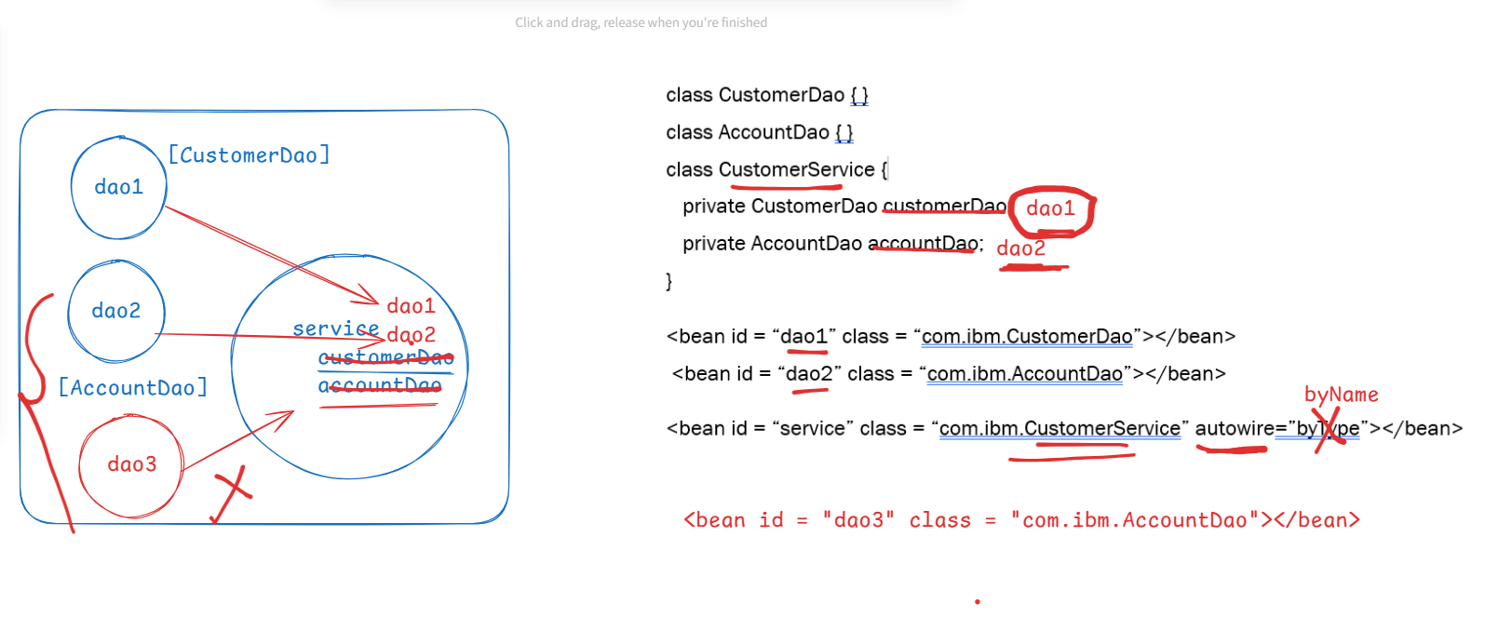

Rule while using autowire byName: property name & bean id must be same

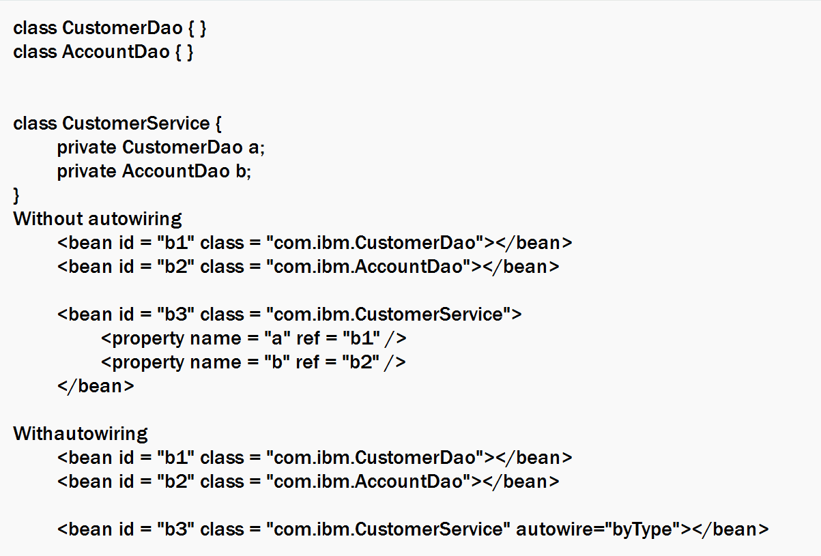

Activity: Create all the above classes & bean declarations in a separate project and create constructors in all the 3 classes & print messages, from the main method initialize the ApplicationContext & you must see all the constructor message

Activity2: Create one more <bean> for AccountDao and observe how the autowire byType fails, and use byName to avoid the error

Inner beans

When you have the reference in an object that can be supplied using autowire or constructor injection or setter injection, but you can also initialize the inner beans using nested bean tag.

class CustomerDao {   
 Datasource ds;  
}

Inner beans

<bean id = “dao” class = “com.ibm.CustomerDao”>  
 <property name = “ds” ref = “ds”></property> [or]  
 <!-- inner bean -->  
 <bean id = “ds2” class = “com.ibm.Datasource”>  
 <property name = “username” value = “root”></property>  
 <property name = “password” value = “root@123”></property>  
 </bean>  
</bean>

Dependency check

It is an attribute used in the <bean> tag to check whether the dependencies are injected, but this is removed from Spring 3.0 onwards

lazy-init vs eager-init

These are the features that helps object to be created at the time of spring container initialization or when you request for the object.

eager-init: Bean objects are created at the time of spring container initialization, this is the default feature of a bean

<bean id = “ds” class = “com.ibm.Datasource”></bean>  
ApplicationContext context = new ClassPathXmlApplicationContext(“beans.xml”);

The above code is initializing the spring container & creates all the beans that will have eager-init by default

<bean id = “ds” class = “com.ibm.Datasource” lazy-init=”true”></bean>

The bean is created only when you invoke the getBean() method, not when spring container is initialized

ApplicationContext context = new ClassPathXmlApplicationContext(“beans.xml”);

Datasource ds = (Datasource)context.getBean(“ds”);

Note: by default lazy-init is false

Annotation based configuration

Spring supports bean configuration with XML as well as annotations, you have following annotations which are called as stereo type annotations to configure the beans,

1. @Component
2. @Repository
3. @Service
4. @Controller
5. @Configuration
6. @RestController

All these annotations you must write on top of the class, which helps spring to create the object & register in the container, the reason we have many annotations to create object is to categorize the objects that come in different layers in a complex application

@Component: This you can apply on any class that is not part of controller, service or dao, ex: Utility classes

@Component  
class Utility { } // spring container creates the object & registers in the container   
@Repository: This is used on top of the class that comes in DAO layer ex: CustomerDao, AccountDao  
@Repository  
class CustomerDao { } // spring container creates the objects & registers in the container  
@Component  
class AccountDao { } // still spring container creates the object & registers in the container.

There are other annotations which wouldn’t create the object instead they perform other tasks

1. @Autowired: Written on top of the reference that needs to be initialized

ex: @Service   
 class CustomerService {   
 @Autowired  
 CustomerDao dao;  
 }

1. @Qualifier: This is used when multiple beans of same type get conflict with Autowiring

ex:

@Repository // id = accountDao1  
class AccountDao1 implements AccountDao { }   
@Repository // id = accountDao2  
class AccountDao2 implements AccountDao { }   
@Repository(name=”b3”) // id = b3  
class AccountDao3 implements AccountDao { }

@Service  
class AccountService {   
 @Autowired  
 @Qualifier(name=“b3”) // inject AccountDao3  
 AccountDao dao;  
}

1. @Primary: This will give priority for a bean that needs to be injected, you can use this as an alternative to @Qualifier  
   @Repository // id = accountDao1  
   class AccountDao1 implements AccountDao { }   
   @Repository // id = accountDao2  
   @Primary  
   class AccountDao2 implements AccountDao { }   
   @Repository(name=”b3”) // id = b3  
   class AccountDao3 implements AccountDao { }

@Service  
class AccountService {   
 @Autowired // accountDao2 is inject as it is having @Primary  
 AccountDao dao;  
}

You can override priority with @Qualifier  
@Autowired  
@Qualifier(name=”b3”) // now priority is for AccountDao3  
 AccountDao dao;

1. @Bean: This is used when user wants to create an object & that object must be registered in the spring container, it must be written on top of the method which must return an object

class Util { } // no stereo type annotations on top of Util class

@Configuration  
class Config {   
 @Bean // the method having @Bean is auto-executed & object will be registered  
 Util createUtil() { return new Util(); }  
   
}

1. @Value: This annotation is used to inject the values to the property

class Util {   
 @Value(“hello world”)  
 private String message;   
 @Value(“${server.port}”) // reads an external configuration file  
 private int portNumber;  
}

${server.port} is an spring expression language

To make these annotations work you must configure <context: component-scan> in the xml file

beans.xml

<beans>  
 <context:component-scan base-package=”com.ibm”></context:component-scan>  
</beans>

beans.xml

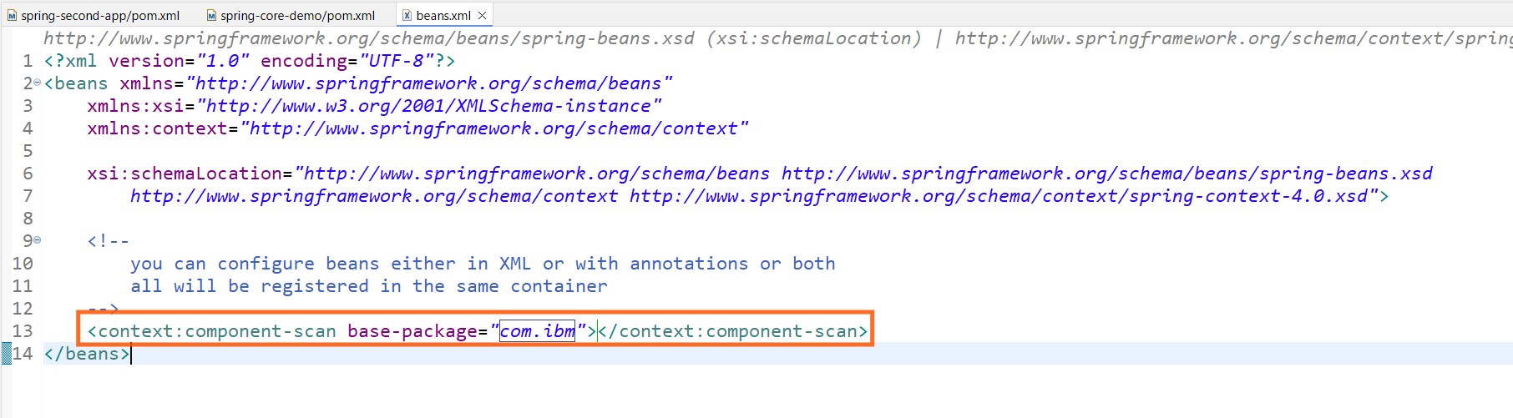

Requirement

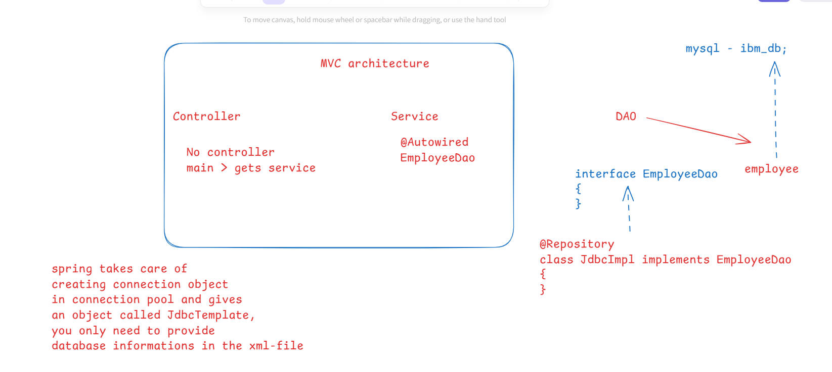

We need to perform CRUD operations on the employee table, but now we can just create an interface to declare the methods & implement those methods without interacting with the database.

EmployeeRepo.java

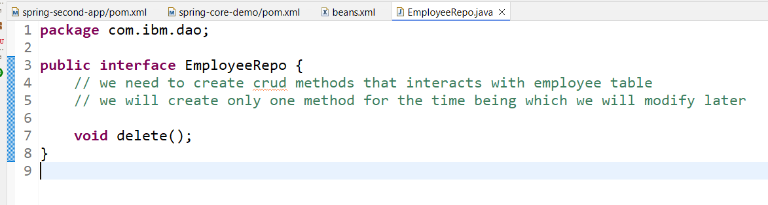

EmployeeJdbcRepo.java

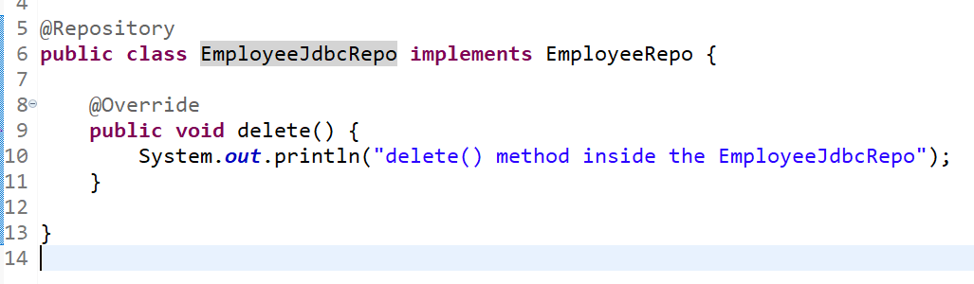

EmployeeService.java

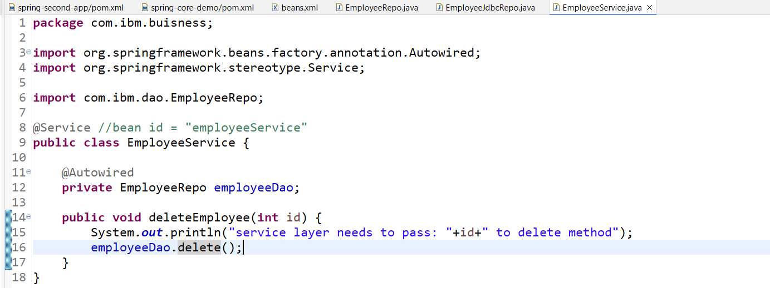

Since it’s a console based application we can’t use controller, hence we will treat main method itself as controller.

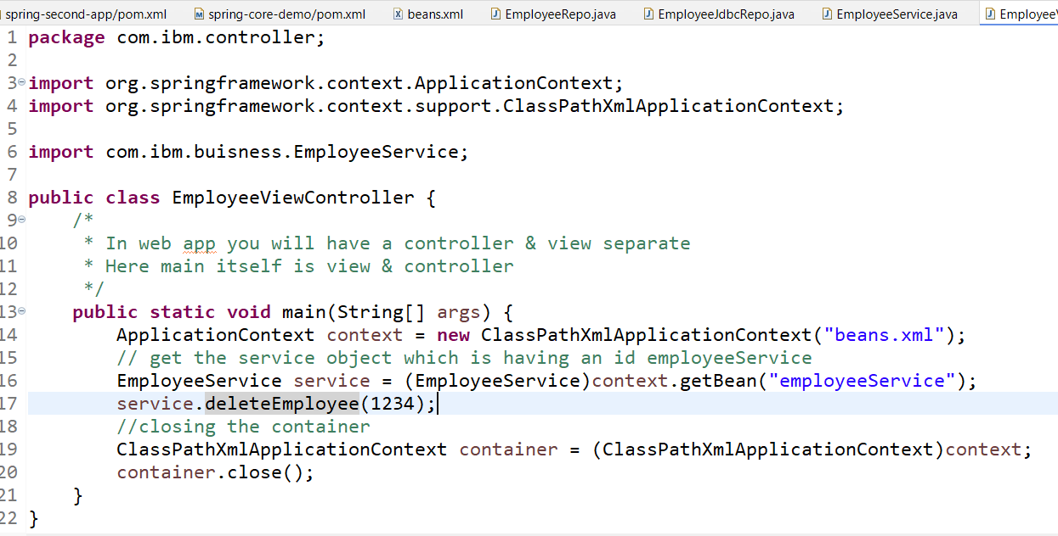

Output:

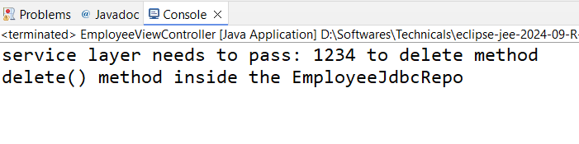

Since service methods & dao methods are called, spring container has created these objects & injected dao to the service

Interacting with the database

Employee.java

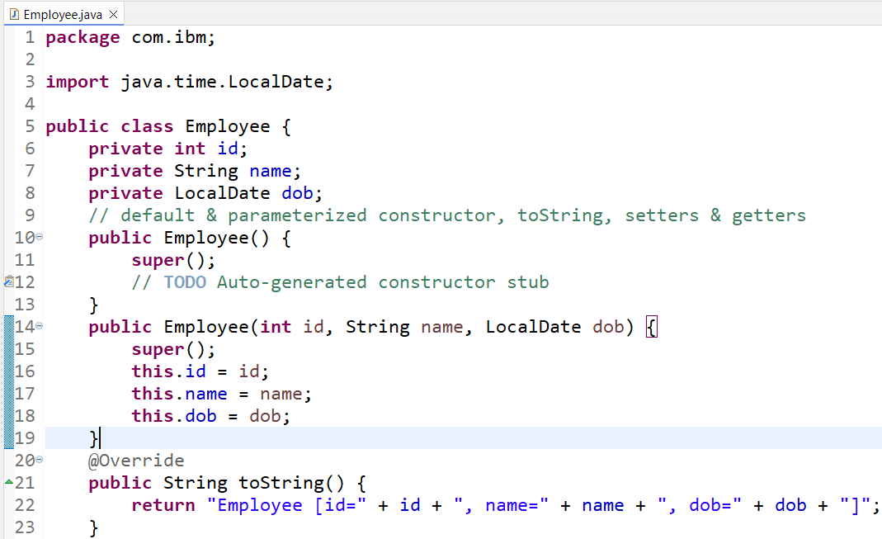

Spring JDBC

It is used to interact with the database using JdbcTemplate object, JdbcTemplate takes care of establishing the database connection, handling all the resource level exceptions and provides methods that can perform CRUD operations.

JdbcTemplate needs database informations to connect, hence you must provide database informations in the xml file.

Below are the methods JdbcTemplate provides to perform CRUD operations

1. update(“query”, parameters): to perform insert, update & delete
2. query(“query”, RowMapper): to perform select

@Autowired  
JdbcTemplate temp;

// insert  
temp.update(“insert into employee values(?,?,?)”, id, name, dob);

// delete

temp.delete(“delete from employee where id = ?”, id);

Steps to use JdbcTemplate

1. Add spring-jdbc library - JdbcTemplate, DataSource classes are present here
2. Add mysql-connector-j library - MySQL driver is present here
3. configure the beans.xml file to provide database credentials required like username, url, password, driver class name

*DriverManagerDataSource* is an inbuilt class in Spring JDBC that stores database credentials

1. inject the *DriverManagerDataSource* object in the JdbcTemplate

JdbcTemplate uses *DriverManagerDataSource* to connect

1. inject the JdbcTemplate in the dao layer

Supplying the JdbcTemplate to the Dao (EmployeeJdbcRepo)

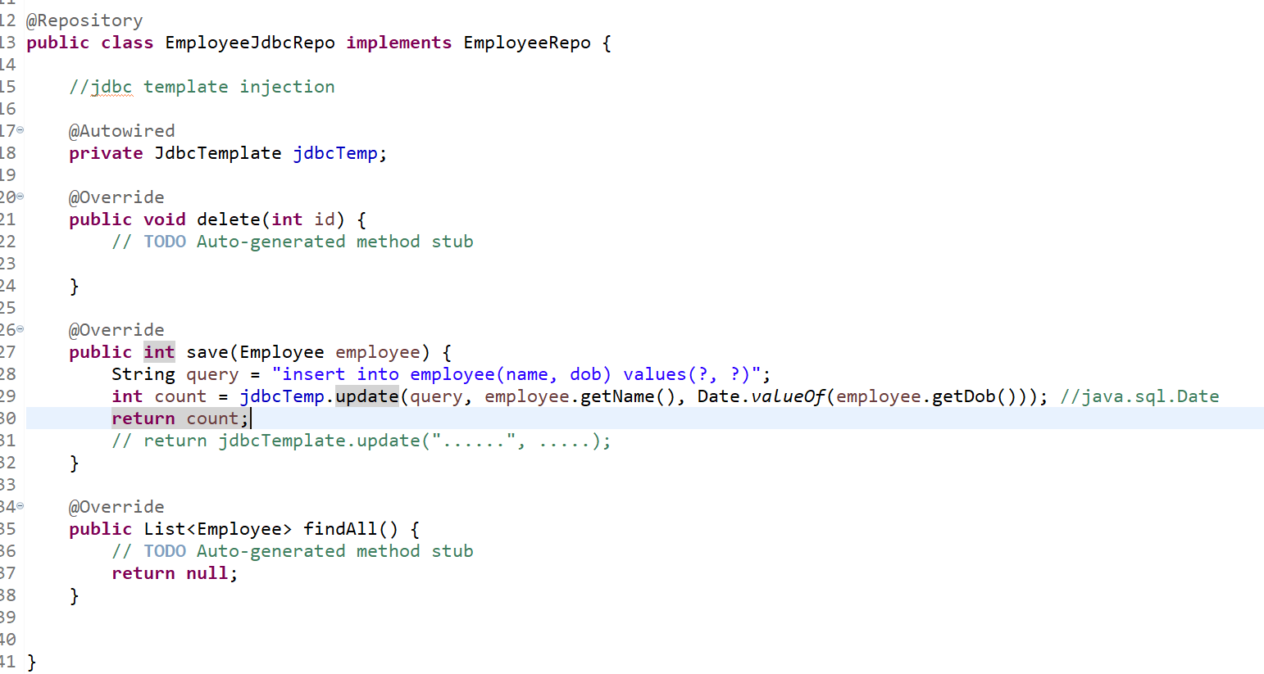

Calling save from service layer

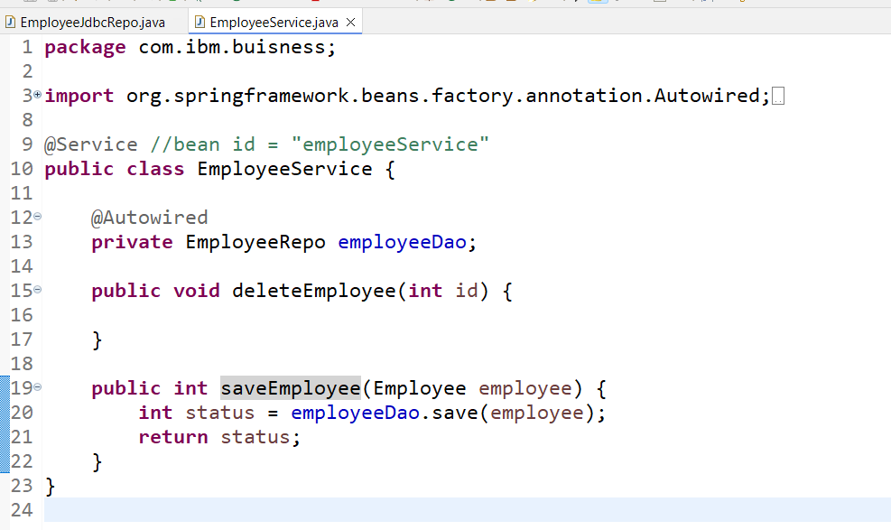

Call the saveEmployee from main method

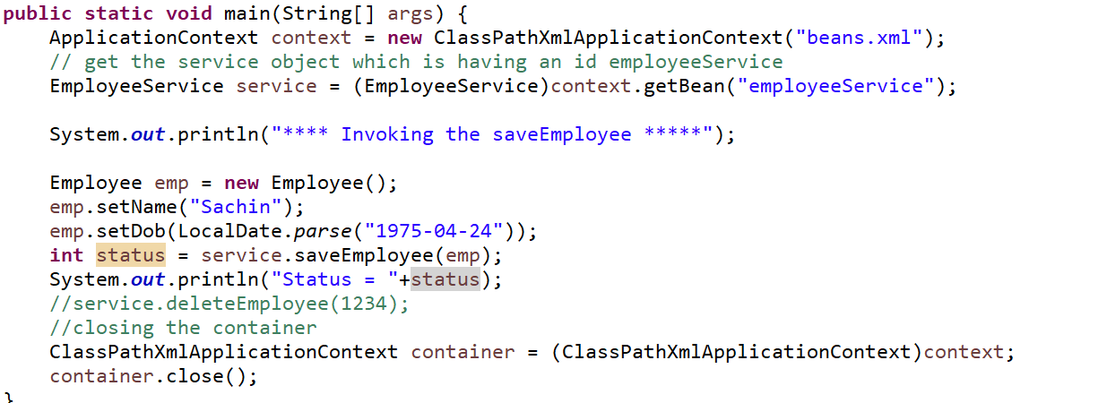

Implementing the select * from employee in findAll method of DAO

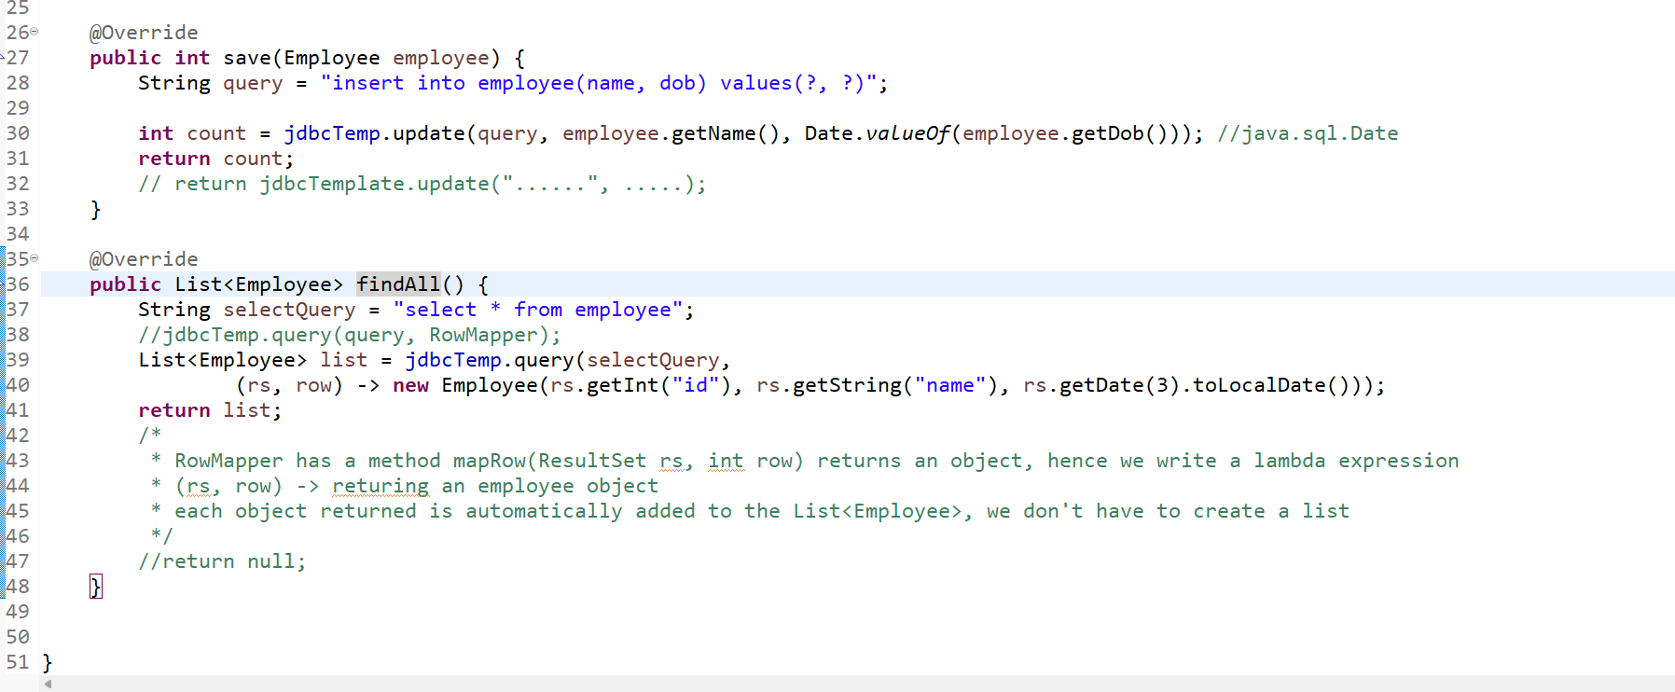

Call the findAll from the service layer

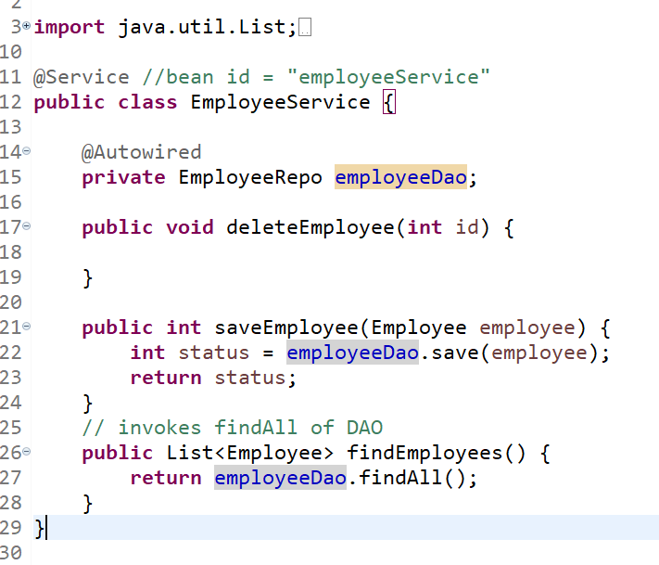

Invoke findEmployees from the main

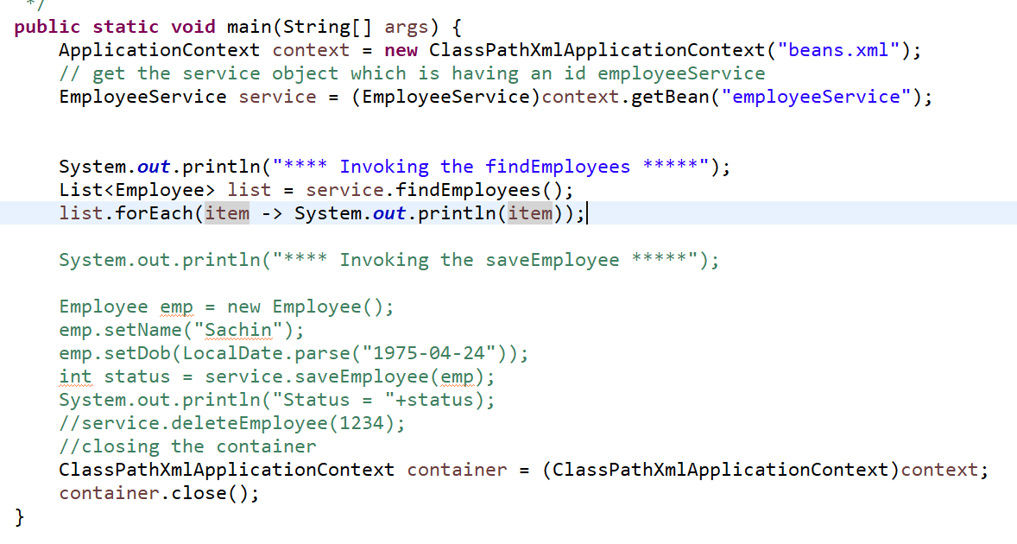

ORM framework

ORM stands for Object Relational Mapping, it can directly map java objects to the table, these objects are called as entities

JDBC vs ORM

|  |  |
| --- | --- |
| JDBC | ORM |
| Database dependent | Database independent |
| You write SQL queries for insert, update, delete and read | In ORM you get inbuilt methods to perform insert, update, delete & read |
| You need to convert Java types to SQL types | Not required |
| Table informations’ are written in SQL queries  Insert into employee(name, dob) values(….); | Table informations are written in entity class  Ex: @Entity @Table(name = “employee”)  class Employee {  id, name, dob; } |

Spring ORM: It user ORM to interact with the database which is much better than Spring JDBC because in Spring ORM queries you don’t write and java objects you can directly save or read or update or delete with the help of inbuilt methods.

Spring ORM is deprecated we must use Spring Data JPA which is similar to what ORM does but it is much simpler than ORM.

Spring MVC:

It is used to develop web applications using spring framework, you need to add a library called

* spring-webmvc

Then you need server (tomcat or any other) to deploy the web application

Spring MVC architecture

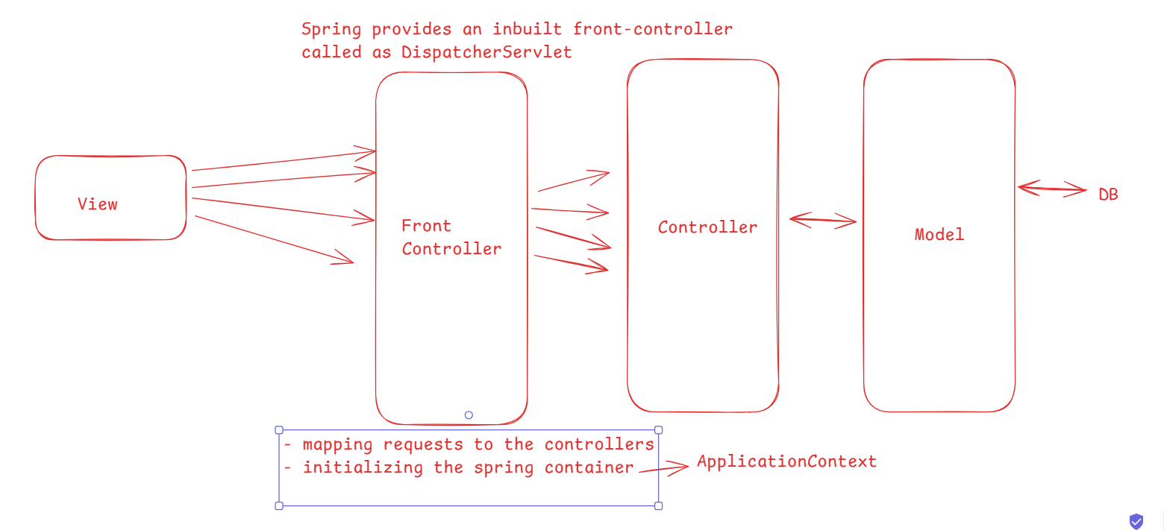

web.xml: It is a deployment description it will have the entry to take all the incoming requests mapping to the DispatcherServlet

List of libraries to add

1. spring webmvc -> it internally adds spring-context
2. spring jdbc -> to interact with the db
3. jstl -> to use JSTL in the JSP

Spring Context: We used the bean configuration file named “beans.xml” and initialized the container using

ApplicationContext ctx = new ClassPathXmlApplicationContext(“beans.xml”);

In Spring MVC, front controller i.e, DispatcherServlet will initialize the container using the below statement

ApplicationContext ctx = new ClassPathXmlApplicationContext(“servlet-name-servlet.xml”);

servlet-name is dispatcher, hence it expects dispatcher-servlet.xml

WEB-INF/dispatcher-servlet.xml: You must keep bean configuration files inside WEB-INF

You can use JSTL in jsp file and render all the list of employees in a table format

<c:forEach items = “${msg}” var = “e”>  
 <c:out value = “${e}” />  
</c:forEach>

EmployeeController.java

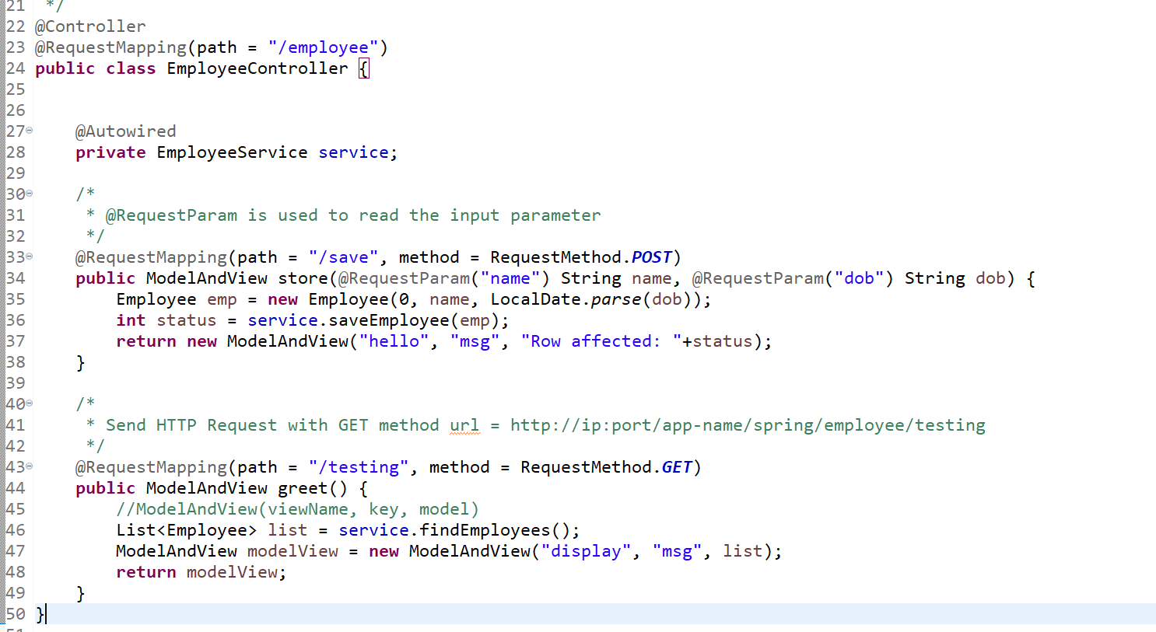

WEB-INF/pages/display.jsp

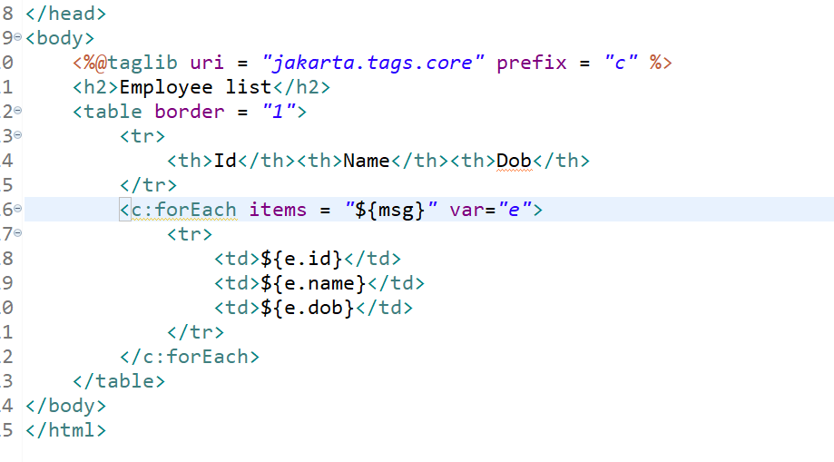

Output:

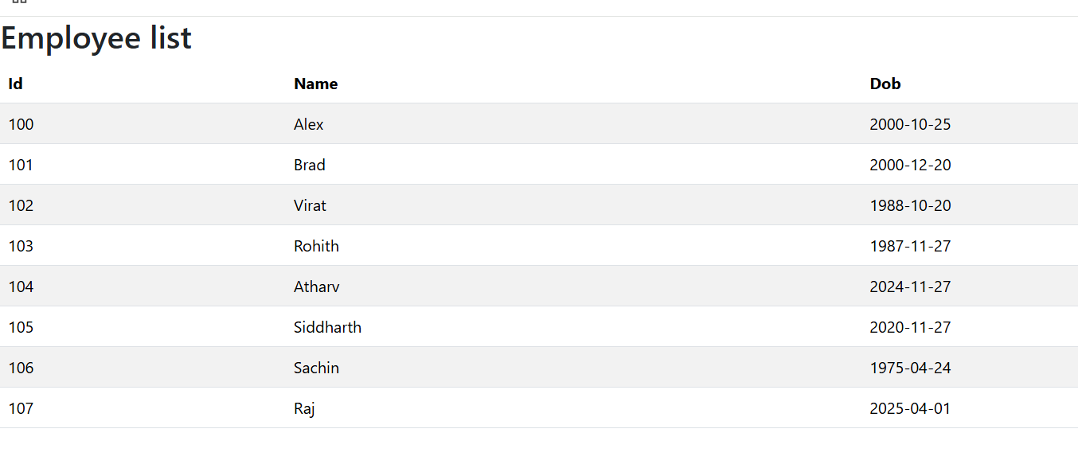

Spring tag-libraries

They allow you to bind the controller and view, so that the data you enter in the view will be auto-initialized to an object (i.e., employee) and you can receive that object using ModelMap

We can use JQuery Ajax to send the request to the backend service

Ajax: Asynchronous Javascript and XML this can send HTTP requests using Javascript or JQuery and can update part of the document, without reloading the entire page, before React, Angular, Vue.js we used Ajax

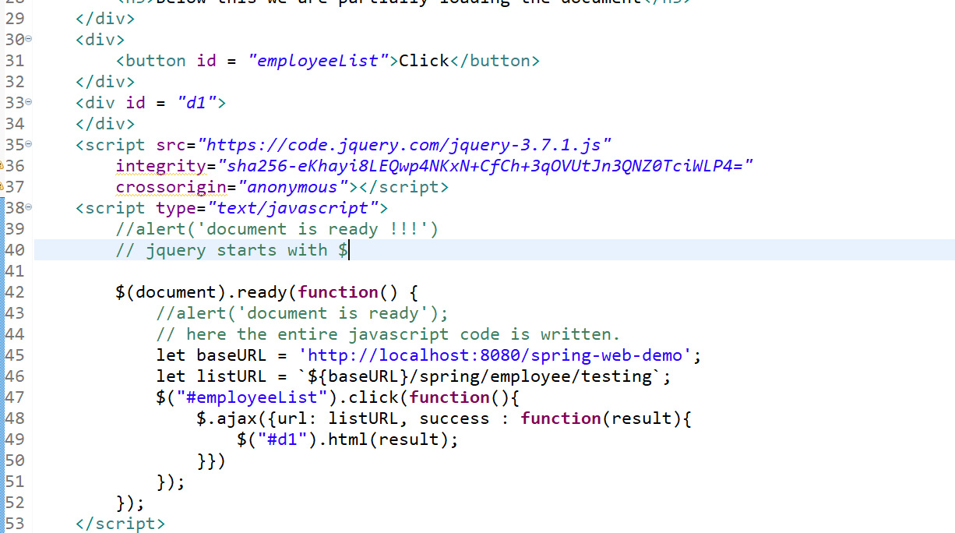

Summary

1. Spring Dependency Injection
2. Spring Container - IOC (inversion of control)
3. XML based configuration
4. Constructor & Setter Injection
5. Collection Injection
6. Annotation based configuration (Java configuration)
7. component scanning
8. Spring JDBC
9. Spring ORM
10. Spring Web MVC - @Controller, @Service, @Repository, @Autowired
11. Jquery & Ajax calls

Spring Boot

It simplifies developing applications that use spring framework by automating lot of generic configurations and provides you a ready to use environment based on your requirement.

Suppose you need to create a web application, you do below configurations like

1. Configuring the server
2. Creating a project
3. Converting to maven project
4. Adding the dependencies with compatible versions
5. Front controller configuration
6. Bean configuration file (XML file)
   1. component scanning
   2. datasource properties
7. Classes like @Component, @Service, @Repository, @Controller and so on.

Spring Boot takes care of providing you the web environment that needs all the 6 steps if you add one library called ‘spring boot starter web’

Note: Spring Boot doesn’t use XML, it uses application.properties file where you can provide the datasource information or any other application configurations like server port, context path, cloud configuraitons and 1000’s of configurations

Note: Spring boot uses parent POM which helps in downloading libraries of compatible version

ex: spring boot parent 3.1 -> downloads spring mvc 6.1, spring context 6.1 and all spring libraries of 6.1

ex: change 3.1 to 3.2 -> downloads spring mvc 6.2 , spring context 6.2 and all spring libraries with 6.2

Note: spring boot parent 3.1 downloading 6.1 libraries is just for understanding purpose, as the correct version of spring libraries can vary.

Spring boot provides starter libraries that takes care of configuring the applications

1. Spring Boot Starter Web - provides inbuilt server, dispatcher servlet, component scanning
2. Spring Boot Data JPA - DB connections, does all the dependency injection required to interact with the db, dynamic implementation of the DAO layer (developers doesn’t need to implement DAO layer), this is possible with some inbuilt interfaces which you must use in the application
3. Spring Cloud Starter: Provides all the necessary patterns required to deploy the application in any cloud environment like Service discovery, Load Balancing, Circuit Breaker, External Cloud Configuration, Log tracing

Spring has provided an official website called start.spring.io (spring initializr) from where you can download the Maven or Gradle project & also you get the UI to add the dependencies to your project, the project you download will have application.properties inbuilt and the main method to run the application

Note: Gradle is similar to maven

The main class has following code

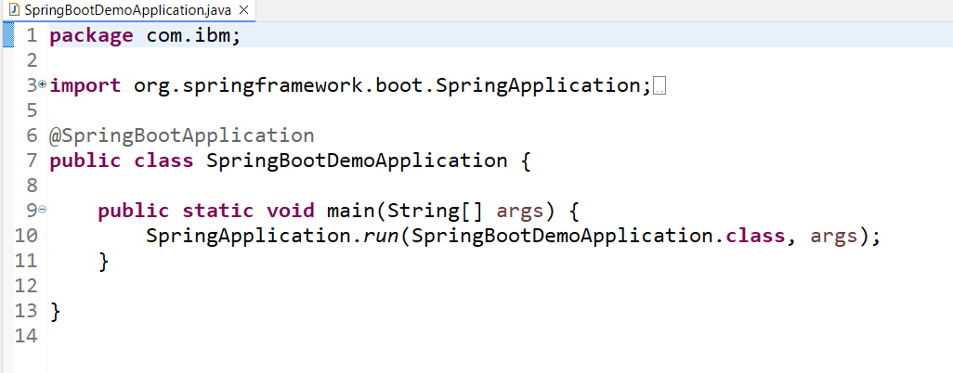

@SpringBootApplication takes care auto-configuring the application based on the libraries you have in your classpath, since we have spring web, it configures server, component-scan from base-package (com.ibm), front controller

RESTful webservices

REST stands for Representational State Transfer

Webservices allow multiple applications written in different technologies to exchange the data in a common format

ex: Zomato exchanges price amount to Phone pay, google pay, banking servers(HDFC, Kotak, BoB and many more)

ex: Phone Pay mapped to one bank exchanges amount to another Phone Pay which is mapped to a different bank

ex: ATM machines of one bank can exchange data with any other bank servers

ex: Google Map exchanges data to Uber / OLA applications

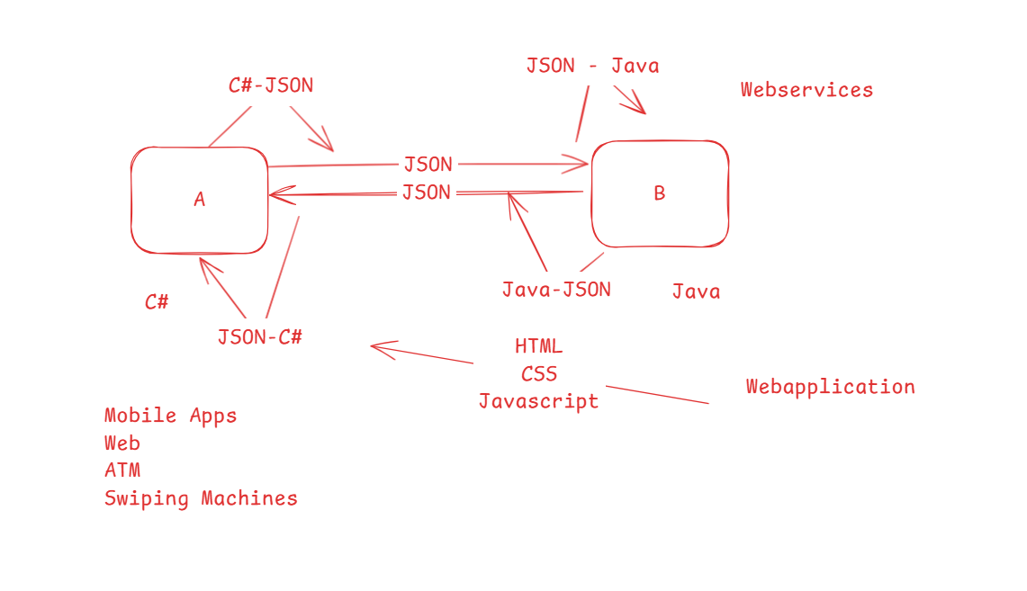

RESTful webservice supports other structures apart from JSON like

1. XML
2. CSV
3. TEXT
4. HTML

RESTful webservice principles

1. URL: Webservice resource must have URL’s so that clients can use to access
2. HTTP Methods: Resources must strictly use HTTP methods to specify what kind of operation they do like GET, POST, PUT & DELETE and clients must use same HTTP methods to perform the right operation

You need to use tools like Postman, VS Code plugin thunder client or SOAP UI to test the webservice as its impossible to access webservice in all the technologies, these tools allow you to choose HTTP methods & specify the URL’s and send the HTTP request and get the HTTP response, if you get an HTTP response in JSON format you must understand that it can be converted to any technology

RESTful webservice can be developed in any language

1. Java - Spring REST / JAX-RS
2. Node.js - Express.js
3. C# - ASP.NET
4. Python - Django

Spring can use controller layer for webservice, you must have a class with @RestController to create webservice class

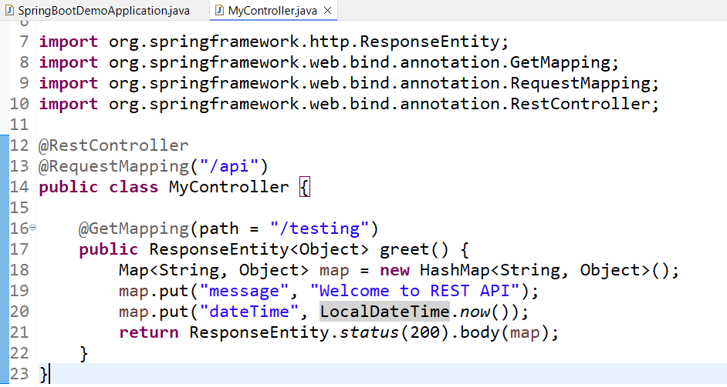

Output:

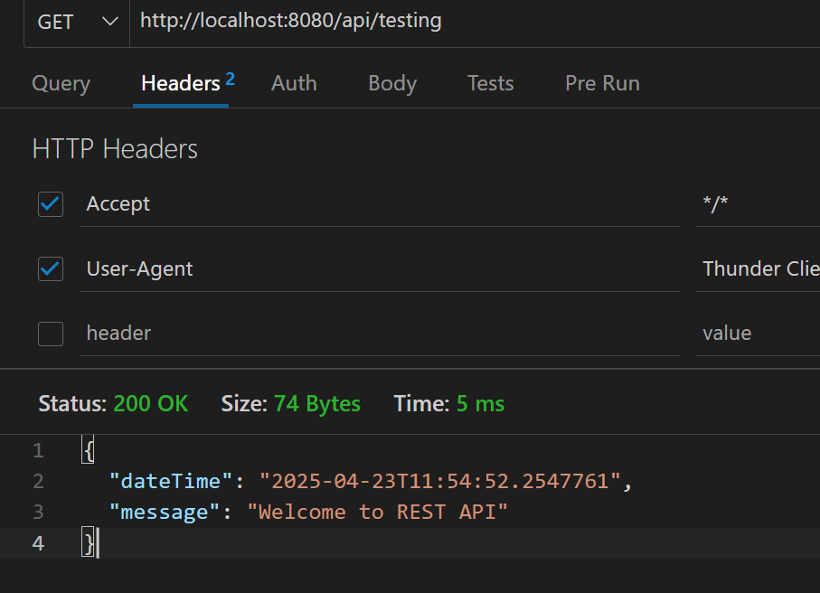

Sending JSON to the webservice

When you send the JSON, then backend must convert the JSON to Java objects if its Java, C# objects if its C# and so on.

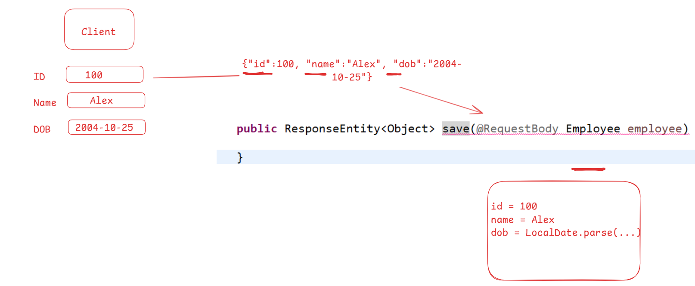

@PostMapping(consumes = MediaType.APPLICATION_JSON_VALUE, path = “/save”)

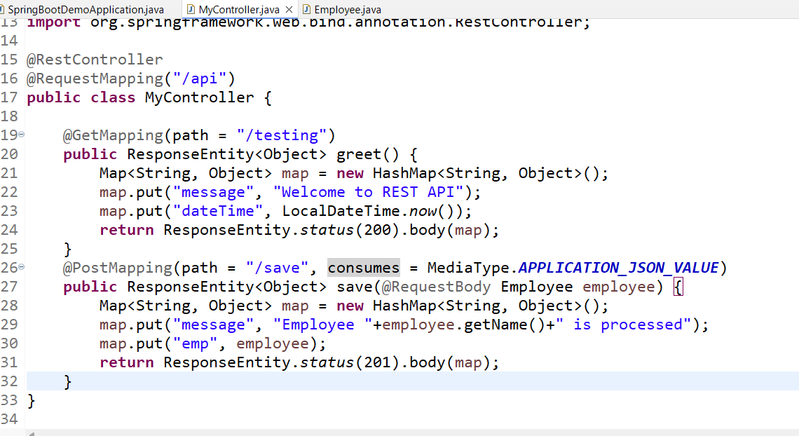

Output:

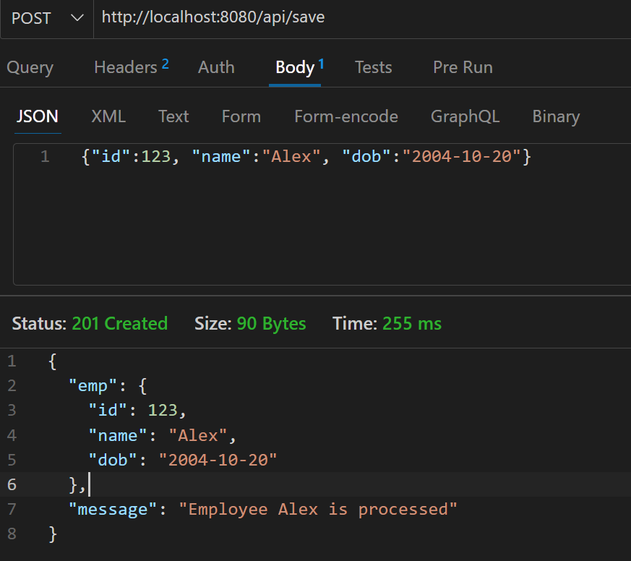

Spring Data JPA

JPA stands for Java Persistence API which is a standard specification to map Java objects to the Relational database which is nothing but ORM

Spring Data JPA is a library that automates spring boot application

1. To connect to the DB using datasource informations present in application.properties
2. Implement the DAO layer for the entity class so that developers doesn’t need to create a DAO layer

Entity classes: These are Java beans that will have the table & column informations with some annotations

@Entity  
@Table(name = “employee”) // optional if table & class name is same  
class Employee {  
 @Column(name = “id”)   
 @Id // inbuilt annotation to specify primary key column  
 @GeneratedValue(strategy=GeneratorType.IDENTITY)  
 int id;  
 @Column(name = “name”)   
 String name;  
 @Column(name =”dob”)  
 LocalDate dob;  
}

Spring Data JPA provides some interfaces with CRUD operations and other operations like sorting, pagination, below are the two important interface

1. CrudRepository<T, ID>: save(T), findById(ID), findAll(), deleteById(ID)
2. JpaRepository<T, ID> extends CrudRepository<T, ID>

T is the entity class name  
ID is the primary key type

These interface will have some methods to perform operation based on the primary key

The only thing you must do is extend any one of these two interface to get the CRUD operations for your entity class

interface EmployeeRepo extends JpaRepository<Employee, Integer> { } all the methods of JpaRepository are inherited as below  
save(Employee emp);  
findById(Integer ID)  
findAll()  
deleteById(Integer ID)

Spring Boot provides a dynamic implementation for EmployeeRepo and its object will be registered in the spring container

What will be there in the implementation?

save(Employee emp) {   
 insert into employee values(?, ?, ?)   
 set ? with emp.getId(), emp.getName() & emp.getDob()  
}

findById(Integer ID) {   
 select * from employee where id = ID;  
}  
deleteById(Integer ID) {   
 delete from employee where id = ID;  
}  
findAll(() {   
 select * from employee >> Result >> List<Employee>  
}

What developers must do is @Autowired the EmployeeRepo and call the CRUD methods

@Autowired // done in the Service layer  
private EmployeeRepo dao;

Steps

1. Add spring data jpa & mysql library
2. application.properties: enter url, username, password & driverClassName
3. Create an entity class for employee table
4. extend JpaRepository<Employee, Integer> in this way
5. Autowire the interface of DAO in the service layer
6. Autowire the service layer in the controller layer

EmployeeRepo.java

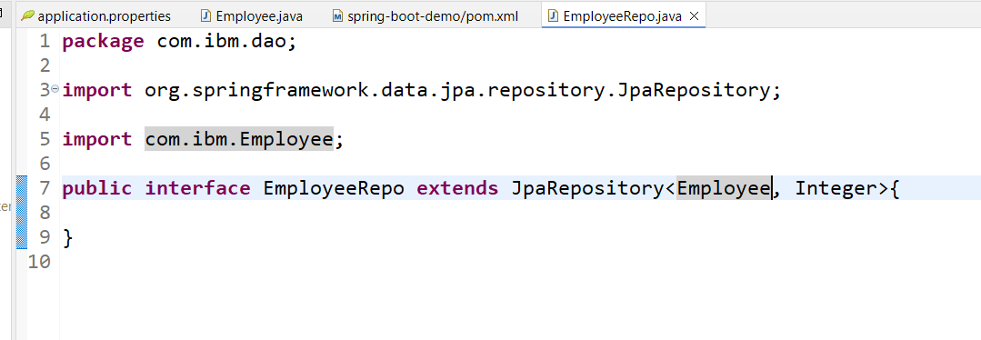

Implementing the service layer

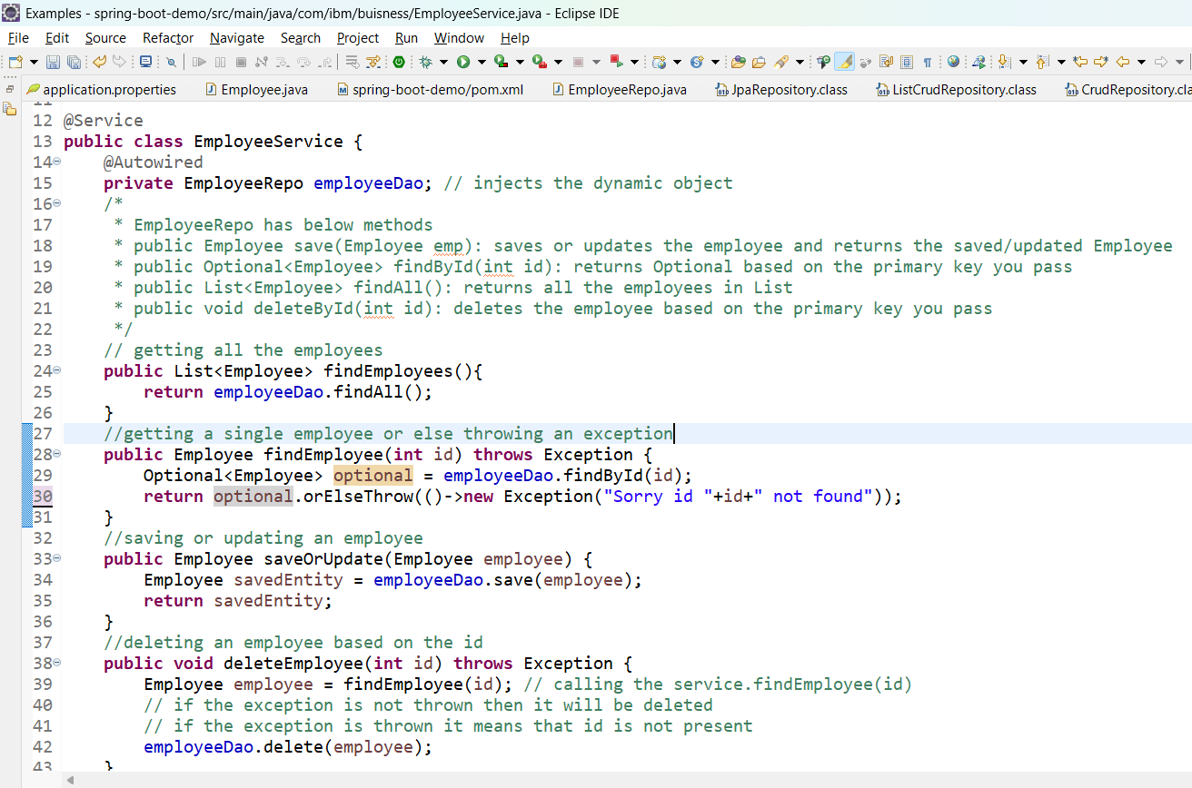

Injecting the service to the Controller & mapping the HTTP methods for the methods that invoke the service layer methods

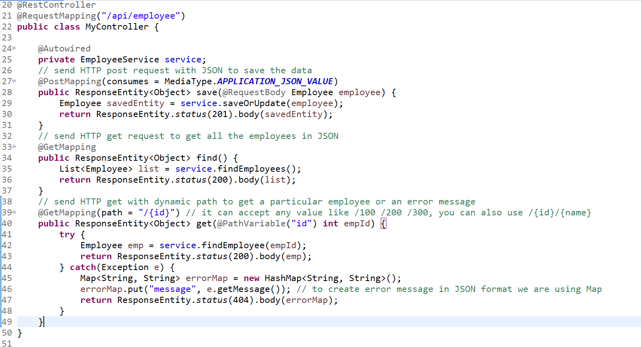

Custom finder methods inside the interface even that will be implemented by the Spring Boot

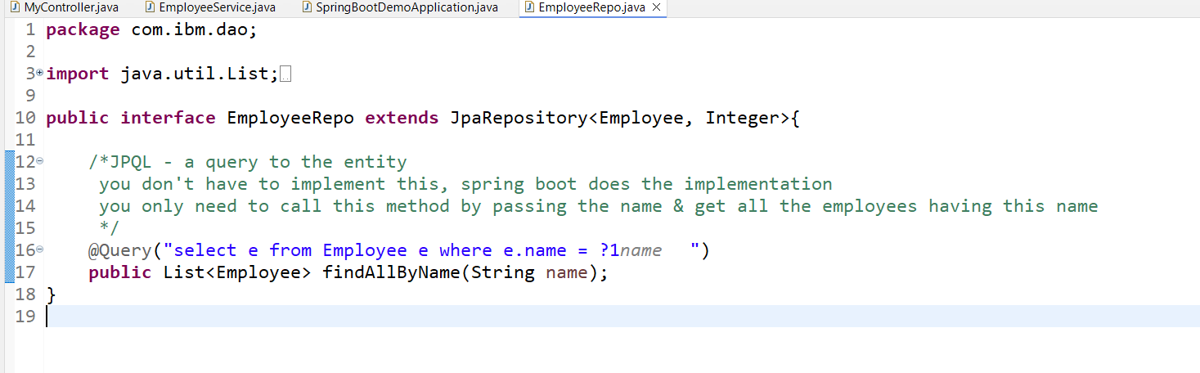

Activity: Create the above method in the EmployeeRepo and call that method from the service layer by passing the name from the controller layer, you will receive the name from the client/thunder-client

Activity: Create 2 methods to map PUT & DELETE in the controller and call the delete by id methods(invoke deleteEmployee(int) & update dob based on the id (invoke saveOrUpdate(Employee)

Microservices using Spring Boot

Microservices is an architectural approach where a large application is broken down into smaller, independent, and loosely coupled services that communicate with each other through well-defined APIs. Each microservice is designed to handle a specific business function and can be developed, deployed, and scaled independently.

Monolithic applications will have all the features in a single application, this has lot of side effects

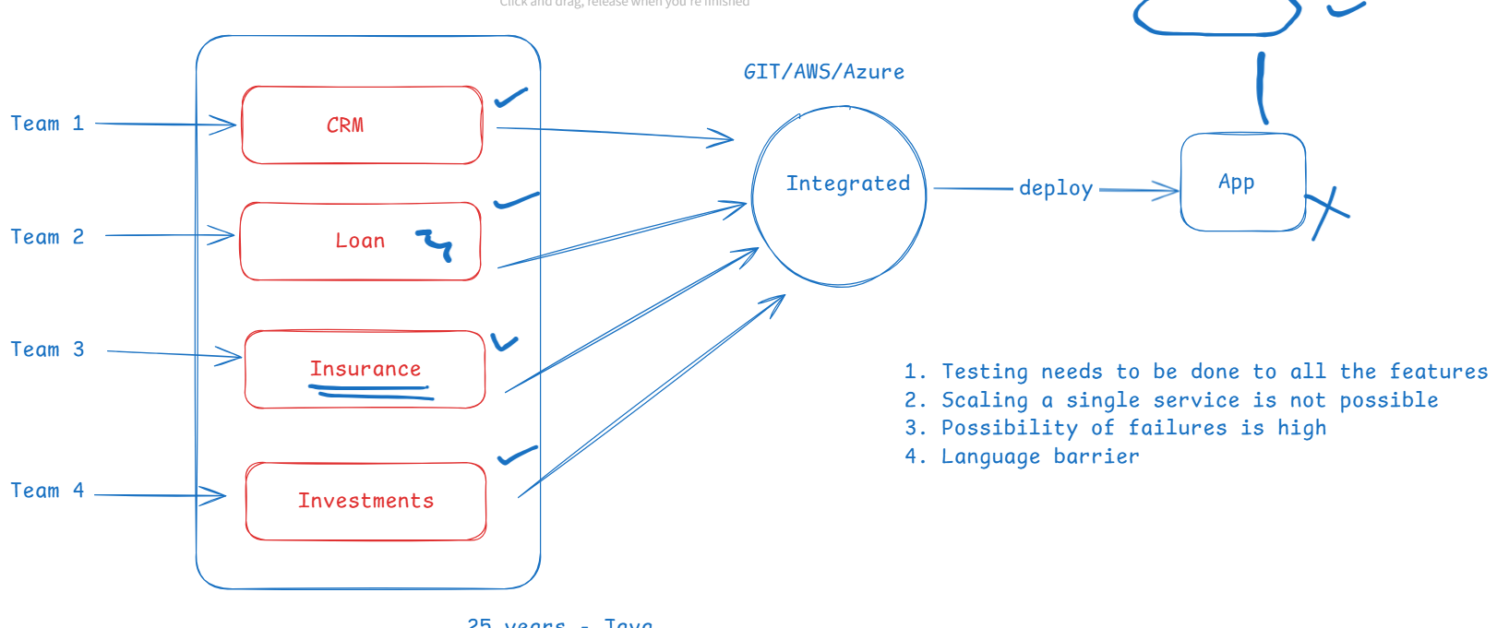

Drawbacks

1. If you do some changes in one features then you need to test all the other features which weren’t changed
2. You can’t scale a single service on demand
3. If one of the module goes down then entire application may go down
4. You are bound to use the same language when you want to add a new feature
5. Releasing a new feature takes more time

Microservices architecture

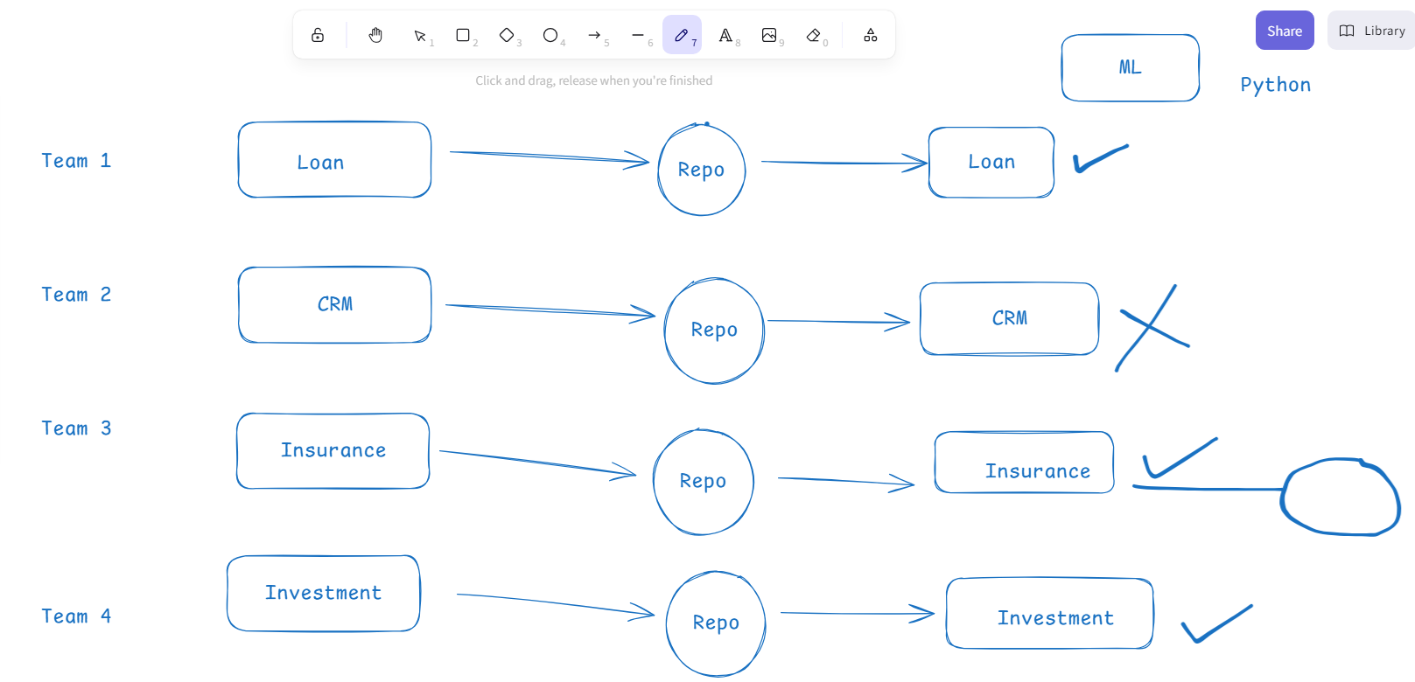

Advantages of Microservice architecture

1. You can develop, deploy & scale the service independently
2. If one service goes down it doesn’t affect other services
3. Releasing the new feature will be faster
4. You can use different languages as per the requirement

Spring microservices uses 2 spring projects to develop microservices

1. Spring boot - automate configurations
2. Spring cloud - has all the design patterns required for microservices which you can apply with simple annotations.

Microservice design patterns

1. Discovery server
2. Discovery client
3. Load balancer
4. External / Distributed Configuration
5. Circuit breaker
6. API gateway
7. Distributed log tracing
8. Security

Discovery server: It is a program that registers all the microservice services, In Spring boot you have EurekaServer which acts as Discovery Server, using @EnableEurekaServer in your application creates a discovery server program

Discovery client: It is a program that will register to the Discovery server, In Spring boot you just need to add Eureka Client library, then automatically the application becomes Discovery client & registers to the Service discovery with an instance-id & its IP address along with this every 30s it sends its status to the Service discovery.

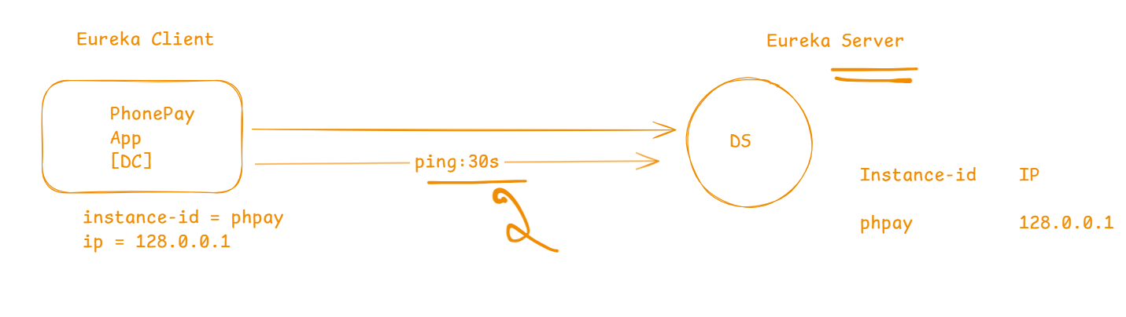

Load Balancer: It is a client side load balancer that equally distributes the load across multiple instances of the microservice

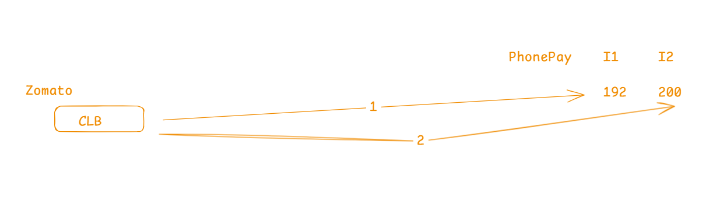

External / Distributed Configuration: It is a common configurations that multiple microservices can use

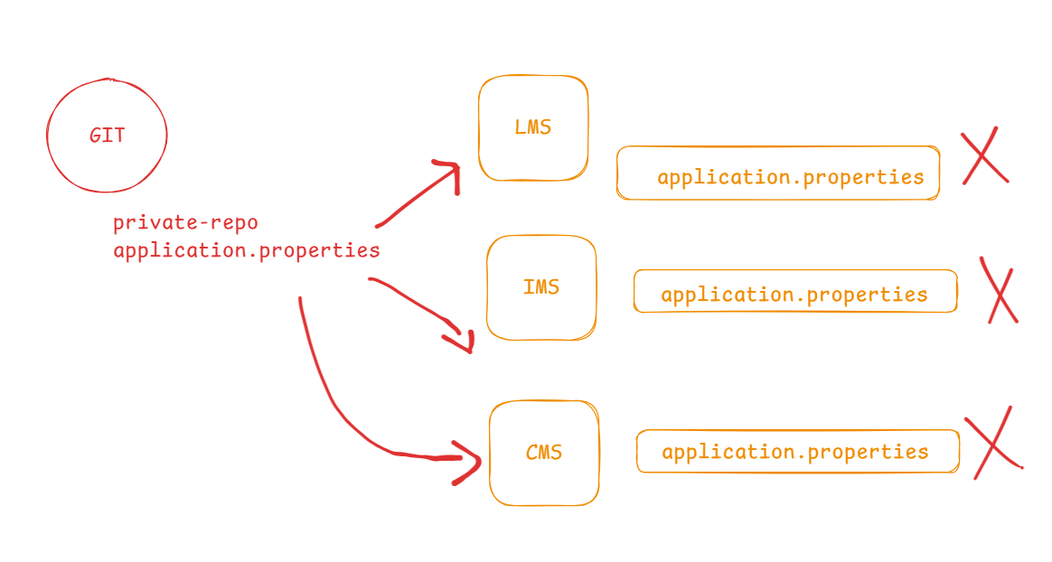

Circuit breaker: This avoids cascading failures when many microservices are communicating with each other

You must have minimum 2 projects to develop a microservice program

1. Service discovery / Discovery server - Eureka Server library
2. Discovery Client - Eureka client

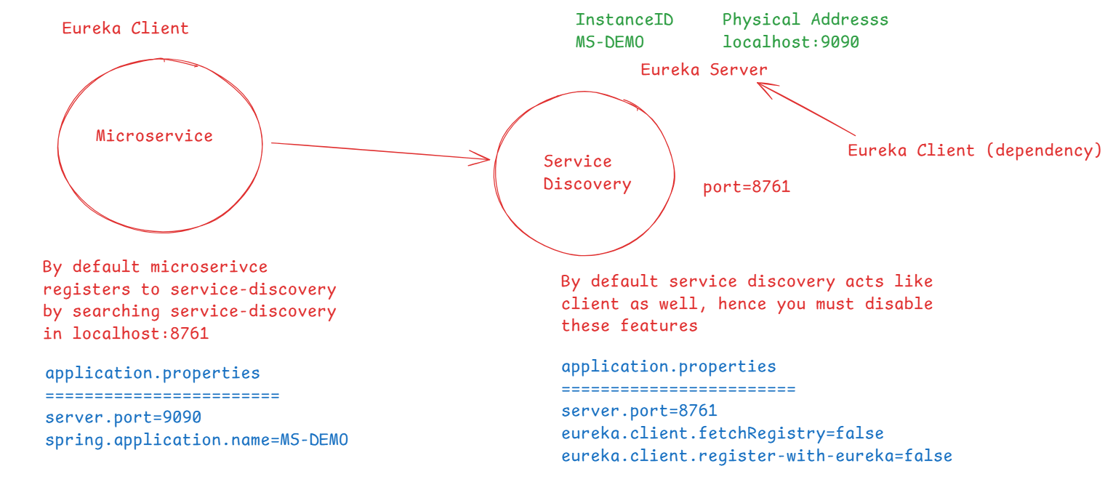

Steps:

1. Create a project for service discovery
2. Configure the existing spring-boot-demo project to act as discovery client

application.properties

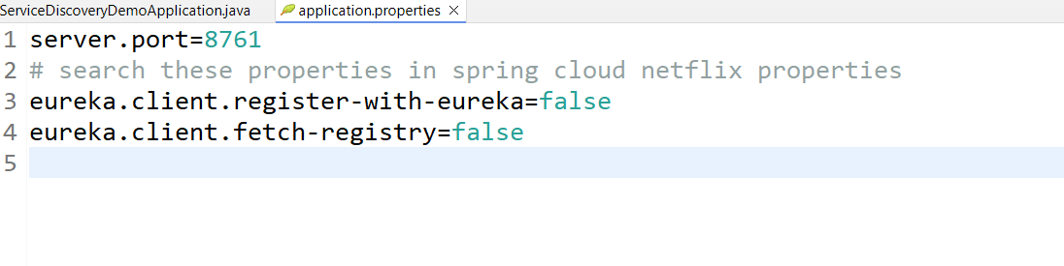

Add @EnableEurekaServer to configure your application to behave like service discovery

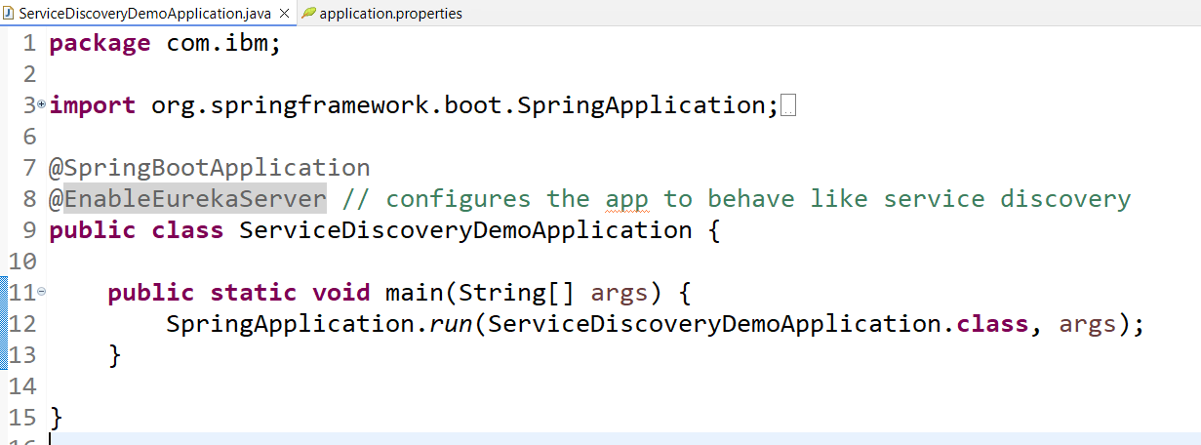

Eureka server gives a dashboard from which you can see all the registered microservice

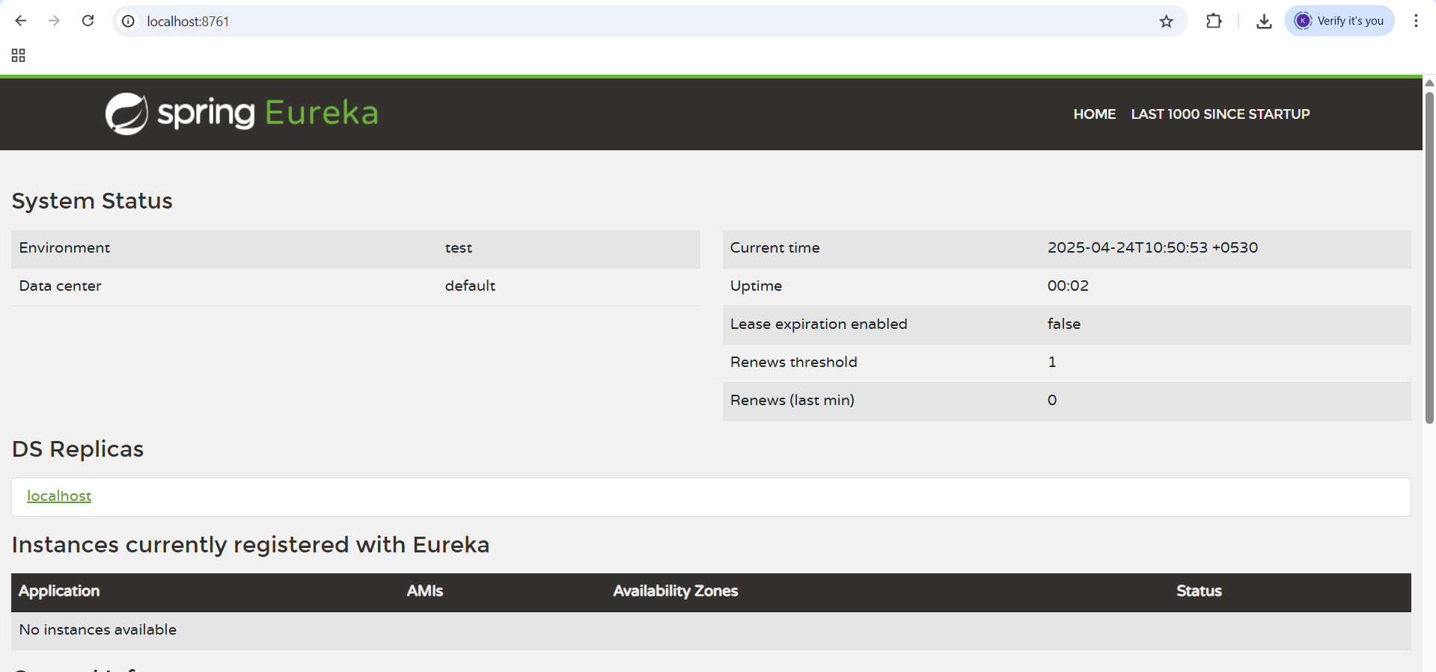

We can create microservice with an instance id

The library you must add is

1. Eureka Client
2. Update the pom.xml with spring.cloud.version as well

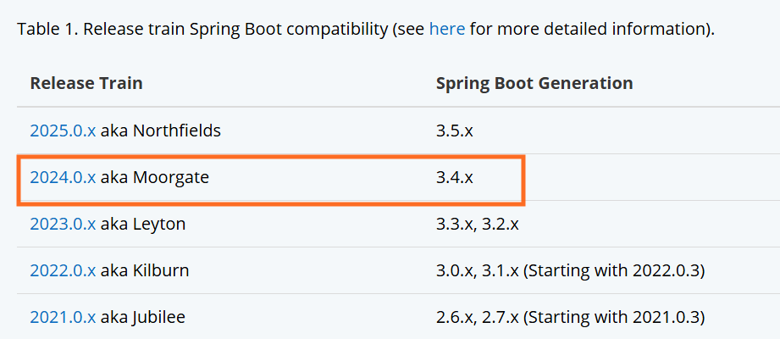

Above table suggests that if you want to add spring cloud to your spring boot then the spring.cloud version must match to the compatible spring boot version

Output:

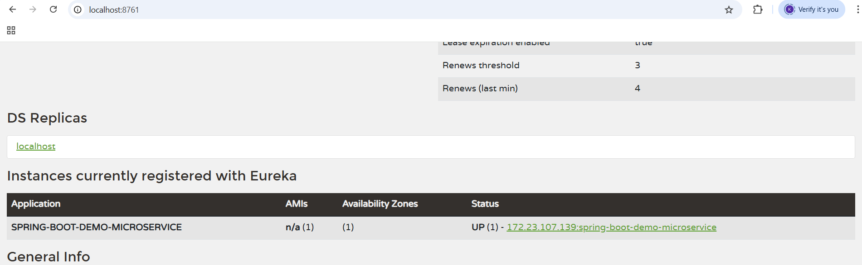

We can create another instance of the spring-boot-demo which is a microservice & register with the service discovery server, for this you must launch separately outside eclipse because in eclipse already spring-boot-demo is running.

For this you can create an executable jar using maven build goals=package option.

java -jar filename.jar --server.port=8081

java -jar filename.jar --server.port=8082

This launches the application in 8081 & 8082 port, by default the port of tomcat server takes is 8080

Another microservice can send request to the above instances so that the load balancer will equally distribute the load

RestTemplate: It is an object a microservice must use to send the HTTP requests to the remote service

@Autowired  
@LoadBalanced  
RestTemplate template;

template.getForObject(“http://SPRING-BOOT-DEMO-MICROSERVICE/api/employees”) this gets the employees in List<Employee> format automatically either from instance-1 or instance-2, the above method getForObject() sends HTTP GET request similarly the RestTemplate has postForObject, putForObject and so on.

Integrating Spring boot with React.js

Note: Since spring boot is using eureka client, you must run service discovery before running this spring boot application

You must support cross origin resource sharing hence the app must use @CrossOrigin as below

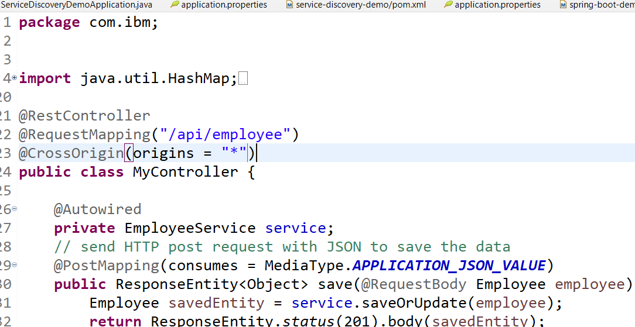

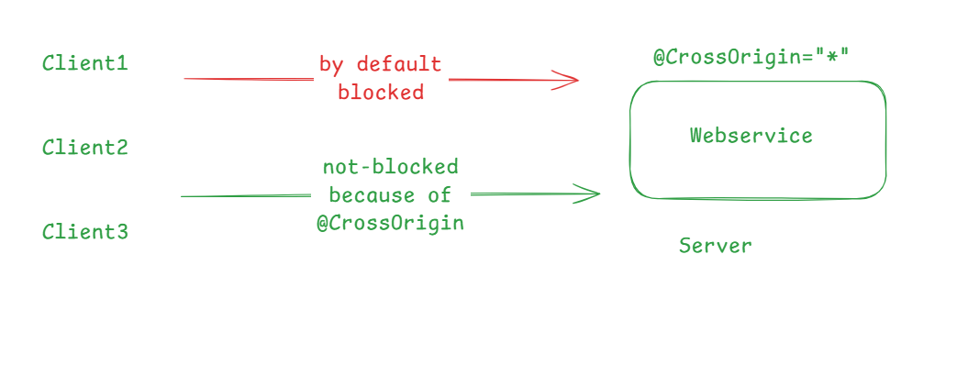

Create a react application

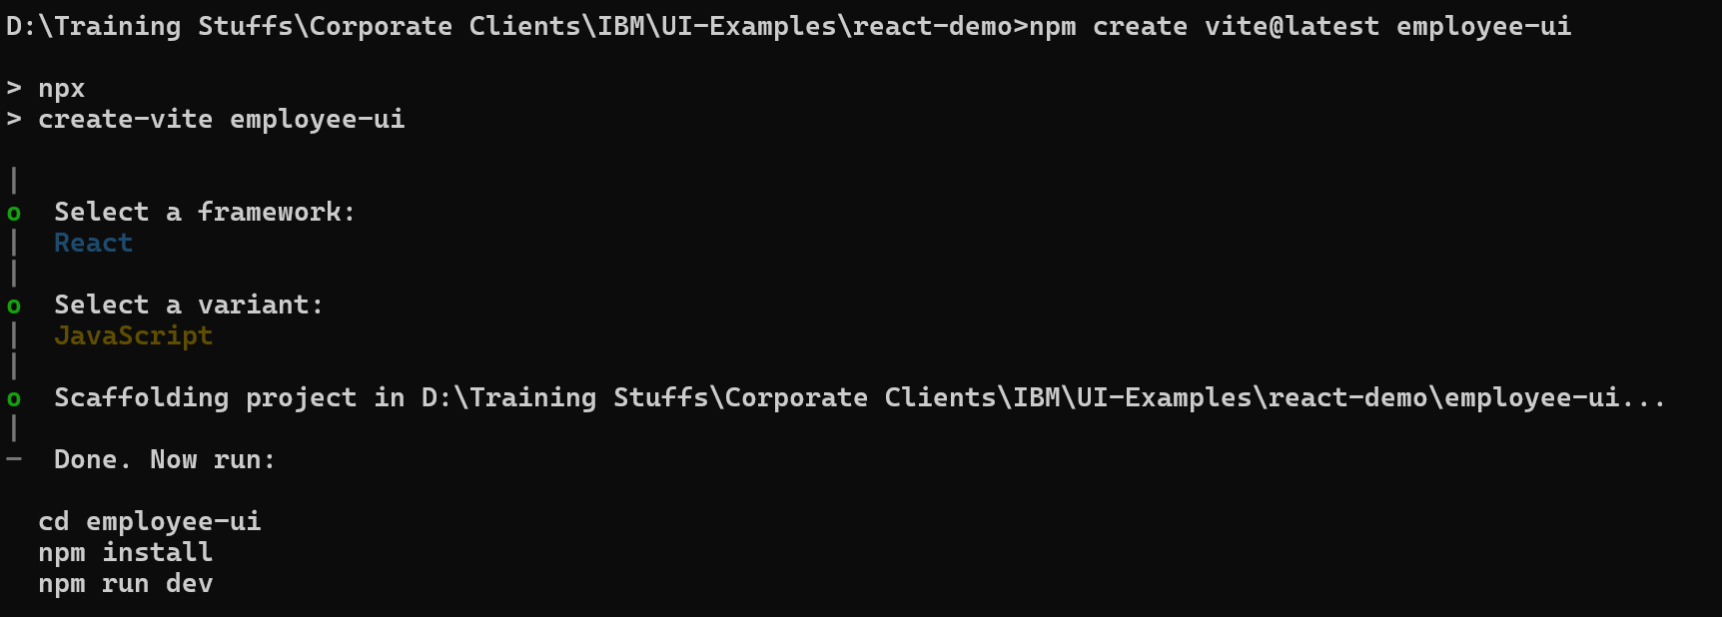

after cd employee-ui, npm install, install below libraries

1. bootstrap
2. axios
3. react-router-dom



Installing bootstrap, axios, react-router-dom at once



UI Requirement

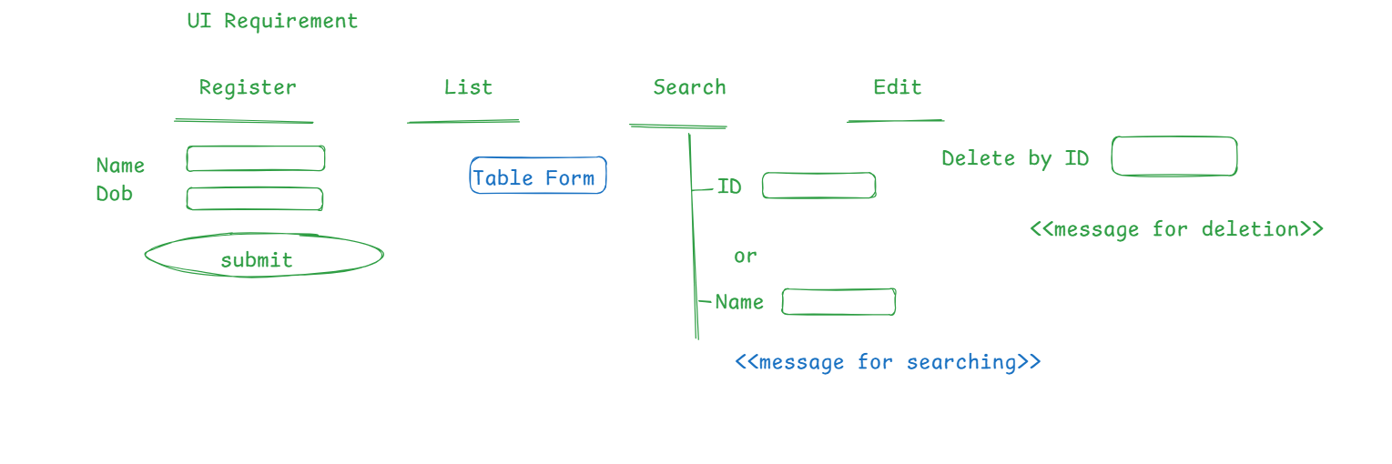

Independent Search component that takes the id & sends the HTTP request to the spring boot application & displays the success / error response.

Implement a controller to return the port number

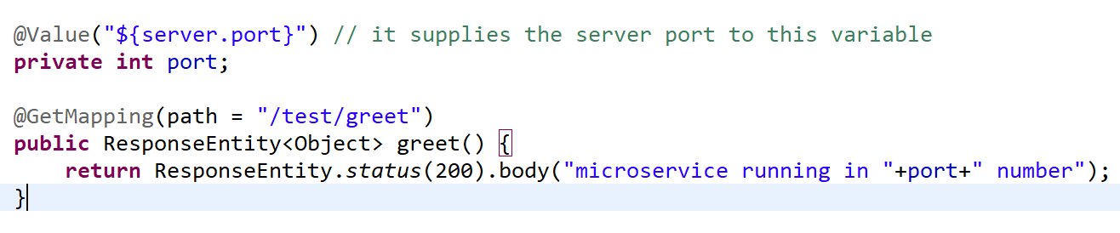

Now you can run multiple instance of this microservice and another microservice can communicate with all the instances with the help of LoadBalancer

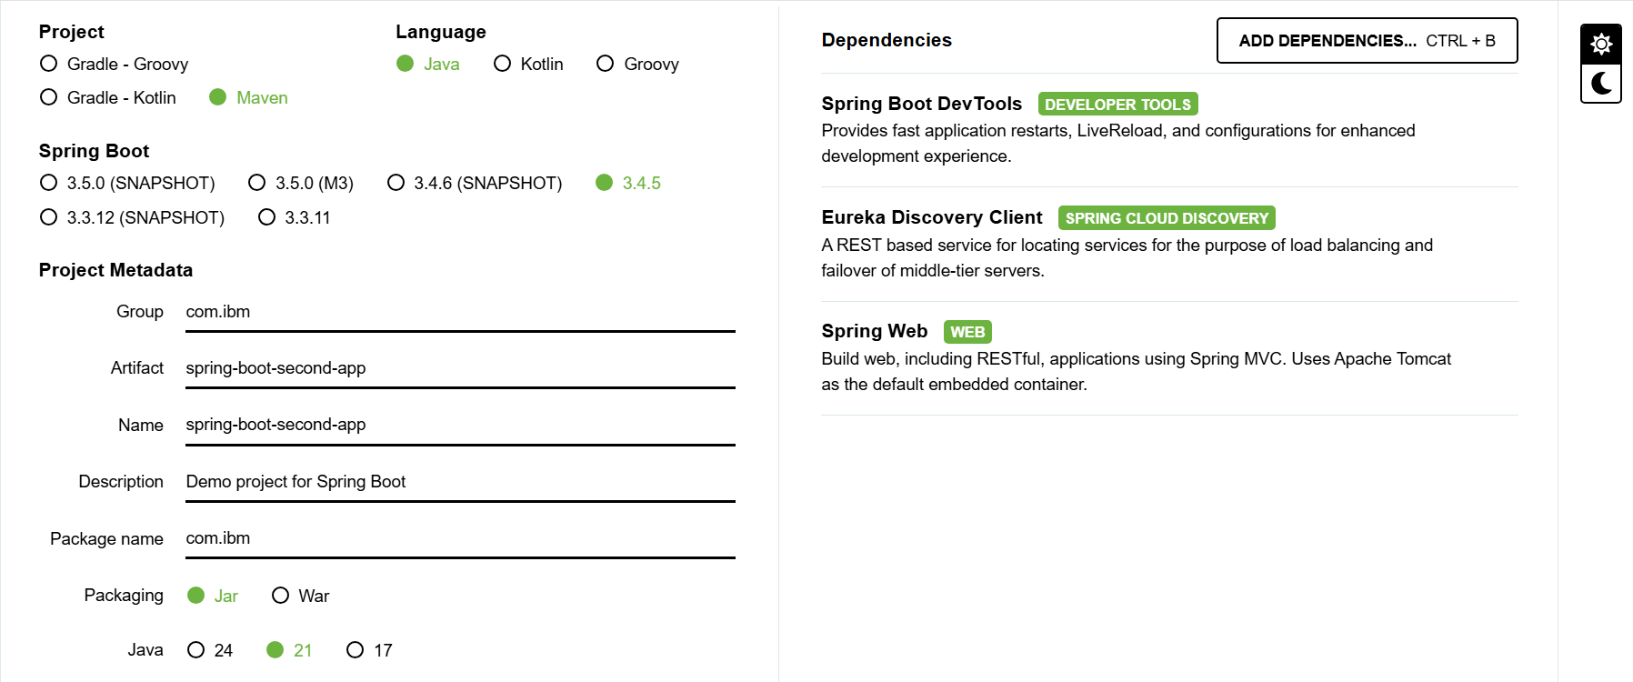

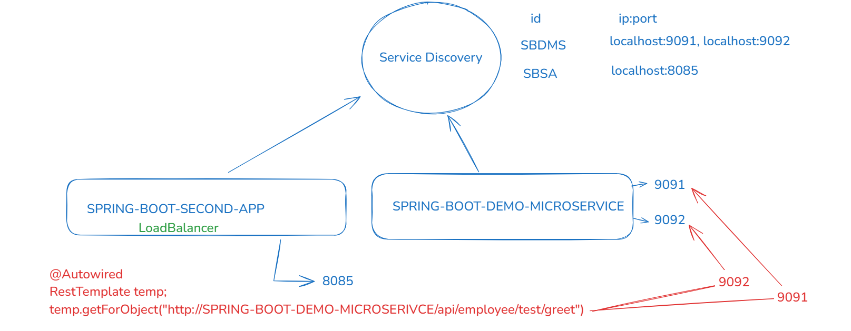

Configure the second application application.properties

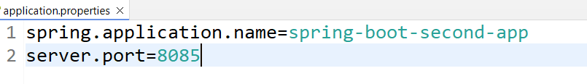

Create a RestTemplate object to use @LoadBalanced annotation

@LoadBalanced takes care of resolves the physical address using the instance-id of the remote microservice by querying the service discovery

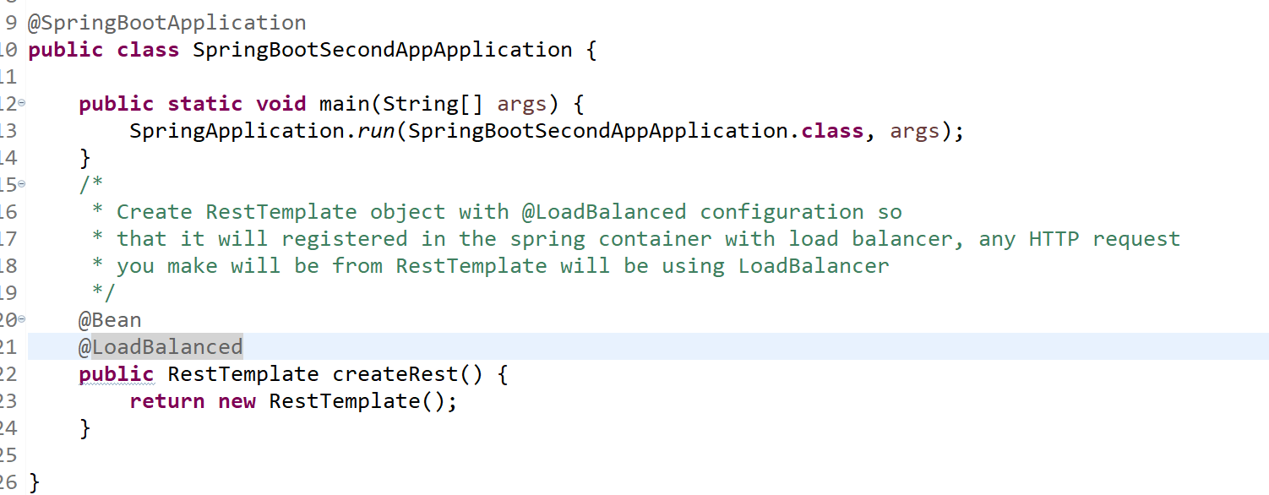

Since second-app is a client that sends request to the spring boot demo we need to send request to the second-app that sends request to the spring boot demo

You must launch the spring boot demo via jar so that you can run more than one instance

1. Build the jar file for both first & second-app
2. We will run 2 instances of first app and 1 instance of second-app
   1. spring boot demo one instance in 9091 & another in 9092
   2. spring boot second app run without --sever.port option
   3. Check the service discovery dashboard
3. We will send multiple GET requests to the /second-app to see the load balancer distributing the requests to the first-app

List of maven goals you can enter from eclipse plugin

1. package: This creates package that will have either jar or war so that you can run on an external environment
2. clean: This removes all the compiled files & other files present in the target folder
3. compile: This compiles the project
4. install: This will install the jar or war of your project in the .m2 folder in your computer, this is required when you want to add your project as a dependency to another project.
5. test: This runs all the test cases present in your project

How to create a maven project

mvn archetype:generate

-DgroupId = com.ibm

-DartifactId = testing-demo

-DarchetypeArtifactId = maven-archetype-quickstart

-DinteractiveMode = false

Spring AOP:

Aspect Oriented Programming, this helps in implementing the cross-cutting concerns without actually writing it in the application logic, below cross cutting concerns like

1. Logging
2. Error handling
3. Security - Authentication & Authorization

Without AOP

method() {  
 some statements  
 log(“log some message”);

some statements  
}

With AOP: without writing the logging logic you can log the methods by separately writing it which is much flexible for the application when any change happens

logging() { // Advice  
 log(“log some message”); // configure this must be executed when any method runs  
}

//business method

method() { // Join point  
 some statements;  
}

Aspect: A class which will have the cross-cutting concerns

Join Point: A point during the execution of a program, such as execution of a method which will have the real business logic

Advice: A cross-cutting concern that is called at a particular join point

Pointcut: A Join point expression provided on the advice

Implementing a Join Point

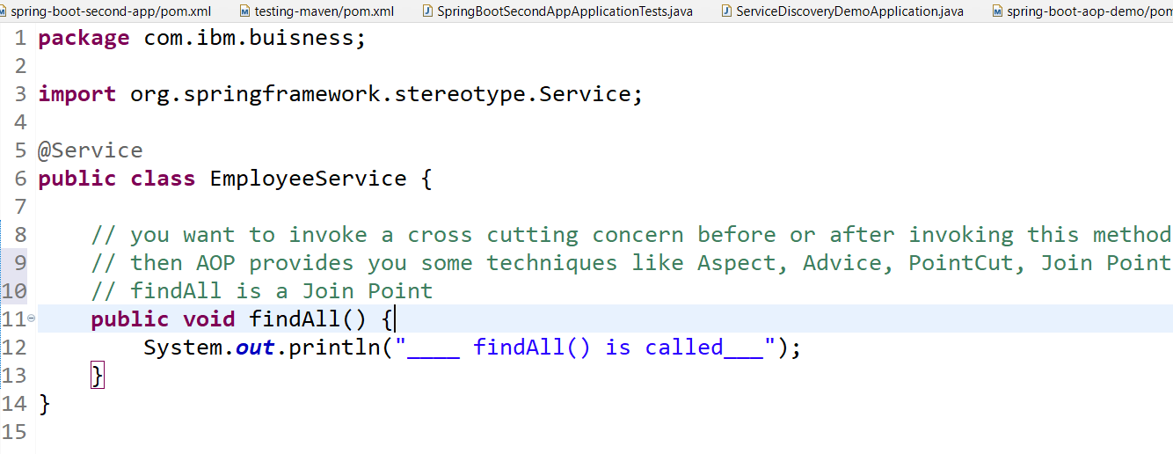

Point Cut expression syntax

execution(modifiers-pattern? ret-type-pattern declaring-type-pattern? name-pattern(param-pattern)

throws-pattern?)

Implementing the Aspects

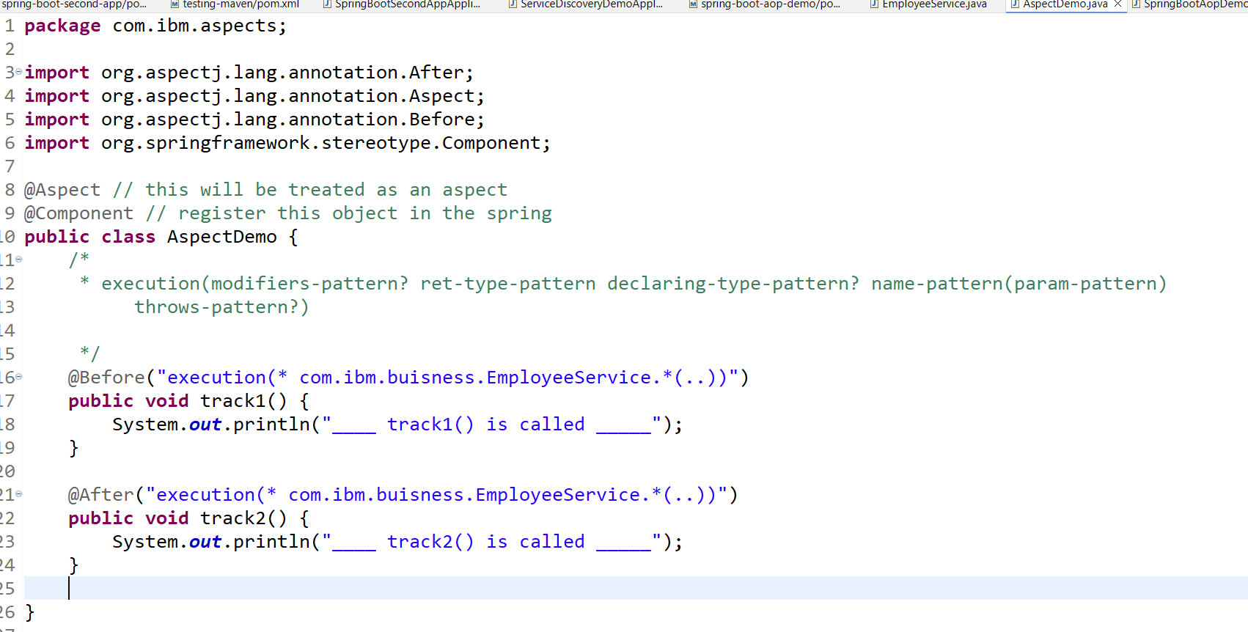

Main class

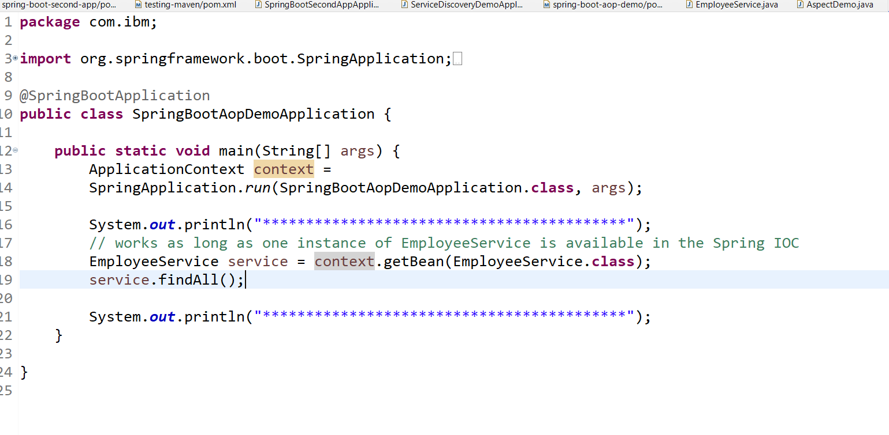

Design patterns

12 Factor app

The **12-Factor App** is a set of best practices for building modern web applications that are scalable, maintainable, and portable. Here's a simple breakdown:

The **12-Factor App** is just a guide to help you build it in a clean, smart way so it's easy to:

* Run anywhere (your laptop, cloud, someone else’s computer)
* Scale if lots of people use it
* Fix or update without breaking everything

12-Factor isn’t something you “install.”  
It’s just a set of **smart habits** so your app:

* Runs better
* Grows easier
* Breaks less

12 Factor app

1. Codebase
2. Dependencies
3. Config
4. Backing Services
5. Build, release, run
6. Processes
7. Port Binding
8. Concurrency
9. Disposability
10. Dev/Pro parity
11. Logs
12. Admin Processes

[**I. Codebase**](https://12factor.net/codebase)

One codebase tracked in revision control, many deploys

You put **all your code in one GitHub repo**. No copying and pasting files for the test or live version. Just **one source of truth**.

[**II. Dependencies**](https://12factor.net/dependencies)

Explicitly declare and isolate dependencies, List what your app needs in a file, so if someone else installs your app it works exactly the same

[**III. Config**](https://12factor.net/config)

Store config in the environment

Passwords, API keys, etc.? **Don’t write them in the code.** Use environment variables (like settings stored outside).

ex: --server.port=9091 --spring.datasource.password=root@123

[**IV. Backing services**](https://12factor.net/backing-services)

Treat backing services as attached resources

If you use a database or file storage, pretend it’s like a charger — you can **unplug one and plug another** without breaking the app.

[**V. Build, release, run**](https://12factor.net/build-release-run)

Strictly separate build and run stages

Think like baking a cake:

* **Build**: Mix ingredients
* **Release**: Put it in the oven
* **Run**: Serve it  
  Don’t mix these steps together.

[**VI. Processes**](https://12factor.net/processes)

Execute the app as one or more stateless processes

Don’t keep any data or state in memory between requests. Use databases or storage services instead.

Don’t keep stuff in memory like “who’s logged in” — store it in a database so if the app restarts, it still works fine.

[**VII. Port binding**](https://12factor.net/port-binding)

Export services via port binding

Your app should be self-contained and expose a web port (like 3000 or 8000) — no need for external web servers like Apache or Nginx.

[**VIII. Concurrency**](https://12factor.net/concurrency)

Scale out via the process model

Run multiple instances (or types) of processes to handle more load, like workers for background jobs.

[**IX. Disposability**](https://12factor.net/disposability)

Maximize robustness with fast startup and graceful shutdown

Apps should start quickly and shut down cleanly — helps with scaling and deploying safely.

[**X. Dev/prod parity**](https://12factor.net/dev-prod-parity)

Keep development, staging, and production as similar as possible

Use the same OS, dependencies, and services in all environments to avoid "it works on my machine" problems.

[**XI. Logs**](https://12factor.net/logs)

Treat logs as event streams

Don’t manage logs yourself. Just output them to stdout/stderr, and let the platform collect and analyze them.

[**XII. Admin processes**](https://12factor.net/admin-processes)

Run admin/management tasks separately, you don’t include them as part of the code, it’s a one time tool run separately whether its creating a database or a table or granting permissions, revoking permissions.

SOLID principles

SOLID is an acronym for five design principles in object-oriented programming:

1. Single Responsibility Principle, - String - LocalDate

2. Open/Closed Principle, - Class must always closed for modification but must be opened for extension

3. Liskov Substitution Principle,

4. Interface Segregation Principle, and

5. Dependency Inversion Principle.

Below are some design patterns

factory pattern: getBean() method of spring is a factory pattern method to return the object

singleton pattern: only one object for a class

prototype pattern: multiple objects on demand

adapter pattern: that allows incompatible interfaces to work together by acting as a bridge between them.

builder pattern: this builds an objects from which you can build another object

ex; ResponseEntity.status(200).headers(..).body(..)

GIT

It is for version controlling to track the changes done to the project so that you can go back to any version of the project if you wish to.